Chapter 4: Data Types

What is the Difference between CHAR and VARCHAR in SQL Server?

Char is fixed width, that means that the storage size of char value is equal to the maximum size of the column/ Variable.
Varchar is variable length. The Storage size used by Varchar depends upon the actual characters saved.
Example 1:
Let's create couple of variables and then save the same string and check the storage used by datalength function in SQL Server.
Declare @Variable1 CHAR(20)
Declare @Variable2 VARCHAR(20)

SET @Variable1='TechBrothersIT'
SET @Variable2='TechBrothersIT'

Select datalength(@Variable1) as VarLength1,
datalength(@Variable2) as VarLength2
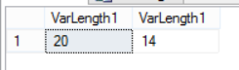
As you can see above, Char occupied 20 Bytes space for 20 characters even we saved only 14 characters. On other hand, Varchar used only 14 bytes to store 14 characters.

Examples 2:
Let's create a table with two columns, once char and other varchar data type. Store the same information and then check the space occupied by each value by using datalength function.

Create table dbo.CharVsVarChar( CHARName CHAR(50),VARName VARCHAR(50))
insert into dbo.CharVsVarChar Values('Aamir','Aamir'),('TechBrothersIT','TechBrothersIT'),('Raza','Raza')
go
Select DataLength(CharName) AS CHARNameLength,
DataLength(VarName) AS VarNameLength
From dbo.CharVsVarChar
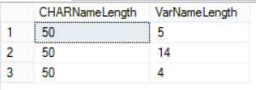
Char vs Varchar in SQL Server - SQL Server / T-SQL Tutorial
We can see that Char always occupy the same space regardless number or characters saved. On other hand Varchar space occupied varies depending upon the number of characters saved.

In cases where we know that we are going to store fixed number of characters, we can use Char otherwise use Varchar.

What is difference between VARCHAR and NVARCHAR in SQL server?

Varchar is variable length character data type which is used to store Non-Unicode data format. You can think of Non-Unicode as English characters.
NVarchar is also variable length character data type which is used to store UniCode data format. For Unicode data formats you can think of alphabets of Chinese, Japanese, Korean and Arabic language.
Varchar can store 'English' characters and it take one byte to store each character. Nvarchar can store English and other languages characters. NVarchar take two bytes to store each character.
Let's create two variables and check the space used by each variable.
Declare @Variable1 VARCHAR(20)
Declare @Variable2 NVARCHAR(20)

SET @Variable1='TechBrothersIT'
SET @Variable2='TechBrothersIT'

Select datalength(@Variable1) as VarLength1, datalength(@Variable2) as VarLength2

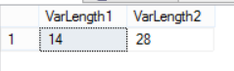
What is the difference between VARCHAR and NVARCHAR - SQL Server Tutorial
As we have declare @Variable2 as NVarchar, it took twice the space as compared to @Variable1 which is Varchar to store the characters.
Let's create a table with Varchar and NVarchar Data type columns and insert few records.
Create table dbo.VarcharVsNvarchar(VarcharName Varchar(50),NVarcharName NVARCHAR(50))
insert into dbo.VarcharVsNvarchar Values
('عامر','عامر'),
('عامر',N'عامر'),
('TechBrothersIT',N'TechBrothersIT')

Select * from dbo.VarcharVsNvarchar
go
Select DataLength(VarcharName) AS CHARNameLength,
DataLength(NVarcharName) AS VarNameLength
From dbo.VarcharVsNvarchar

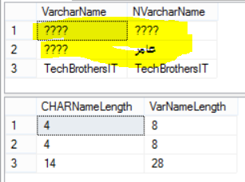
Varchar VS Nvarchar in SQL Server - TSQL Tutorial

Our first Select query returned us the data. Noticed that we have some garbage data ?. Even we have defined the data type of column NVarchar, it inserted the garbage. To insert Unicode data in Nvarchar type column, we need to Use N with data as you can see in second insert ( ('عامر',N'عامر')).

What is the difference between Float and Numeric/Decimal in SQL Server?

Float and Real are approximate data types. Float and Real data types do not store exact values for many numbers.The value can be extremely closed.
Numeric/Decimal are fixed precision data types. It will stored the values with exact precision and scale what you have defined.
If you need to store data where small difference does not matter, you can use Float or Real. But if you need to have exact data such as for financial application. You should be using Numeric/Decimal or Money data type to save exact data, as small difference can impact in calculations.

Example:

Let's declare two variables and save same data and see what happen to output due to data type of them.

DECLARE @DecimalVariable DECIMAL(8, 2)

SET @DecimalVariable = 213429.95

DECLARE @FloatVariable FLOAT(24)

SET @FloatVariable = 213429.95

SELECT @DecimalVariable AS DecimalVariable
,@FloatVariable AS FloatVariable
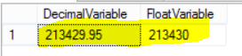
Difference between Float and Decimal/Numeric in SQL Server - T SQL Tutorial
As we can see in above snapshot, Decimal stored and showed exact values and where we have saved values in float, it rounded the values.

As float/ real data types are approximate data types, Avoid using them using in Where clause specially with = or < > operators.

Chapter 5: Tables / Columns

Use Create Statement to Create Table in SQL Server?

Scenario:
An Excel file is provided to you with some information related to Customer with below columns
First Name,
Last Name,
Age,
Phone Number,
Data of Birth,
Sex
and you are asked to create Table in SQL Server Database and save the data in newly created Table.

Solution:
We can use create statement to create Table in SQL Server Database. Below is Create Statement

Create Table Table_Name
(
Column_OneName DataType(Size if required),
Column_TwoName DataType(Size if required),
Column_ThreeName DataType(Size if required),
Column_FourName DataType(Size if required)
)
If we would like to create table with our above requirement, our Create Statement with be
Create Table Customer
(FirstName VARCHAR(50),
LastName VARCHAR(50),
Age SmallInt,
PhoneNumber CHAR(9),
DOB Date,
Sex CHAR(1)
)
There are few points to notice in above Create Statement. I have not used the Schema Name with Table Name. If you would not provide Schema Name with Table Name, it will be created with dbo schema.
Let's say if we have Sales Schema and we would like to create Customer in Sales Schema. Our Create Statement will be
Create Table Sales.Customer
(FirstName VARCHAR(50),
LastName VARCHAR(50),
Age TinyInt,
PhoneNumber CHAR(9),
DOB Date,
Sex CHAR(1)
)

VARCHAR(50) for First Name and Last Name : It will let us store characters and the max number will be 50.
TinyInt for Age: It will let us store integer value between 0 to 255.
CHAR(9) for PhoneNumber : Char will let us store characters, as we know that we need to store 9 Characters, we used Char(9).
Date for DOB: In Date of Birth column, we will be able to store date as we have data type= date.
Char(1) for Sex: As we would like to store M or F for Sex, Char is going to let us store single character.

How to Alter Table in SQL Server by using Alter Statement ?

Scenario:
Let's say that you are working as SQL Server developer in Mortgage Company. In TechBrotherIT database, there is Dbo.Customer Table with below definition.
Create Table dbo.Customer
(FirstName VARCHAR(50),
LastName VARCHAR(50),
Age TinyInt,
PhoneNumber CHAR(9),
DOB Date,
Sex CHAR(1)
)
You got the requirement in which you have to generate Alter statement for below changes
- Add Column Address to Customer Table
- Modify column FirstName data type from VARCHAR(50) to VARCHAR(60)
- Drop Column Age from Customer Table

Solution:
Add Column/Columns to Table:
To add Column to Table, we can use below Alter statement.
Alter Table TableName
Add Column_Name DataType (Size if required)
by using above script, Let's prepare our script to add Address Column to Customer Table.
Alter Table dbo.Customer
Add Address VARCHAR(50)
As address will be variable length character string, I selected VARCHAR data type and max length with 50 characters.
If you need to add more than one column to Table, you can add all of them in single Alter statement. In below statement I added two columns to customer table ColumnName1 and ColumnName2.
Alter Table dbo.Customer
Add ColumnName1 VARCHAR(50),
ColumnName2 Int
Modify Data Type of Existing Column in SQL Server Table:
You can use below Alter statement to modify data type of FirstName column in Customer Table.
Alter Table SchemaName.TableName
Alter Column ColumnName new DataType (Size if required)
Alter statement to modify FirstName data type from VARCHAR(50) to VARCHAR(60)
Alter Table dbo.Customer
Alter Column FirstName VARCHAR(60)
Drop Column in SQL Server Table:
To drop column in existing SQL Server Table, we can use below statement.
Alter table SchemaName.TableName
Drop Column Column_Name
To drop Age column from dbo.Customer table, we can use below statement.
Alter Table dbo.Customer
Drop Column Age

If you need to drop more than one column in Single Alter statement, you can do that as well.
Alter table SchemaName.TableName
Drop Column ColumnName1,ColumnName2,....

How to Rename a Column Name or Table Name in SQL Server?

Scenario:
You are working as SQL Server developer for Auto Insurance Company. On one of SQL Server Instance, they have Database with name Insurance. In Insurance Database they have table dbo.Customer with below definition.
Create Table Customer
(FirstName VARCHAR(50),
LastName VARCHAR(50),
Age SmallInt,
PhoneNumber CHAR(9),
DOB Date,
Sex CHAR(1)
)
You got the requirement to change the name of Customer table to USCustomers and also change the Sex column Name to Gender. You need to prepare SQL Scripts for QA, UAT and Production.

Solution:
Rename Table in SQL Server:
You can use system Stored Procedure to rename Table in SQL Server.
sp_rename 'OldTableName' , 'NewTableName'
Let's rename our Customer table to USCustomer by using sp_rename Stored Procedure.
EXEC sp_rename 'Customer','USCustomer'

Rename Column in SQL Server Table:
To Rename column in SQL Server Table, we can use the sp_rename system Stored Procedure as well. The only thing we have to add it to is 'Column' Parameter at the end.
sp_rename 'TableName.OldColumnName' , 'NewColumnName' , 'Column'
Let's use sp_rename to change Column Name from Sex to Gender in dbo.Customer Table.
EXEC sp_rename 'Customer.Sex','Gender', 'Column'

How to create Table by using GUI In SQL Server ?

Scenario:
You are working as SQL Server developer for Trading Company. They have some users who have permission to create tables in one of the Sandbox Database. You need to show them how to create table by using SSMS GUI. The users don't know much T-SQL , so they are interested only to create table by graphical interface.
Table Name: Customer
Column Names
First Name : String Data Type ( Max Size 50)
Last Name : String Data Type (Max Size 30)
Age : Integer
Phone Number: 9 Characters
DOB : Date
Gender: Single Character ( M or F)

Solution:
Step 1:
Connect to the SQL Server Instance where database exists. In our Case the Database Name is TechBrothersIT. Expand it and go to Tables tab. Right click and then hit New and click on Table as shown below.
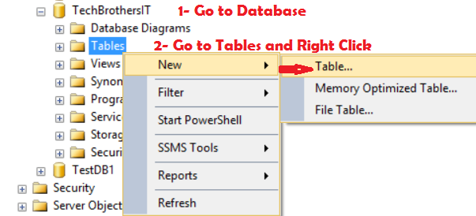

How to create Table in SQL Server from Graphical user interface - SQL Server / T-SQL Tutorial

Step 2:
A window will open, you will be able to provide Column Names and Data Types as you like. Also you can choose if Column can accept Null values or not. In our case, we are Ok to allow Nulls.

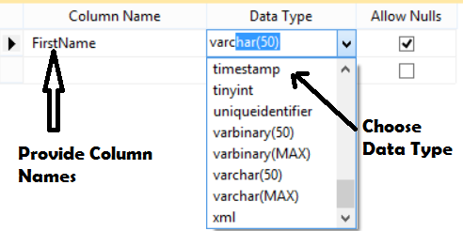
How to create Table in SQL Server by using Graphical User Interface - SQL Server / T-SQL Tutorial

Step 3:
Type all the columns and choose data types as per your requirements as shown. Once done. Hit Save button and it will ask you to provide the name you like for your table. I have provided Customer.
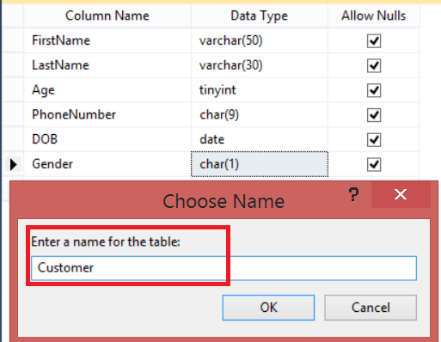
How to create Table in SQL Server by using Graphical User Interface(GUI) - SQL Server Tutorial

Once you hit Ok, table will be created in Database.

How to Alter Columns or Generate Alter Scripts by using GUI in SQL Server?

Scenario:
You are working as SQL Server developer for Law Firm. You have created table customer in one of the Database "TechBrothersIT" by using below Script.
CREATE TABLE [dbo].[Customer](
[FirstName] [varchar](50) NULL,
[LastName] [varchar](50) NULL,
[Age] [tinyint] NULL,
[PhoneNumber] [char](9) NULL,
[DOB] [date] NULL,
[Sex] [char](1) NULL
)
You need to make below changes to dbo.Customer but don't want to write scripts by yourself. You want to use Graphical User Interface to generate these script or even make those change right away.
Change Sex Column Name to Gender
Change First Name to FName
Change LastName to LName and Max size to Varchar (30)

Solution:
Step 1:
Go to Database and then go to Tables tab. Once you see your required table, Right Click and hit Design.
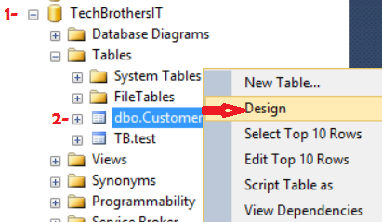
How to generate Alter Script or Alter Table in Design Mode in SQL Server Management Studio

Step 2:
Once you hit Design, Design window will open. Start making changes as per your requirement.
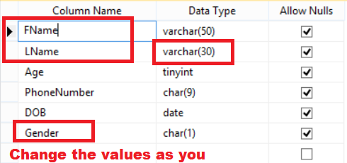
How to Alter Table in SQL Server by using Design Windows - SQL Server Tutorial

Step 3:
Now you have two options, You can hit Save button and all changes will be saved. If you would like to generate scripts so you can use in DEV, QA , UAT and Prod. You can click on Generate Script Button and it will generate scripts for you.
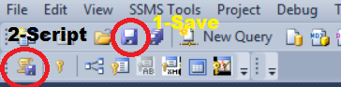
How to generate Alter script for table from Design Windows in SQL Server - T-SQL Tutorial

Once you hit Generate Script Button, below window will open and you can save the scripts to file to use in any environment.
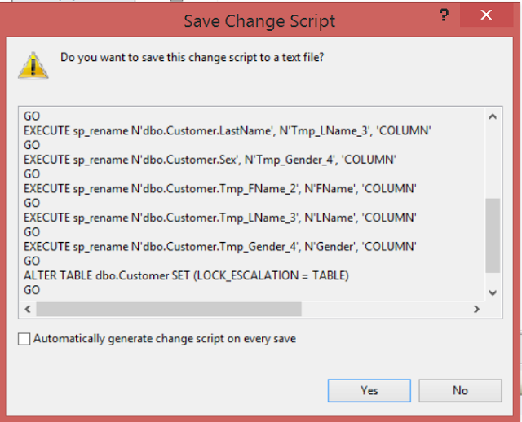
How to generate Modify Columns in SQL Server Table from Design Windows - T-SQL Tutorial

How to Add or Drop Column by using GUI in SQL Server?

Scenario:
You have created table dbo.Customer by using below script in Database TechBrothersIT.

CREATE TABLE [dbo].[Customer](
[FName] [varchar](50) NULL,
[LName] [varchar](30) NULL,
[Age] [tinyint] NULL,
[PhoneNumber] [char](9) NULL,
[DOB] [date] NULL,
[Gender] [char](1) NULL
)

You received new requirement.You have to add new column "Address" to table and delete Column "Gender" from Table.

Solution:
In SSMS, you can use Design window to add columns and drop columns. You can also script the changes to run in other environments such as QA,UAT and Production.

Step 1:
Go to Database and then Tables tab and then find your required table. Right Click on Table and select Design.

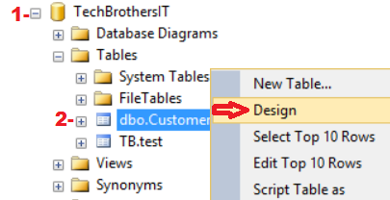

How to Add Column or Drop Column in Design Windows in SSMS- SQL Server Tutorial

Step 2:
Design windows will open, Go ahead at the end and add new column. Provide the Column Name and Data Type and if you would like to allow Null values for it or not.
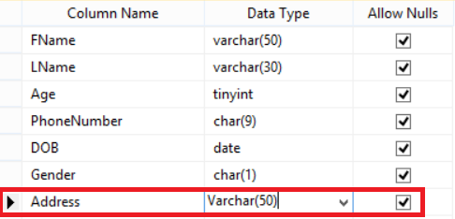
Add Column to SQL Server Table in Design Mode in SSMS - TSQL Tutorial

To Delete Column, Choose the Column and Then hit Right Button on your mouse and click Delete Column as shown below.
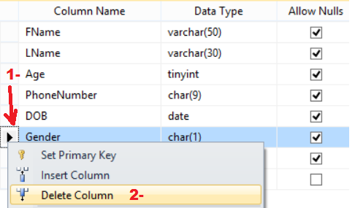
How to Delete Column in Design Windows from SQL Server Table - T-SQL Tutorial

Now you have two options, if you would like to save the changes to table, Go ahead and hit Save button. If you want to script the changes, Click on Generate Scripts Button so you can use in any environment.
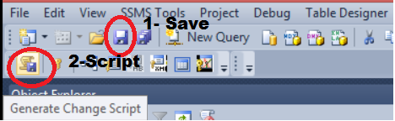
Generate Add or Drop Column Scripts from Design Windows in SSMS - SQL Server Tutorial

Once you hit Generate Change Script Button, Below windows will appear and ask you to save the scripts as shown below.

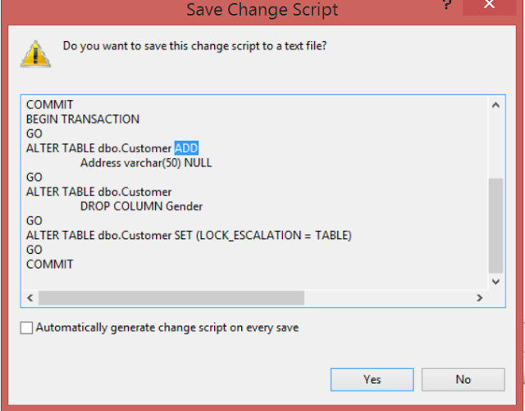
Add Column or Drop Column Scripts for SQL Server Table - T-SQL Tutorial

How to Add identity Column to Table by TSQL and GUI in SQL Server?

Scenario:
You are working as SQL Server Developer and you have created a dbo.Customer table by using below Script.
CREATE TABLE Customer (
FirstName VARCHAR(50)
,LastName VARCHAR(50)
,Age SMALLINT
,PhoneNumber CHAR(9)
,DOB DATE
,Gender CHAR(1)
)
You need to add a column CustomerId that should start from 1 and every time new row inserts into table, it should increment by 1.

Solution:
SQL Server provide us the facility to add column like that. It is call Identity. You can provide the initial value(seed) and provide Increment value.

Let's say if we would like to Add CustomerId to Customer Table with Starting Value=1 and Incremental value=1, Our script will be like below

CREATE TABLE Customer (
CustomerId INT Identity(1, 1)
,FirstName VARCHAR(50)
,LastName VARCHAR(50)
,Age SMALLINT
,PhoneNumber CHAR(9)
,DOB DATE
,Gender CHAR(1)
)

Add Identity from Design Windows:
Let's say if you are creating table by using Design windows, you can add Identity from there as well as shown below.

Go to Database, Go to Tables and then use Right Mouse click and hit New. A window will open and you have to provide Column Name, Data Types and If Column allows Null or not.

Once done, then click on CustomerId column that we want to make identity column. In Column Properties windows, Enable Identity and provide the Seed and Incremental value as shown below.
Once all done. hit save or Generate Change Script to run on any SQL Server Instances later.
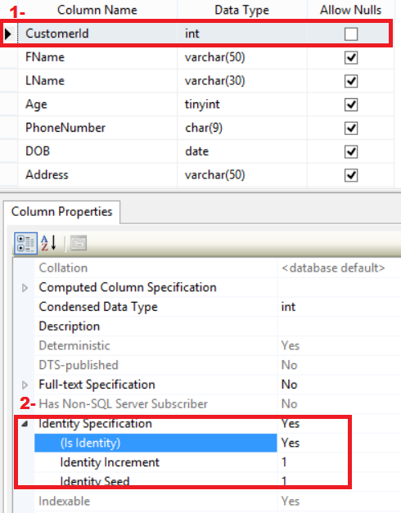
How to Add Identity Column to Table in SQL Server - SQL Server / T-SQL Tutorial

How To Insert Value In Identity Column Manually in SQL Server Table?

Scenario:
We have a dbo.Customer table that has ID as identity column. We need to insert one record in this table with -1 for ID.
Solution :
We will be using Identity_insert ON and Off to do this as shown below.It will disable identity property and then we will insert record and then enable it back.
CREATE TABLE dbo.Customer(
ID INT IDENTITY(1,1)
, CustomerCode VARCHAR(50)
, FirstName VARCHAR(50)
, LastName VARCHAR(50))

SET IDENTITY_INSERT dbo.Customer ON
GO
INSERT INTO dbo.Customer ( ID,CustomerCode,FirstName,LastName)
VALUES (-1,'UNKNOWN','UNKNOWN','UNKNOWN')
SET IDENTITY_INSERT Dbo.Customer OFF

SELECT * FROM dbo.Customer

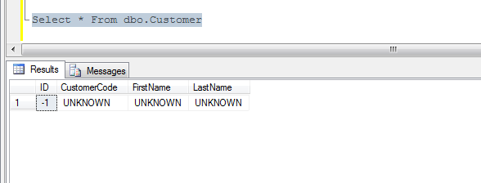
How to insert value in Identity Column manually in SQL Server Table

How to use GO Statement in SQL Server To Insert Records in Identity Column?
Go is command that is recognized by sqlcmd, osql and SSMS utilities and we use it to terminate batch. GO is not Transact SQL command.
We can use GO [Count] to run the batch the times we want to. To insert records into a table that has only identity column, we can use GO statement with count as well.
USE TestDB
GO

DROP TABLE dbo.CustomerAddress
GO

CREATE TABLE dbo.CustomerAddress (
FName VARCHAR(100)
,LName VARCHAR(100)
,HouseNumber INT
,StreetName VARCHAR(100)
,City VARCHAR(100)
,[State] CHAR(2)
,IsActive BIT
)
GO

--Insert the same record ten times by using GO [count]
INSERT INTO dbo.CustomerAddress
VALUES (
'Aamir'
,'Shahzad'
,123
,'Test Street'
,'Charlotte'
,'NC'
,1
) GO 10

CREATE TABLE dbo.CustomerT (id INT identity(1, 1))
GO

--Insert 100 records into table that has only id as identity column by using GO [Count]
INSERT INTO dbo.CustomerT DEFAULT
VALUES GO 100

How To Reset Identity Column Value in SQL Server Table?
Let's start with understanding the Identity property first and then we can proceed to step,how can we reset it? Create a SQL Server Table with Identity Column by using below script
USE TEST
GO
CREATE TABLE dbo.Person( ID INT IDENTITY(1,1), Name VARCHAR(10))

Let's insert below records by using below statements
INSERT INTO dbo.Person(name)
VALUES ('Aamir')
INSERT INTO dbo.Person(Name)
VALUES ('Aamir Shahzad')

Only one record will be inserted and second record will fail as the size of string is more than the size of column data type
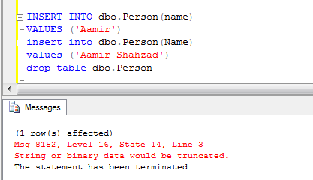
Fig 1-Insert records in SQL Server Table

Check the Identity Value of a Column:
To check the identity value of a column, we can use below statement
--Check the Identity Value of a Column
DBCC CHECKIDENT ('dbo.Person');

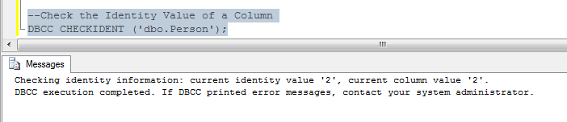
Fig 2- DBCC CHECKIDENT to see the Identity Value
Even the insert was failed for second record but the identity value is incremented. If we will insert next record, the identity value will be 3 for that as we can see in Fig 3.
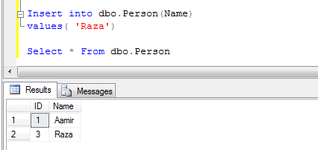

Here are couple of ways to reset the identity value of a column after deleting data.
Reset Identity Value by Using TRUNCATE:
If we want to delete everything from table and table does not have any foreign Key relation, we can Truncate table and that will clean the data as well set the identity value
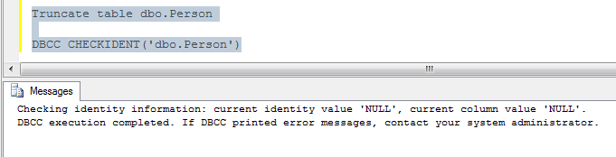
Fig 3-Use Truncate to clean table and reset Identity Value
Reset Identity Value By Using DBCC CHECKIDENT:
If the table is in relationship with any other table (Primary-Foreign Key) relationship, we will not be able to truncate the table. In that case we have to delete the values from table by using Delete statement and then set identity value.
DBCC CHECKIDENT ('dbo.Person', RESEED, 0);

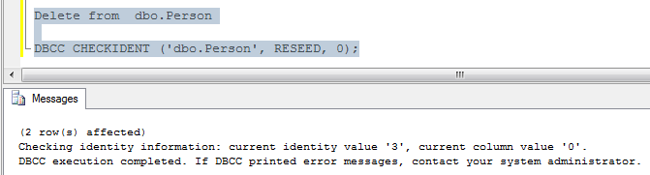
Fig 4. Delete data from Table and use DBCC CHECKIDENT to reseed identity value

How to Drop Identity Property of a Column in SQL Server Table?
In this post we will learn how to drop identity property of a column in SQL Server Table.
We will follow below steps.
- Add a new column with TestID to existing Table
- Update the records from Id ( Identity enable Column) to TestID (Newly Added) Column.
- Drop the Id ( Identity Enable Column) from Table
- Rename the Newly Added Column ( TestID) to Id.
--Create Table with Identity Property
CREATE TABLE dbo.Employee ( Id INT IDENTITY(1,1), Name VARCHAR(10))
GO
--Insert the record after creating Table with Identity Property on Id Column
INSERT INTO dbo.Employee
VALUES('Shahzad')
GO
--Run to See the Data
SELECT * FROM dbo.Employee
--Find out all the columns for all the tables on which Identity Property is enabled
SELECT OBJECT_NAME(OBJECT_ID) AS TableName,name AS ColumnName FROM sys.columns
WHERE is_identity=1
/** Drop Identity ********/
--Add a new column with any name
ALTER TABLE dbo.Employee
ADD TestId INT
--Update the Records in newly Added column , in our case TestID
UPDATE dbo.Employee
SET TestId=Id
--Drop Identity Column
ALTER TABLE dbo.Employee
DROP COLUMN Id
--Rename the newly Added Column to Identity Column you had at first.
EXEC sp_rename 'dbo.Employee.TestId','Id','COLUMN'

How to find all the tables with Identity Column in SQL Server Database?

Scenario:
How would you find all the tables in a SQL Server Database which has identity Column?

Solution:
We can use system tables such as sys.columns and sys.tables to get this information.
--Find out all the columns for all the tables on which Identity Property is enabled
SELECT DB_Name() AS DatabaseName
,OBJECT_NAME(c.OBJECT_ID) AS TableName
,c.NAME AS ColumnName
FROM YourDBName.sys.columns c
INNER JOIN sys.tables t ON c.object_id = t.object_id
WHERE is_identity = 1
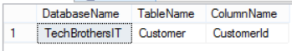
How to get Tables in a Database with Identity Column in SQL Server - SQL Server/T-SQL Tutorial

How to Get Identity Column Values without mentioning Identity Column Name in Select?

Scenario:
You took a quick look on Table and Columns in SQL Server but could not find if Identity Property is enabled on one of the column. You don't want to use system tables to find out the column name if identity is enabled or not but want to get the column name with data. How would you do that?

Solution:
You can use $Identity in your select, that will return all the values for identity Column.
Let's say we have table customer with couple of records.
CREATE TABLE Customer (
CustomerId INT Identity(1, 1)
,FirstName VARCHAR(50)
,LastName VARCHAR(50)
,Age SMALLINT
,PhoneNumber CHAR(9)
,DOB DATE
,Gender CHAR(1)
)
insert into dbo.Customer(FirstName,LastName,Age)
Values('Aamir','Shahzad',66),
('Raza','M',44)

To get Identity Column with Data, you can use below syntax
Select $identity from SchemaName.TableName
To get the identity column with values from our dbo.Customer table, we can use below script
Select $Identity from dbo.Customer
We will see below results.
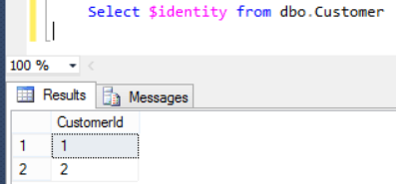
How to get Identity Column Name and Values without using System tables in SQL Server

How to add Computed Column in SQL Server Table?

Scenario:
You are working as SQL Server Developer for one of the Law Firm. You have created a dbo.Customer table by using below definition
CREATE TABLE Customer (
CustomerId INT Identity(1, 1)
,FirstName VARCHAR(50)
,LastName VARCHAR(50)
,Age SMALLINT
,PhoneNumber CHAR(9)
,DOB DATE
,Gender CHAR(1)
)
You need to have Full Name that should consist of First Name and Last Name. You don't want to save the duplicate data into table by adding new column for Full Name. What are your options?
Also depending upon Age, We would like to Add New Column call IsSenior and mark it 1 if above 65 else 0.

Solution:
SQL Server provide us Computed Column, that is virtual column and it does not store data unless it is marked as Persisted. That means that we can create computed column (Full name) that will use First Name and Last Name data. By creating Computed Column we don't have to save duplicate data for full Name column.
Let's go ahead and create Computed Columns Full Name and IsSenior depending upon our criteria.
CREATE TABLE Customer (
CustomerId INT Identity(1, 1)
,FirstName VARCHAR(50)
,LastName VARCHAR(50)
,Age SMALLINT
,PhoneNumber CHAR(9)
,DOB DATE
,Gender CHAR(1)
,FullName AS FirstName + ' ' + LastName
,IsSenior AS CASE
WHEN Age > 65
THEN 1
ELSE 0
END
)
We concatenated First Name and Last Name for Full Name and wrote the Case Statement for IsSenior Computer Column. Let's go ahead and insert couple of records.
insert into dbo.Customer(FirstName,LastName,Age)
Values('Aamir','Shahzad',66),
('Raza','M',44)
Noticed I have not inserted anything for FullName and IsSenior Columns. The values for these columns will be calculated when we will select the data.
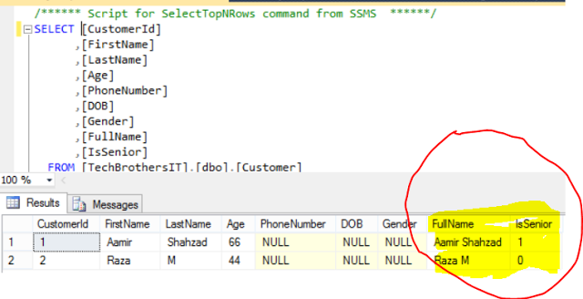
How to add Computed Columns in SQL Server Table - T-SQL Tutorial
If you need to add Computed Column to exiting Table, you can use below syntax
Alter Table SchemaName.TableName
Add ColumnName AS Logic( such as FistName +''+LastName)
Let's say if we want to add FullName Computer Column to Customer table, we can use below script.
Alter table dbo.Customer
Add FullName AS FirstName+' '+LastName
Drop Computed Column from SQL Server Table:
The syntax for dropping Computed or normal column is same.
Alter Table SchemaName.TableName
drop Column ColumnName
Let's say if we want to drop FullName computed column from dbo.Customer Table. We can use below script.
Alter table dbo.Customer
drop column FullName

How to Generate Drop Table Statement for all the tables in a database?

Scenario:
You are working as SQL Server developer in Credit Card Company. You need to generate Drop Table statements for all the tables in Database TechBrothersIT that you are using as Staging for Data Loading process. How would you do that?

Solution:
There are multiple ways to generate Drop Statements for All the tables in a database. We can use Object Explorer Detail Windows, Click HERE to see the blog and video. But in this post, We are going to use simple Select Query to generate Drop Statements for all the tables in a database.
SELECT 'Drop Table [' + TABLE_SCHEMA + '].[' + TABLE_NAME + ']' AS DropTableQuery
FROM INFORMATION_SCHEMA.TABLES
WHERE TABLE_TYPE = 'BASE TABLE'

If you would like to filter the Tables by Schema, you can add Where Clause to Query or if you like to filter tables by name you can add Table_Name in Where clause.
Once you run above statement, Drop statements will be shown, copy them and run in new query.
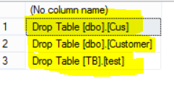
How to Generate Drop Table Statements for all the tables in SQL Server Database - T-SQL Tutorial

How to Generate Add Column Statement for all the tables in a Database in SQL Server?

Scenario:
You are working in Auto Insurance Company as SQL Server Developer. Your company has a database in which they have more than 300 Tables. In initial design, they forgot to add Audit columns such as CreatedBy and CreatedOn. They want you to generate Add Column CreatedBy and CreatedOn for all the Tables in a Database, How would you do that?

Solution:
There are many ways to generate the SQL Statements for above requirement, we are going to keep it simple and quick. We will use Select Query to generate Add Column Statements for all the tables.

Let's generate the scripts in a way so we have to make very small changes every time and we can use anytime to add new column. I have declared two variables, @ColumnName and @ColumnDataType. Once we will provide the values for variables. The Select query is going to check all the tables and if column does not exist for the table, it will generate Add Column statement.

--Declare Variables for Column Name and Data Type
Declare @ColumnName VARCHAR(100)
Declare @ColumnDataType VARCHAR(50)

--Set the Values for Variables
SET @ColumnName='CreatedBy'
SET @ColumnDataType='VARCHAR(50)'

--Run the Query and copy results and paste in new window to run.
Select 'ALTER Table ['+Table_Schema+'].['+Table_Name+'] '
+'Add '+@ColumnName+' '+@ColumnDataType AS AddColumnQuery
from Information_Schema.Tables T
where T.Table_Type='BASE TABLE'
And Not exists (
Select 1 from INFORMATION_SCHEMA.COLUMNS C
WHERE C.TABLE_Name=T.Table_Name and Column_Name=@ColumnName)

Run above query and copy the results to new Query Windows, Select the Database on which you would like to run and execute.

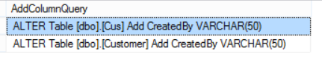
How to Generate Add Column SQL Statement for all the tables in a database - T-SQL Tutorial

Chapter 6: Constraints

What are different Types of Constraints Available in SQL Server?

What are Constraints in SQL Server?
In simple words, Constraints define rules those we implement to avoid insertion of any data that does not follow the rule.
By using the Constraint, we can validate the data and if complies the rule, It will be inserted in table otherwise rolled back.
Constraints are used to maintain Data Integrity. They make sure the data entered follow the rules we have defined.

There are different types of Constraints available in SQL Server.

- Not Null Constraint
- Check Constraint
- Default Constraint
- Unique Constraint
- Primary Key Constraint
- Foreign Key Constraint

6.1 : Not Null Constraint

How to create Not Null Constraint on Column in SQL Server Table?

Scenario:
You are creating customer table for one of your requirement, you want to make sure the First name Column always have the value. How will you make sure First Name Column always have the value?

Solution:
Constraints defined rules which make sure the data we insert in column follow the rules.
For above requirement we can create Not Null constraint on a column, Not Null Constraint make sure the value inserted in that column is not Null. If user will try to insert row without providing the value for the column on which we have created the Not Null Constraint , The insert will fail as column can not accept Null values.
To create Not Null Constraint on Column in a Table, we have to Add Not Null after the Data Type as shown below for First Name Column.
Create Table Customer
(FirstName VARCHAR(50) Not Null,
LastName VARCHAR(50),
Age SmallInt,
PhoneNumber CHAR(9),
DOB Date,
Gender CHAR(1)
)
You can see that I did not provide Not Null Constraint for other columns, that means those column can accept Null values or Unknown value.
Let's insert below rows and see what happen
insert into dbo.Customer ( FirstName,LastName,Age,PhoneNumber,DOB,Gender)
Values
('Aamir','Shahzad',Null,Null,Null,Null)
,(Null,'Raza',33,'00000000',Null,'M')
As you can see that the transaction failed as we can't insert the Null in First Name column, No Record will be inserted.
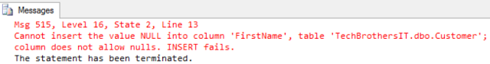
How to create Not Null Constraint on a column in SQL Server - TSQL Tutorial
Let's consider second Insert , Where we are not inserting anything in First Name column. Still the insert will fail, as when you don't provide the column in insert list, it try to insert Null value for that column and we have created Not Null Constraint on First Name column.
insert into dbo.Customer (LastName,Age,PhoneNumber,DOB,Gender)
Values
('Raza',33,'00000000','2016-01-26','M')
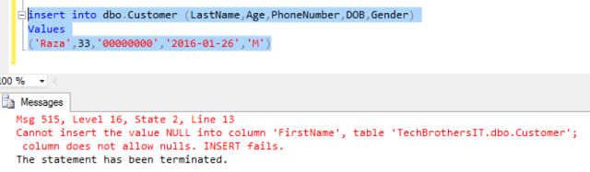
How to create Not Null Constraint in SQL Server - SQL Server / TSQL Tutorial

How to Alter Column from Null to Not Null in SQL Server Table ?

Scenario:
You are working as SQL Server developer with a Bank. They have Dbo.Customer table in TechBrothersIT database with below definition.
Create Table dbo.Customer
(FirstName VARCHAR(50) Not Null,
LastName VARCHAR(50),
Age SmallInt,
PhoneNumber CHAR(9),
DOB Date,
Gender CHAR(1)
)
As you noticed that LastName can be Null. That is the problem. Company noticed that later and always want to have the value for LastName. You are asked to do analysis and write Alter script to Change Column from Null to Not Null. What things you will consider or suggestions you will provide?

Solution:
The very first thing to consider in this scenario is to find out if any values are already inserted in the table for Last Name as Null. If that is the case, you can't really go ahead and Alter column from Null to Not Null. If you try , you will get below error.

Msg 515, Level 16, State 2, Line 14
Cannot insert the value NULL into column 'LastName', table 'TechBrothersIT.dbo.Customer';
column does not allow nulls. UPDATE fails.

It means we have to deal with Null values in this column first. You can talk with business and ask them what they would like to do for all the customer where Last Name is Null. You can find the list of customers where Last Name is Null by using below query.

Select * From dbo.Customer
where LastName Is null
Business can provide different suggestions such as
Let's update the LastName to Unknow where it is Null
Or Update the Last Name to blank('') if it is Null
Or Update the Last Name column to LNNP (Last Name Not Provided)
Or they go back to customers and get their last Name to update

Depending upon the suggestions, go ahead and update the values in Last Name column. Let's say we decided to update to blank '', we can use below query to update

update dbo.Customer
set LastName=''
where LastName is Null
Now you are all set to change column in table from Null to Not Null.

Alter Table dbo.Customer
Alter Column LastName VARCHAR(50) Not Null

Get List of All Null and Not Null Columns in SQL Server Database ?

Scenario:
You are working as SQL Server Developer, You are doing some analysis and want to get the list of all columns in SQL Server Database which are Nullable or Not Nullable.How would you get this information?

Solution:
We can use system views in SQL Server to get this information. Below Query will return us Database Name, Schema Name, Table Name, Column Name,Data Type and IS_Nullable.

SELECT Table_CataLog AS DBName
,table_Name
,Column_Name
,Data_Type
,IS_NULLABLE
FROM INFORMATION_SCHEMA.COLUMNS
--Uncomment the Where Clause if you want to filter the records
--where TABLE_SCHEMA = 'dbo' and TABLE_NAME = 'TableName' and COLUMN_NAME = 'ColumnName'

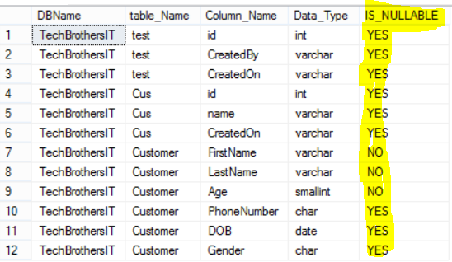
How to get list of Nullable and Non-Nullable Columns in SQL Server Database- TSQL Tutorial

6.2 : Primary Key Constraint

What is Primary Key Constraint in SQL Server Database?

What is Primary Key Constraint:
Primary Key Constraint is created to ensure uniqueness of records/rows. Primary Key Constraint can be created on single or set of columns as long as the column/columns do not allow Null values.

1) Primary Key Constraint creates Clustered Index by default if does not exist already
Let's say that you are creating new table and you have added column with Primary Key, it is going to create clustered index.

In below example we are creating table dbo.Customer and we have added CustomerId as Primary Key Constraint. Let's check what type of index is created.

USE YourDatabaseName
GO

CREATE TABLE dbo.Customer (
Customerid INT PRIMARY KEY
,FName VARCHAR(100)
,LName VARCHAR(100)
,SSN VARCHAR(10)
)

We can query sys.indexes system view to get index information

SELECT *
FROM sys.indexes
WHERE object_name(object_id) = 'Customer'

As you can see that Clustered index is created as there was no cluster index on this table before.Noticed the name for Clustered Index, it is generate by SQL Server. It is always good idea to provide proper name for indexes according to naming convention/ Standards your company is using.

2) If clustered index is already created on Column, Primary Key is going to Create Unique Index
If clustered index is already present on column/columns in a table and we try to create Primary Key, it will create Unique Non-clustered.

Let's drop and re-create dbo.Customer table. As we can not create Clustered Index on columns which accept Null values, we have to define our Columns Not Null.

USE YourDatabaseName
GO
Drop table dbo.Customer
GO

CREATE TABLE dbo.Customer (
Customerid INT Not Null
,FName VARCHAR(100)
,LName VARCHAR(100)
,SSN VARCHAR(10) Not Null
)

--Create Clustered Index on SSN Column
CREATE CLUSTERED INDEX IX_Customer_SSN
ON dbo.Customer (SSN);

--Create Primary Key on CustomerID
Alter Table dbo.Customer
Add Constraint Pk_Customer_CustomerId Primary Key(CustomerId)
Let's check what type of indexes are created by using sys.indexes system view. There should be one Clustered Index as we created on SSN and there should be one unique nonclustered that should be created by Primary Key Constraint.

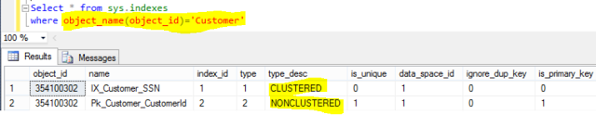
What is Primary Key Constraint in SQL Server - SQL Server / TSQL Tutorial

How to Get all the Tables which has Primary Key Constraint Created in SQL Server Database ?

Scenario:
You are working as SQL Server Developer/ SQL Server DBA in Auto Insurance Company. You are asked to provide a query that should return list of all the tables with Schema Name, Column Name and Primary Key Constraint which has primary key constraint created on them.

Solution:
There are multiple ways to get this information. We are going to use system views to get all the tables with primary key constraints in SQL Server Database.

Select
TC.Table_Catalog as DatabaseName,
TC.Table_Schema AS TableSchema,
TC.Table_Name AS TableName,
CCU.Column_Name AS ColumnName,
TC.Constraint_Name AS ConstraintName
From
information_Schema.Table_Constraints TC
INNER JOIN
Information_Schema.constraint_column_usage CCU
on TC.Constraint_Name=CCU.Constraint_Name
and TC.Table_Name=CCU.Table_Name
where
Constraint_Type='PRIMARY KEY'

I execute above query on one of my test database and here are my results with table names which has primary key constraints.

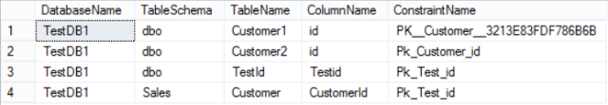
Get list of tables in SQL Server Database which has Primary Constraint - SQL Server/ TSQL Tutorial

How to get list of Tables without Primary Key Constraint in SQL Server Database?

Scenario:
You are working as SQL Server developer for software development company. You are asked to provided list of Tables from a Database which do not have Primary Key Constraints created on them.

Solution:
There are different ways to get list of tables without primary key constraints in sql server database. In below query we are going to use system views to get List of tables in a database without Primary Key Constraints.

Select
Table_CataLog as DatabaseName,
Table_Schema as TableSchema,
Table_Name as TableName
from
information_schema.tables T
where
Not Exists(
Select
1
from
information_Schema.Table_Constraints C
where
Constraint_Type='PRIMARY KEY'
and C.Table_Name=T.Table_Name
and C.Table_Schema=T.Table_Schema
)
and Table_Type='BASE TABLE'

I execute above query on one of my database and got list of tables which do not have Primary Key Constraint created on them.
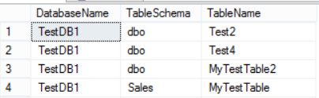
How to get list of tables without Primary Key Constraints in SQL Server Database - SQL Server / TSQL Tutorial

How to get all the Tables with or without Primary Key Constraint in Sql Server Database ?

Scenario:
You are working as SQL Server Developer / SQL Server DBA and you need to get list of tables from a database with information if the table has the primary key constraint or don't have primary key constraint.

Solution:
We are going to use system views in SQL server database to get list of tables with or without Primary Key Constraints.
use YourDatabaseName
go
Select
T.Table_Catalog as DatabaseName,
T.Table_Schema AS TableSchema,
T.Table_Name AS TableName,
CCU.Column_Name AS ColumnName,
TC.Constraint_Name AS ConstraintName,
Case When TC.Constraint_Name is not Null Then 'Yes'
Else 'No' End as HasPrimaryKeyConstraint
From
information_schema.tables T
left join

information_Schema.Table_Constraints TC
on T.Table_Catalog=TC.Table_Catalog
and T.Table_Schema=TC.Table_Schema
and T.Table_Name=TC.Table_Name
and TC.Constraint_Type='PRIMARY KEY'

left JOIN
Information_Schema.constraint_column_usage CCU
on TC.Constraint_Name=CCU.Constraint_Name
and TC.Table_Name=CCU.Table_Name
and T.Table_Type='BASE TABLE'

I execute above code on one of my database and list of tables with Primary Key Constraint or Without Primary Key Constraint.
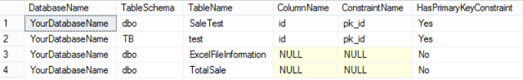
Get list of tables from SQL Server Database with or without Primary Key Constraint - SQL Server / TSQL Tutorial

How to get list of Primary Key Constraint from all the databases on SQL Server Instance?

Scenario:
You are working on documentation of database objects and you are asked to provide the list of all the primary key constraint on all the database tables on entire SQL Server Instance. How would you provide the list of all primary key constraints with Database Name, Schema Name, Table Name, Column Name, Constraint Name?

Solution:
We will be using System views to get the Primary Key Constraint Information. As we need to run the query on all the database , we will be using Cursor with dynamic sql. For each database , we will insert the results in temp table and finally we will select the result at the end from temp table for display.

USE master
GO
--Declare Variables
DECLARE @DatabaseName AS VARCHAR(500)
--Create Temp Table to Save Results
IF OBJECT_ID('tempdb..#Results') IS NOT NULL
DROP TABLE #Results
CREATE TABLE #Results (
ServerName VARCHAR(128)
,DatabaseName VARCHAR(128)
,SchemaName VARCHAR(128)
,TableName VARCHAR(128)
,ColumnName VARCHAR(128)
,ConstraintName VARCHAR(128)
)
DECLARE CUR CURSOR
FOR
SELECT '[' + NAME + ']' AS DBName
FROM sys.databases
WHERE NAME NOT IN (
'master'
,'tempdb'
,'model'
,'msdb'
)
OPEN Cur
FETCH NEXT
FROM Cur
INTO @DatabaseName
WHILE @@FETCH_STATUS = 0
BEGIN
--Build dynamic sql for each database
DECLARE @SQL VARCHAR(MAX) = NULL
SET @SQL = 'Insert into #Results
Select
@@ServerName,
TC.Table_Catalog as DatabaseName,
TC.Table_Schema AS TableSchema,
TC.Table_Name AS TableName,
CCU.Column_Name AS ColumnName,
TC.Constraint_Name AS ConstraintName
From' + @DatabaseName + '.information_Schema.Table_Constraints TC
INNER JOIN
' + @DatabaseName +
'.Information_Schema.constraint_column_usage CCU
on TC.Constraint_Name=CCU.Constraint_Name
and TC.Table_Name=CCU.Table_Name
where
Constraint_Type=''PRIMARY KEY'''
EXEC (@SQL)
PRINT @SQL
FETCH NEXT
FROM Cur
INTO @DatabaseName
END
CLOSE Cur
DEALLOCATE Cur
--Select all records from temp table for Primary Key
--Constraint Information
SELECT *
FROM #Results

I execute above query on my SQL Server Instance and got the list of all Primary Key Constraint with Database Name, Schema Name, Table Name, Column Name and Constraint Name as shown below.
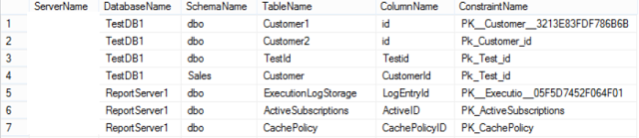

How to get list of all Primary Key Constraints from each database from SQL Server Instance - SQL Server / T-SQL Tutorial

Get List of Tables with or without Primary Key Constraint in all Database from SQL Server ?

Scenario:
You are working as SQL Server developer / SQL Server DBA for Insurance company. You are creating documentation for database objects. You need to get list of all tables from all the database from SQL Server Instance with out without Primary Key Constraints.

Solution:
We can use system views to list of tables with Primary Key Constraint or not from each database. As query has to run on each of the database to gather this information, we need to loop through list of user databases, we will be using cursor to perform looping through all the databases on SQL Server instance. We will build our dynamic sql for each database and save the results to temp table and finally we will select the records for display.

USE master
GO

--Declare Variables
DECLARE @DatabaseName AS VARCHAR(500)

--Create Temp Table to Save Results
IF OBJECT_ID('tempdb..#Results') IS NOT NULL
DROP TABLE #Results

CREATE TABLE #Results (
ServerName VARCHAR(128)
,DatabaseName VARCHAR(128)
,SchemaName VARCHAR(128)
,TableName VARCHAR(128)
,ColumnName VARCHAR(128)
,ConstraintName VARCHAR(128)
,HasPrimaryKeyConstraint VARCHAR(10)
)

DECLARE CUR CURSOR
FOR
SELECT '[' + NAME + ']' AS DBName
FROM sys.databases
WHERE NAME NOT IN (
'master'
,'tempdb'
,'model'
,'msdb'
)

OPEN Cur

FETCH NEXT
FROM Cur
INTO @DatabaseName

WHILE @@FETCH_STATUS = 0
BEGIN
--Build dynamic sql for each database
DECLARE @SQL VARCHAR(MAX) = NULL

SET @SQL = 'Insert into #Results
Select
@@ServerName,
T.Table_Catalog as DatabaseName,
T.Table_Schema AS TableSchema,
T.Table_Name AS TableName,
CCU.Column_Name AS ColumnName,
TC.Constraint_Name AS ConstraintName,
Case When TC.Constraint_Name is not Null Then ''Yes''
Else ''No'' End as HasPrimaryKeyConstraint
From
' + @DatabaseName + '.information_schema.tables T
left join

' + @DatabaseName + '.information_Schema.Table_Constraints TC
on T.Table_Catalog=TC.Table_Catalog
and T.Table_Schema=TC.Table_Schema
and T.Table_Name=TC.Table_Name
and TC.Constraint_Type=''PRIMARY KEY''

left JOIN
' + @DatabaseName +
'.Information_Schema.constraint_column_usage CCU
on TC.Constraint_Name=CCU.Constraint_Name
and TC.Table_Name=CCU.Table_Name
and T.Table_Type=''BASE TABLE'''

EXEC (@SQL)

PRINT @SQL

FETCH NEXT
FROM Cur
INTO @DatabaseName
END

CLOSE Cur

DEALLOCATE Cur

--Select all records from temp table
SELECT *
FROM #Results
I execute above query on my SQL Server instance and here are list of tables from all the databases with Primary Key constraint if available otherwise Null.
How to get all the tables with or without primary key Constraint in all the database from SQL Server Instance- SQL Server / TSQL Tutorial

How to get list of Tables without Primary Key Constraint in all Databases of SQL Server Instance?

Scenario:
You are working as SQL Server developer or SQL Server DBA. You need to get the list of all the tables from all the databases on SQL Server instance which do not have Primary Key Constraints. How would you do that?

Solution:
We will be using system views to get all the tables from all the databases on SQL Server Instance which do not have Primary Key Constraints.

USE master
GO
--Declare Variables
DECLARE @DatabaseName AS VARCHAR(500)
--Create Temp Table to Save Results
IF OBJECT_ID('tempdb..#Results') IS NOT NULL
DROP TABLE #Results
CREATE TABLE #Results (
ServerName VARCHAR(128)
,DatabaseName VARCHAR(128)
,SchemaName VARCHAR(128)
,TableName VARCHAR(128)
)
DECLARE CUR CURSOR
FOR
SELECT '[' + NAME + ']' AS DBName
FROM sys.databases
WHERE NAME NOT IN (
'master'
,'tempdb'
,'model'
,'msdb'
)
OPEN Cur
FETCH NEXT
FROM Cur
INTO @DatabaseName
WHILE @@FETCH_STATUS = 0
BEGIN
--Build dynamic sql for each database
DECLARE @SQL VARCHAR(MAX) = NULL
SET @SQL = 'Insert into #Results
Select
@@ServerName,
Table_CataLog as DatabaseName,
Table_Schema as TableSchema,
Table_Name as TableName
from
'+@DatabaseName+'.information_schema.tables T
where
Not Exists(
Select
1
from
'+@DatabaseName+'.information_Schema.Table_Constraints C
where
Constraint_Type=''PRIMARY KEY''
and C.Table_Name=T.Table_Name
and C.Table_Schema=T.Table_Schema
)
and Table_Type=''BASE TABLE'''
EXEC (@SQL)
--PRINT @SQL
FETCH NEXT
FROM Cur
INTO @DatabaseName
END
CLOSE Cur
DEALLOCATE Cur
--Select all records from temp table
SELECT *
FROM #Results
I executed above query on my SQL Server Instance and got list of tables from all the databases which do not have Primary Key Constraints.

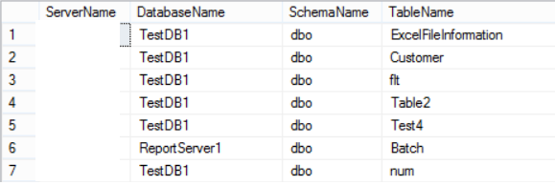

Get all the tables from SQL Server Instance which do not have Primary Key Constraint - SQL Server / TSQL Tutorial

How to add Primary Key Constraint to Identity Columns to all the tables in SQL Server Database?

Scenario:
You are working as SQL Server developer. You got this requirement in which you have to create Primary Key Constraint on all identity columns on all the tables in SQL Server database if does not exists.
The Primary Key name should be Pk_SchemaName_TableName_ColumnName.

Solution:
First of all we need to get the list of tables which has identity column and Primary Key Constraint is not created on them. we will be using system tables and system views to get all the tables with identity columns which do not have Primary Key Constraints.

Then we are going to use the Cursor with dynamic SQL to generate Alter statement for table to add Primary Key Constraint and execute the script.

USE YourDatabaseName
GO

--Declare Variables
DECLARE @DatabaseName AS VARCHAR(128)
DECLARE @SchemaName AS VARCHAR(128)
DECLARE @TableName AS VARCHAR(128)
DECLARE @ColumnName AS VARCHAR(128)

DECLARE CUR CURSOR
FOR
--Get list of tables with Identity Column
--on which have no Primary Key
SELECT DB_Name() AS DatabaseName
,Schema_Name(Schema_id) AS TableSchema
,OBJECT_NAME(c.OBJECT_ID) AS TableName
,c.NAME AS ColumnName
FROM sys.columns c
INNER JOIN sys.tables t ON c.object_id = t.object_id
WHERE is_identity = 1
AND type_desc = 'USER_TABLE'

EXCEPT

SELECT TC.Table_Catalog AS DatabaseName
,TC.Table_Schema AS TableSchema
,TC.Table_Name AS TableName
,CCU.Column_Name AS ColumnName
FROM information_Schema.Table_Constraints TC
INNER JOIN Information_Schema.constraint_column_usage CCU
ON TC.Constraint_Name = CCU.Constraint_Name
AND TC.Table_Name = CCU.Table_Name
WHERE Constraint_Type = 'PRIMARY KEY'

OPEN Cur

FETCH NEXT
FROM Cur
INTO @DatabaseName
,@SchemaName
,@TableName
,@ColumnName

WHILE @@FETCH_STATUS = 0
BEGIN
--Build dynamic sql for each database
DECLARE @SQL VARCHAR(MAX) = NULL

SET @SQL = 'Alter Table [' + @SchemaName + '].[' + @TableName + ']' + CHAR(10)
SET @SQL += 'Add Constraint [Pk_' + @SchemaName
+ '_' + @TableName
+ '_' + @ColumnName + '] '
SET @SQL += 'Primary Key ([' + @ColumnName + '])'

EXEC (@SQL)

PRINT @SQL

FETCH NEXT
FROM Cur
INTO @DatabaseName
,@SchemaName
,@TableName
,@ColumnName
END

CLOSE Cur

DEALLOCATE Cur
If you like to just generate the alter statements for adding Primary Key Constraint, you can add comment to Exec(@SQL) part, The above script will print Alter statements and you can run on your convenience.

Also if you don't like to add the Schema name part to Primary Key constraint, you can remove @SchemaName.

I executed above query and it created Primary Key Constraint on Identity Columns where it was missing.
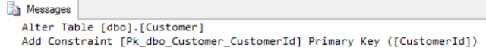
Alter scripts generated by script to add Primary Key Constraint to identity Columns

I verified the tables and Primary Key Constraints were created successfully.
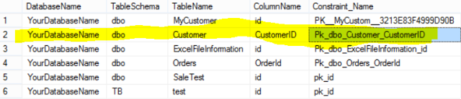
How to create Primary Key Constraint on Identity Columns in SQL Server Database

How to Rename Primary Key Constraint for Multiple Tables in SQL Server Database?

Scenario:
You are working as SQL Server Developer or SQL Server DBA. You are working on naming standards for database objects. You noticed that in one of the database the Primary Key Constraints are not following your company naming convention standards that is "Pk_SchemaName_TableName_ColumnName" as shown below in red.
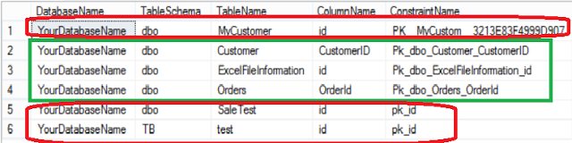
How to rename Primary Key Constraint for Multiple Tables in SQL Server Database - SQL Tutorial

Solution:
First of all we need to find the Primary Key Constraints which do not follow naming convention standards. Every company can have different naming convention document. You company might not include Schema Name in Primary Key Constraint. You can change the select query and remove Table_Schema from below script.

USE YourDatabaseName
GO
--Declare Variables
DECLARE @DatabaseName AS VARCHAR(128)
DECLARE @SchemaName AS VARCHAR(128)
DECLARE @TableName AS VARCHAR(128)
DECLARE @ColumnName AS VARCHAR(128)
DECLARE @ConstraintName AS VARCHAr(128)

DECLARE CUR CURSOR
FOR
--Get Primary Key Constraint
Select
TC.Table_Catalog as DatabaseName,
TC.Table_Schema AS TableSchema,
TC.Table_Name AS TableName,
CCU.Column_Name AS ColumnName,
TC.Constraint_Name AS ConstraintName
From
information_Schema.Table_Constraints TC
INNER JOIN
Information_Schema.constraint_column_usage CCU
on TC.Constraint_Name=CCU.Constraint_Name
and TC.Table_Name=CCU.Table_Name
where
Constraint_Type='PRIMARY KEY'
--Change your criteria as per your naming convention
and 'Pk_'+TC.Table_Schema+'_'+TC.Table_Name
+'_'+CCU.Column_Name<>TC.Constraint_Name
OPEN Cur
FETCH NEXT
FROM Cur
INTO @DatabaseName,@SchemaName,@TableName,@ColumnName,
@ConstraintName
WHILE @@FETCH_STATUS = 0
BEGIN
--Build dynamic sql for each database
DECLARE @SQL VARCHAR(MAX) = NULL
SET @SQL ='sp_rename '+Char(10)
SET @SQL+='@objname ='''+@SchemaName+'.'+@ConstraintName+''','
SET @SQL+='@newname='''+'Pk_'+@SchemaName
SET @SQL+='_'+@TableName+'_'+@ColumnName+''','
SET @SQL+='@objtype = ''object'''
--EXEC (@SQL)
PRINT @SQL
FETCH NEXT
FROM Cur
INTO @DatabaseName,@SchemaName,@TableName,@ColumnName,
@ConstraintName
END
CLOSE Cur
DEALLOCATE Cur

I executed above script on one of my database and here are printed statements those I see for two Primary Key Constraints which were not following naming standards as per my company standards.

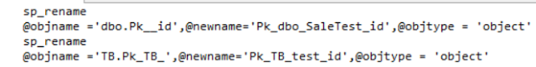
How to rename Primary Key Constraints for multiple SQL Server Tables in SQL Database

The Primary Key Constraints were renamed successfully as shown below.
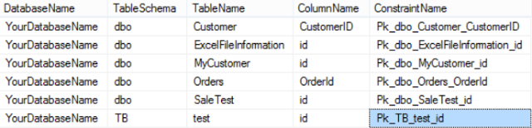
How to verify and rename Primary Key Constraints in SQL Server Database in SQL Server

How to drop all Primary Keys from all the tables in SQL Server Database?

Scenario:
You are working as SQL Server Developer, You have a database that has Primary Key Constraints on almost all the tables. You need to use this database as staging database for ETL process. You really don't need Primary Key Constraint anymore. How would you drop all the Primary Key Constraints for all the table in Database?

Solution:
We will get the list of Primary Key Constraint by using System Views. Once we have the information we will use the Cursor to loop through list of Primary Key Constraint and drop them by using below script.

The general script to drop Primary Key Constraint is

Alter Table SchemaName.TableName
Drop Constraint ConstraintName

Here is our script to drop all the Primary Key Constraints from a Database

USE YourDatabaseName
GO
--Declare Variables
DECLARE @DatabaseName AS VARCHAR(128)
DECLARE @SchemaName AS VARCHAR(128)
DECLARE @TableName AS VARCHAR(128)
DECLARE @ColumnName AS VARCHAR(128)
DECLARE @ConstraintName AS VARCHAr(128)

DECLARE CUR CURSOR
FOR
--Get Primary Key Constraint
Select
TC.Table_Catalog as DatabaseName,
TC.Table_Schema AS TableSchema,
TC.Table_Name AS TableName,
CCU.Column_Name AS ColumnName,
TC.Constraint_Name AS ConstraintName
From
information_Schema.Table_Constraints TC
INNER JOIN
Information_Schema.constraint_column_usage CCU
on TC.Constraint_Name=CCU.Constraint_Name
and TC.Table_Name=CCU.Table_Name
where
Constraint_Type='PRIMARY KEY'

OPEN Cur
FETCH NEXT
FROM Cur
INTO @DatabaseName,@SchemaName,@TableName,@ColumnName,
@ConstraintName
WHILE @@FETCH_STATUS = 0
BEGIN
--Build dynamic sql for each database
DECLARE @SQL VARCHAR(MAX) = NULL
SET @SQL ='Alter table ['
SET @SQL+=@SchemaName+'].['+@TableName+']'
SET @SQL+=' Drop Constraint ['
SET @SQL+=@ConstraintName+']'
PRINT @SQL
EXEC (@SQL)
FETCH NEXT
FROM Cur
INTO @DatabaseName,@SchemaName,@TableName,@ColumnName,
@ConstraintName
END
CLOSE Cur
DEALLOCATE Cur

I executed above script on one of my database, it printed out alter statements for drop Primary Key Constraint for all the tables in database and executed.

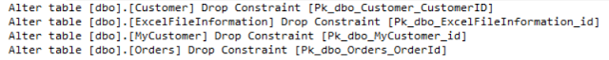
How to drop all Primary Key Constraints for a SQL Server Database - SQL Server Tutorial

6.3 : Foreign Key Constraint

How to Create Table with Foreign Key Constraint in SQL Server?

What is Foreign Key in SQL Server Table:
Foreign Key in a table is a column or group of columns that provides a link between data in two tables. The Foreign Key in a table points to the primary key in another table.

Let's create dbo.Customer Table with Primary Key by using below DDL statement

USE YourDatabaseName
GO

CREATE TABLE dbo.Customer (
Customerid INT PRIMARY KEY
,FName VARCHAR(100)
,LName VARCHAR(100)
,SSN VARCHAR(10)
)
As you can see that Customerid is the primary key in dbo.Customer Table.

As we are ready with our first table and have the Primary Key, we are good to go and create second table with foreign Key Constraint.

CREATE TABLE dbo.Orders (
OrderId INT Identity(1, 1)
,OrderitemName VARCHAR(50)
,OrderItemAmt INT
,Customer_id INT FOREIGN KEY REFERENCES Customer(CustomerId)
)

You can see that we have added Customer_id column in dbo.Orders table that references to Customerid in dbo.Customer Table.

The primary key in first table is Customerid and Foreign Key Column in second table is Customer_id, that means the columns don't have to have same names. It is good idea to keep the same name so when you write queries and join the tables, you don't have to take a look which is primary key and which is foreign key, instead you would know that the same column names are in relationship.

Let's insert couple of records and see how Foreign Key Constraint works.

insert into dbo.Customer
(CustomerId,FName, LName,SSN)
values
(1,'Aamir','Shahzad','000-000-00')

insert into dbo.Orders
(OrderItemName,OrderItemAmt,Customer_Id)
values ('TV',1,1)

Both records will be inserted just fine, as we are inserting same customerid in dbo.Orders that does exists in dbo.Customer.

If we will try to insert any value in dbo.Orders that is not present in dbo.Customer(CustomerId), It will through an error due to foreign key constraint.

insert into dbo.Orders
(OrderItemName,OrderItemAmt,Customer_Id)
values ('TV',1,2)

When we run above query, it through error as we don't have 2 as Customerid in dbo.Customer table.

Msg 547, Level 16, State 0, Line 28
The INSERT statement conflicted with the FOREIGN KEY constraint "FK__Orders__Customer__286302EC".
The conflict occurred in database "YourDatabaseName", table "dbo.Customer", column 'Customerid'.
The statement has been terminated.

How to create Foreign Key Constraint on Multiple Columns in SQL Server?

Scenario:
You are working as SQL Server developer, you need to create a table dbo.Customer with composite primary key by using columns FName and SSN. One you are done with creating primary key in dbo.Customer table, you need to create second table dbo.Orders and create foreign key constraint by using Primary Key columns.

Solution:
Let's create the dbo.Customer table with composite primary key by using below script.

USE YourDatabaseName
GO

CREATE TABLE dbo.Customer (
Customerid INT Identity(1,1)
,FName VARCHAR(100) Not Null
,LName VARCHAR(100)
,SSN VARCHAR(10) Not Null,
Constraint Pk_FName_SSN Primary Key (FName,SSN)
)

Notice that we have use Constraint Constraint_Name Primary Key(Column1, Column2) as highlighted in green to create Composite Primary Key.

Let's create the dbo.Orders table by using below script.

CREATE TABLE dbo.Orders (
OrderId INT Identity(1, 1)
,OrderitemName VARCHAR(50)
,OrderItemAmt INT
,FirstName VARCHAR(100),
SSN VARCHAR(10) Not Null,
Constraint Fk_Order_Customer_FName_SSN
FOREIGN KEY (FirstName,SSN) REFERENCES dbo.Customer(FName,SSN)
)

To create Foreign Key Constraint with multiple columns you will be using script as highlighted in green.
You will say
Constraint Constraint_Name Foreign Key(Column1,Column2) References dbo.PrimaryKeyTable(PrimaryKeyColumn1,PrimaryKeyColumn2)

You can see that In dbo.Orders, I have columns FirstName instead of FName that I have in dbo.Customer table. It means that you don't have to have the same column name in both tables when you are creating foreign key reference.

Let's insert a records in each of table and see if all working fine with Foreign Key Constraint.
INSERT INTO dbo.Customer
(FName, LName,SSN)
values
('Aamir','Shahzad','000-000-01')

INSERT INTO dbo.Orders
(OrderItemName,OrderItemAmt,FirstName,SSN)
values ('TV',1,'Aamir','000-000-01')
Records are inserted successfully. Let's verify by using Select query
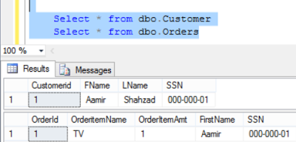
How to create Foreign Key Constrain on Multiple Columns in SQL Server Table

Let's try to insert a value in dbo.Orders which does not exists in dbo.Customer. It should through us as error due to Foreign Key constraint.

INSERT INTO dbo.Orders
(OrderItemName,OrderItemAmt,FirstName,SSN)
values ('TV',1,'Aamir','000-000-02')

As highlighted SSN value does not exists in dbo.Customer, we got below error.

Msg 547, Level 16, State 0, Line 30
The INSERT statement conflicted with the FOREIGN KEY constraint "Fk_Order_Customer_FName_SSN". The conflict occurred in database "YourDatabaseName", table "dbo.Customer".
The statement has been terminated.

*** The order of columns should be same what you have in primary key when we create foreign key constraint. If I try to create foreign key constraint with different order, I will get below error.

CREATE TABLE dbo.Orders (
OrderId INT Identity(1, 1)
,OrderitemName VARCHAR(50)
,OrderItemAmt INT
,FirstName VARCHAR(100),
SSN VARCHAR(10) Not Null,
Constraint Fk_Order_Customer_FName_SSN
FOREIGN KEY (SSN,FirstName) REFERENCES dbo.Customer(SSN,FName)
)

Msg 1776, Level 16, State 0, Line 13
There are no primary or candidate keys in the referenced table 'dbo.Customer' that match the referencing column list in the foreign key 'Fk_Order_Customer_FName_SSN'.
Msg 1750, Level 16, State 0, Line 13
Could not create constraint or index. See previous errors.

How to add Foreign key Constraint to existing table in SQL Server?

Scenario:
You have already created two tables dbo.Customer and dbo.Orders. Primary Key is created on CustomerId column in dbo.Customer table.

USE YourDatabaseName
GO

CREATE TABLE dbo.Customer (
Customerid INT PRIMARY KEY
,FName VARCHAR(100)
,LName VARCHAR(100)
,SSN VARCHAR(10)
)

CREATE TABLE dbo.Orders (
OrderId INT Identity(1, 1)
,OrderitemName VARCHAR(50)
,OrderItemAmt INT
)

You need to alter dbo.Orders table and add Foreign key constraint for CustomerId from dbo.Customer.

Solution:
As the tables are already present, the below script can be used to alter dbo.Orders table and add Foreign Key constraint.

If the column already exists in second table on which you would like to create Foreign Key Constraint, you are good to run the below script. As we don't have the column in table, we are going to add CustomerId column in dbo.Orders table first. The column Name does not has to match with first table column in our case dbo.Customer.CustomerId

--Add new column to Table in case you don't have
Alter table dbo.Orders
Add CustomerId int

--Add Foreign Key Constraint on Existing Table
Alter table dbo.Orders
Add Constraint Fk_CustomerId
Foreign Key(CustomerId) References dbo.Customer(CustomerId)

Create Foreign Key Constraint on Composite Columns
The below script can be used to create Foreign Key Constraint for Composite Columns.

USE YourDatabaseName
GO

CREATE TABLE dbo.Customer (
Customerid INT Identity(1,1)
,FName VARCHAR(100) Not Null
,LName VARCHAR(100)
,SSN VARCHAR(10) Not Null,
Constraint Pk_FName_SSN Primary Key (FName,SSN)
)

CREATE TABLE dbo.Orders (
OrderId INT Identity(1, 1)
,OrderitemName VARCHAR(50)
,OrderItemAmt INT
,FirstName VARCHAR(100),
SSN VARCHAR(10) Not Null
)
Columns already exists in both tables so we don't have to add columns to second table. We only need to create Foreign Key Constrain. Below script can be used to create Foreign Key Constraint for composite columns.

Alter table dbo.Orders
Add Constraint Fk_Order_Customer_FName_SSN
FOREIGN KEY (FirstName,SSN) REFERENCES dbo.Customer(FName,SSN)

You will write you syntax for your table

Alter table dbo.YourTableName
Add Constraint Constraint_Name
Foreign Key (Column1FromYourTableName,Column2FromYourTable) References dbo.YourFirstTable(Column1FromPrimaryKey,Column2FromPrimaryKey)

The ALTER TABLE statement conflicted with the FOREIGN KEY constraint in SQL Server?

Scenario:
You have created two tables dbo.Customer and dbo.Orders without having primary-foreign key relationship. After creating tables you inserted few records. Later you realized that you were supposed to add Foreign Key Constraint. When you tried to alter dbo.Orders table , you received error.
Create dbo.Customer and Dbo.Order Tables by using below script
USE YourDatabaseName
GO

CREATE TABLE dbo.Customer (
Customerid INT PRIMARY KEY
,FName VARCHAR(100)
,LName VARCHAR(100)
,SSN VARCHAR(10)
)

CREATE TABLE dbo.Orders (
OrderId INT Identity(1, 1)
,OrderitemName VARCHAR(50)
,OrderItemAmt INT,
CustomerId int
)
Insert sample records by using below script.
INSERT INTO dbo.Customer
(CustomerId,FName, LName,SSN)
VALUES
(1,'Aamir','Shahzad','000-000-00')

INSERT INTO dbo.Orders
(OrderItemName,OrderItemAmt,Customerid)
values ('TV',2,2)
Now let's add Foreign Key Constraint
Alter table dbo.Orders
Add Constraint Fk_CustomerId
Foreign Key(CustomerId) References dbo.Customer(CustomerId)
When we execute above script, we get below error.
Msg 547, Level 16, State 0, Line 31
The ALTER TABLE statement conflicted with the FOREIGN KEY constraint "Fk_CustomerId". The conflict occurred in database "YourDatabaseName", table "dbo.Customer", column 'Customerid'.

As dbo.Customer has value 1 for CustomerId column and in dbo.Orders table column CustomerId has value 2. The values does not match with each other. That is the reason we received above error.

Solutions:
1) Fix the data in second table (dbo.Orders)
We can fix the data in second table and update the CustomerId column values. Once we will have correct data that matches with our Primary Table ( Dbo.Customer.CustomerId), it will let us create Foreign Key Constraint without any issue.

2) Use Alter Table with Nocheck ( Ignore existing data)
If you don't care about relationship of existing data. You can use With NoCheck with alter table statement and it will ignore the check to validate data and create Foreign Key Constraint. Once the Foreign Key Constraint will be created, it will enforce integrity for any new records inserted.

Alter table dbo.Orders with Nocheck
Add Constraint Fk_CustomerId
Foreign Key(CustomerId) References dbo.Customer(CustomerId)

Cannot truncate table because it is being referenced by a FOREIGN KEY constraint ?

Scenario:
You need to truncate a table but when you try to execute truncate table tableName. You get below error.
Msg 4712, Level 16, State 1, Line 43
Cannot truncate table 'SchemaName.TableName' because it is being referenced by a FOREIGN KEY constraint.
How would you truncate this table?

Solution:
As the table in involved in Foreign Key relationship, you need to drop the foreign key constraint first and then execute the truncate table statement.
Let's demo this example, I am going to create two table dbo.Customer and dbo.Orders and then create Foreign Key Constraint on one of the column of Dbo.Orders to dbo.Customer table.
USE YourDatabaseName
GO

CREATE TABLE dbo.Customer (
Customerid INT PRIMARY KEY
,FName VARCHAR(100)
,LName VARCHAR(100)
,SSN VARCHAR(10)
)

CREATE TABLE dbo.Orders (
OrderId INT Identity(1, 1)
,OrderitemName VARCHAR(50)
,OrderItemAmt INT,
CustomerId int
)

--Create Foreign Key Constraint
Alter table dbo.Orders with Nocheck
Add Constraint Fk_CustomerId
Foreign Key(CustomerId) References dbo.Customer(CustomerId)
Now if I try to truncate dbo.Orders table, it will throw no error. But when I try to truncate dbo.Customer table it will throw error as dbo.Customer is begin references by Foreign Key Constraint.
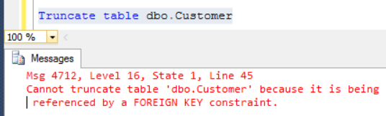
How to truncate a table which is reference by Foreign Key Constraint in SQL Server
We can drop the constraint for now, truncate the table and then recreate Foreign key constraint.
To find the Foreign Key Constraints on a table, you can use below statement.
SELECT *
FROM sys.foreign_keys
WHERE referenced_object_id = object_id('dbo.Customer')
How to get Constraint name from system tables in SQL Server
The below script can be used to generate drop Constraint statement for your table
SELECT
'ALTER TABLE '
+ OBJECT_SCHEMA_NAME(parent_object_id)
+'.[' + OBJECT_NAME(parent_object_id)
+'] DROP CONSTRAINT '
+ name as DropFKConstraint
FROM sys.foreign_keys
WHERE referenced_object_id = object_id('dbo.Customer')
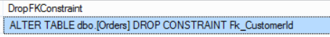
How to drop Foreign Key Constraint on Table in SQL Server

Take the result for Drop Foreign Key Constraint and execute, After that run your truncate table statement to truncate table. It should complete without any error.

Truncate all the tables in a Database in SQL Server?

Scenario:

Let's think about a database that we use for our ETL process and we call that database staging. We want to truncate all the tables in morning so those can be used for the daily process. Once way is to write our Truncate statement for each of the table but tables can be dropped or new tables can be created as well. We want to write a query that we can be use to Truncate all the tables from a database and we don't have to rewrite our Truncate statements.
If the tables do not have Primary Key -Foreign Key relationship, we can use Truncate. But we often have tables which are referenced by other tables. We can not use Truncate statement for those tables. The only way to Truncate those tables is to drop the Foreign Key Constraint before Truncating and then Truncate and Recreate Relationship after that.
The below Code can be used to Truncate all the tables from the database. If Tables will have the Pk-Fk relationship, The script will drop the Foreign Key Constraints first and then Truncate those tables and finally recreate the Foreign Key constraints.
Before you run below Script, Make sure you are pointing to correct Database and Server! All the best with Truncating all the tables from a SQL Server Database.
-- Drop Temp Tables if Exists
IF OBJECT_ID('tempdb..#DropConstraint') IS NOT NULL
DROP TABLE #DropConstraint
IF OBJECT_ID('tempdb..#CreateConstraint') IS NOT NULL
DROP TABLE #CreateConstraint
IF OBJECT_ID('tempdb..#TempTruncateTables') IS NOT NULL
DROP TABLE #TempTruncateTables
-- Drop Constraint Script Save in #DropConstraint Temp Table
SELECT 'ALTER TABLE ' + '['
+ Schema_name(o.schema_id) + '].['
+ OBJECT_NAME(FK.parent_object_id) + ']'
+ ' DROP CONSTRAINT ' + '[' + FK.name + ']' AS DropConstraintQuery
INTO #DropConstraint
FROM sys.foreign_keys AS FK
INNER JOIN sys.foreign_key_columns AS FKC
ON FK.OBJECT_ID = FKC.constraint_object_id
INNER JOIN sys.objects O
ON O.OBJECT_ID = FKC.parent_object_id
-- Create Constraint Script Save in #CreateConstraint Temp Table
SELECT 'ALTER TABLE ' + '['
+ Schema_name(o.schema_id) + '].' + '['
+ OBJECT_NAME(FK.parent_object_id) + ']'
+ ' ADD CONSTRAINT ' + '[' + FK.name
+ '] Foreign Key (['
+ (SELECT name
FROM sys.columns c
WHERE c.OBJECT_ID = FKC.parent_object_id
AND c.column_id = FKC.parent_column_id)
+ ']) REFERENCES ' + '['
+ Schema_name(o.schema_id) + '].['
+ (SELECT name
FROM sys.objects o
WHERE OBJECT_ID = FKC.referenced_object_id)
+ '] (['
+ (SELECT name
FROM sys.columns c
WHERE c.OBJECT_ID = FKC.referenced_object_id
AND c.column_id = FKC.referenced_column_id)
+ '])' AS CreateConstraintQuery
INTO #CreateConstraint
FROM sys.foreign_keys AS FK
INNER JOIN sys.foreign_key_columns AS FKC
ON FK.OBJECT_ID = FKC.constraint_object_id
INNER JOIN sys.objects o
ON FKC.parent_object_id = o.OBJECT_ID
-- Build Truncate Statement for all the tables and save into #TempTruncateTables
SELECT 'Truncate table ' + Schema_name(schema_id)
+ '.' + name AS TruncateTableQuery
INTO #TempTruncateTables
FROM sys.tables
WHERE TYPE = 'U'
AND is_ms_shipped = 0
GO
-- Drop Constraints
DECLARE @DropConstraintQuery AS VARCHAR(4000)
DECLARE DropConstraintCur CURSOR FOR
SELECT DropConstraintQuery
FROM #DropConstraint
OPEN DropConstraintCur
FETCH Next FROM DropConstraintCur
INTO @DropConstraintQuery
WHILE @@FETCH_STATUS = 0
BEGIN
DECLARE @SQL VARCHAR(MAX)=NULL
SET @SQL=@DropConstraintQuery
EXEC (@SQL)
PRINT ' Query ::' + @DropConstraintQuery
+ 'Completed'
FETCH Next FROM DropConstraintCur INTO @DropConstraintQuery
END
CLOSE DropConstraintCur
DEALLOCATE DropConstraintCur
GO-- Truncate tables
DECLARE @TempTruncateTablesCur AS VARCHAR(4000)
DECLARE TempTruncateTablesCur CURSOR FOR
SELECT TruncateTableQuery
FROM #TempTruncateTables
OPEN TempTruncateTablesCur
FETCH Next FROM TempTruncateTablesCur
INTO @TempTruncateTablesCur
WHILE @@FETCH_STATUS = 0
BEGIN
DECLARE @SQL VARCHAR(MAX)=NULL
SET @SQL=@TempTruncateTablesCur
EXEC (@SQL)
PRINT ' Query ::' + @TempTruncateTablesCur
+ 'Completed'
FETCH Next FROM TempTruncateTablesCur INTO @TempTruncateTablesCur
END
CLOSE TempTruncateTablesCur
DEALLOCATE TempTruncateTablesCur
GO
-- Create Constraint After Truncate
DECLARE @CreateConstraintQuery AS VARCHAR(4000)
DECLARE CreateConstraintQueryCur CURSOR FOR
SELECT CreateConstraintQuery
FROM #CreateConstraint
OPEN CreateConstraintQueryCur
FETCH Next FROM CreateConstraintQueryCur
INTO @CreateConstraintQuery
WHILE @@FETCH_STATUS = 0
BEGIN
DECLARE @SQL VARCHAR(MAX)=NULL
SET @SQL=@CreateConstraintQuery
EXEC (@SQL)
PRINT ' Query ::' + @CreateConstraintQuery
+ 'Completed'
FETCH Next FROM CreateConstraintQueryCur INTO @CreateConstraintQuery
END
CLOSE CreateConstraintQueryCur
DEALLOCATE CreateConstraintQueryCur
GO

How to get Parent Table, Reference Table, Foreign Key Constraint Name and Columns in SQL Server?

Scenario:
You are working as SQL Server Developer, you are asked to provide the query that should return all the parent tables, reference tables, Foreign Key Constraints and Columns used in Foreign Key Constraint definition.

Solution:
We can use the system views to gather this information. In our below query we will be using three
system views
sys.foreign_keys
sys.foreign_key_columns
sys.columns
to answer the request. As we can have composite primary key columns used in Foreign Key Constraint, I have used FOR XML Path to concatenate rows into column so can provide list of columns in single row.
;With CTE_FK AS (
SELECT Schema_Name(Schema_id) as TableSchemaName,
object_name(FK.parent_object_id) ParentTableName,
object_name(FK.referenced_object_id) ReferenceTableName,
FK.name AS ForeignKeyConstraintName,c.name as ReferencedColumnList,
cf.name as ParentColumnName
FROM sys.foreign_keys AS FK
INNER JOIN sys.foreign_key_columns AS FKC
ON FK.OBJECT_ID = FKC.constraint_object_id
INNER JOIN sys.columns c
on c.OBJECT_ID = FKC.referenced_object_id
AND c.column_id = FKC.referenced_column_id
INNER JOIN sys.columns cf
on cf.OBJECT_ID = FKC.parent_object_id
AND cf.column_id = FKC.parent_column_id
)
Select TableSchemaName,
ParentTableName,
ReferenceTableName,
ForeignKeyConstraintName,stuff((
Select ','+ParentColumnName
from CTE_FK i
where i.ForeignKeyConstraintName=o.ForeignKeyConstraintName
and i.TableSchemaName=o.TableSchemaName
and i.ParentTableName=o.ParentTableName
and i.ReferenceTableName=o.ReferenceTableName
for xml path('')), 1, 1, '') ParentColumnList
,stuff((
Select ','+ReferencedColumnList
from CTE_FK i
where i.ForeignKeyConstraintName=o.ForeignKeyConstraintName
and i.TableSchemaName=o.TableSchemaName
and i.ParentTableName=o.ParentTableName
and i.ReferenceTableName=o.ReferenceTableName
for xml path('')), 1, 1, '') RefColumnList
from CTE_FK o
group by
tableSchemaName,
ParentTableName,
ReferenceTableName,
ForeignKeyConstraintName

I executed above script on one of my database and here is output with Schema Name,Parent Table Name, Referenced Table Name, Foreign Key Constraint Name, Parent Column List and Reference Column List used in Constraint.
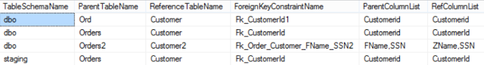
How to get Parent Table, Referenced Table,Foreign Key Constraint Name, Columns list in SQL Server

How to drop Foreign Key Constraints in SQL Server Database for all the tables?

Scenario:
You are working as SQL Server developer, you are asked to provide the scripts those can be used to drop Foreign Key Constraints on all the tables in a database if exists.

Solution:
We can use system view to generate the drop Foreign Key Constraints for all the tables in SQL Server Database by using below query.
USE YourdatabaseName
go
-- Drop Foreign Key Constraints Script
SELECT distinct 'ALTER TABLE '
+ '['+ Schema_name(FK.schema_id)
+ '].['+ OBJECT_NAME(FK.parent_object_id)
+ ']'+ ' DROP CONSTRAINT '
+ '[' + FK.name + ']' AS DropConstraintQuery
FROM sys.foreign_keys AS FK

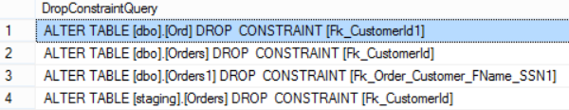
How to drop all the Foreign Key Constraints in SQL Server Database

Execute above query and then take the results and run in SSMS to drop all the Foreign Key Constraint in database.

How to generate scripts to Re-create Foreign Key Constraints in SQL Server Database?

Scenario:
You need to truncate all the tables in SQL Server database, when when you run truncate statement, you get error below error.
Msg 4712, Level 16, State 1, Line 43
Cannot truncate table 'SchemaName.TableName' because it is being referenced by a FOREIGN KEY constraint.
The easy way would be drop the Foreign Key Constraints, truncate the tables and recreate the Foreign Key Constraint again.
I wrote a post that you can use to generate Drop Foreign Key Constraints in a database. Click here.
But before we drop them, we need to generate the create Foreign key Constraints scripts so we can run after truncating the table.
You can use below script to generate truncate table statement for all the user tables from a database.
Select 'Truncate table '+'['
+Schema_name(Schema_id)
+'].['+name+']' as TruncateTablesScript
from sys.tables
where is_ms_shipped=0
The below script can be used to re-generate Foreign Key Constraint in a database.
;With CTE_FK AS (
SELECT Schema_Name(Schema_id) as TableSchemaName,
object_name(FK.parent_object_id) ParentTableName,
object_name(FK.referenced_object_id) ReferenceTableName,
FK.name AS ForeignKeyConstraintName,c.name as RefColumnName,
cf.name as ParentColumnList
FROM sys.foreign_keys AS FK
INNER JOIN sys.foreign_key_columns AS FKC
ON FK.OBJECT_ID = FKC.constraint_object_id
INNER JOIN sys.columns c
on c.OBJECT_ID = FKC.referenced_object_id
AND c.column_id = FKC.referenced_column_id
INNER JOIN sys.columns cf
on cf.OBJECT_ID = FKC.parent_object_id
AND cf.column_id = FKC.parent_column_id
where fk.is_ms_shipped=0
)
Select
'Alter table ['+TableSchemaName+'].['+ParentTableName+']'
+' Add Constraint '+ForeignKeyConstraintName+
' Foreign Key('+stuff((
Select ','+ParentColumnList
from CTE_FK i
where i.ForeignKeyConstraintName=o.ForeignKeyConstraintName
and i.TableSchemaName=o.TableSchemaName
and i.ParentTableName=o.ParentTableName
and i.ReferenceTableName=o.ReferenceTableName
for xml path('')), 1, 1, '')+') References '+
'['+TableSchemaName+'].['+ReferenceTableName+']('+stuff((
Select ','+RefColumnName
from CTE_FK i
where i.ForeignKeyConstraintName=o.ForeignKeyConstraintName
and i.TableSchemaName=o.TableSchemaName
and i.ParentTableName=o.ParentTableName
and i.ReferenceTableName=o.ReferenceTableName
for xml path('')), 1, 1, '')+')'
AS CreateForeignKeyConstraintScript,
ParentTableName,
ReferenceTableName,
ForeignKeyConstraintName
from CTE_FK o
group by
tableSchemaName,
ParentTableName,
ReferenceTableName,
ForeignKeyConstraintName
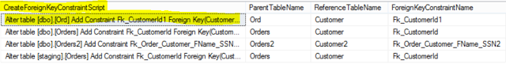
How to generate script to re-create Foreign Key Constraint in SQL Server Database

Take the results from CreateForeignKeyConstraintScript Column. I suggest you to run the scripts in DEV or QA first to make sure all working fine before you run in Production.

Could not drop object because it is referenced by a FOREIGN KEY constraint?

Scenario:
You are working as SQL Server DBA or Developer, You need to drop a table from a database. When you execute drop table SchemaName.TableName statement, you get below error.
Msg 3726, Level 16, State 1, Line 12
Could not drop object 'SchemaName.TableName' because it is referenced by a FOREIGN KEY constraint.
Now we know that the table is referenced by Foreign Key Constraint. The problem is how to find which table has that Foreign Key Constraint that is referencing to this table.

Solution:
1) There are many ways to get this information. We can use system views to find the name of table which has the Foreign Key Constraint which is referencing our Primary Table.
SELECT Schema_Name(Schema_id) as TableSchemaName,
object_name(FK.parent_object_id) ParentTableName,
object_name(FK.referenced_object_id) ReferenceTableName
FROM sys.foreign_keys AS FK
WHERE object_name(FK.referenced_object_id)='YourTableName'
and Schema_Name(Schema_id)='YourTableSchemaName'

I executed above script for my customer table which is present in dbo schema and here is what I got.
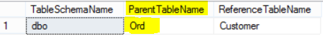
How to find which table's Foreign Key is referencing to Table in SQL Server.
Now we know that Ord is the table which has the Foreign Key Constraint which is referencing our table. We can go ahead and drop the foreign key Constraint and then drop our table.
2) Use System Stored Procedure sp_fkeys
We can use system Stored Procedure to get the Foreign Key Constraints information which are referencing to our table. If my table name is Customer, I can run script as below

EXEC sp_fkeys 'Customer'

How to get Foreign Key Constraint name for a Table in SQL Server

The sp_fkeys returns very detailed information, few of the columns are not shown in snapshot above. here is the list of columns it will return.
- PKTABLE_QUALIFIER
- PKTABLE_OWNER
- PKTABLE_NAME
- PKCOLUMN_NAME
- FKTABLE_QUALIFIER
- FKTABLE_OWNER
- FKTABLE_NAME
- FKCOLUMN_NAME
- KEY_SEQ
- UPDATE_RULE
- DELETE_RULE
- FK_NAME
- PK_NAME

How to Drop Foreign Key Constraint in SQL Server Database?

Scenario:
You are working as SQL Server developer and you need to prepare the script to drop the Foreign Key Constraint which was created on dbo.Orders table.

Solution:
Let's create dbo.Customer and dbo.Orders sample tables and include Foreign Key Constraint as part of create table by using below script.

USE YourDatabaseName
GO

CREATE TABLE dbo.Customer (
Customerid INT PRIMARY KEY
,FName VARCHAR(100)
,LName VARCHAR(100)
,SSN VARCHAR(10)
)

CREATE TABLE dbo.Orders (
OrderId INT Identity(1, 1)
,OrderitemName VARCHAR(50)
,OrderItemAmt INT
,Customer_id INT FOREIGN KEY REFERENCES Customer(CustomerId)
)

Once the tables are created and Foreign Key Constraint as well, you can use below statement to find the Foreign Key Constraint Name with table name.

USE YourDatabaseName
GO
Select
Schema_name(Schema_id) as SchemaName,
object_name(Parent_object_id) as TableName,
name as ForeignKeyConstraintName
from sys.foreign_keys
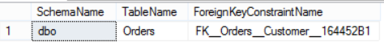
Find Foreign Key Constraint Name in SQL Server with Table Name
Now we know the constraint name, we can go ahead and write our drop constraint statement.

Syntax for Drop Foreign Key Constraint on Table
Alter Table SchemaName.TableName
Drop Constraint Constraint_Name

I used below statement to drop FK__Orders__Customer__164452B1 Foreign Key Constraint.

Alter table dbo.Orders
Drop Constraint FK__Orders__Customer__164452B1

If you are interested to generate scripts to drop all Foreign Key Constraints in a database, Check this link.

The UPDATE statement conflicted with the REFERENCE constraint ?

Scenario:
You are working as SQL Server developer, You wrote an update statement for one of the table and getting below error.
Msg 547, Level 16, State 0, Line 32
The UPDATE statement conflicted with the REFERENCE constraint "FK_".
The conflict occurred in database "YourDatabaseName", table "SchemaName.YourTableName", column 'ColumnName'.
The statement has been terminated.

How to resolve this issue?

Solution:
Let's create this error first by using below script. We are going to create two tables dbo.Customer and dbo.Orders. The tables has Primary-Foreign Key Relationship.

USE YourDatabaseName
GO

CREATE TABLE dbo.Customer (
Customerid INT PRIMARY KEY
,FName VARCHAR(100)
,LName VARCHAR(100)
,SSN VARCHAR(10)
)

CREATE TABLE dbo.Orders (
OrderId INT Identity(1, 1)
,OrderitemName VARCHAR(50)
,OrderItemAmt INT
,Customer_id INT FOREIGN KEY REFERENCES Customer(CustomerId)
)

--insert sample data
insert into dbo.Customer
(CustomerId,FName, LName,SSN)
values
(1,'Aamir','Shahzad','000-000-00')

insert into dbo.Orders
(OrderItemName,OrderItemAmt,Customer_Id)
values ('TV',1,1)
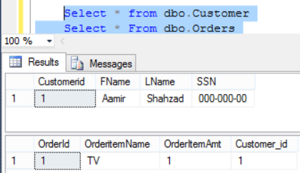
How to update record when Column is referenced by Foreign Key Constraint in SQL Server

Now let's say if you feel that CustomerId value is incorrect in dbo.Customer and need to be updated. You wrote below update statement to update CustomerId to 100.

update dbo.Customer
set Customerid=100
You will get below error.

Msg 547, Level 16, State 0, Line 33
The UPDATE statement conflicted with the REFERENCE constraint "FK__Orders__Customer__1ED998B2".
The conflict occurred in database "YourDatabaseName", table "dbo.Orders", column 'Customer_id'.
The statement has been terminated.

As there is no Customer_id value=100 in dbo.Orders table, You can't update the record in reference table. Now you thought that let's fix the Parent table first ( dbo.Orders) and then I can update the dbo.Customer table.

update dbo.Orders
set Customer_Id=100
Again you got the error as shown below, because we don't have CustomerId=100 available in dbo.Customer table.

Msg 547, Level 16, State 0, Line 36
The UPDATE statement conflicted with the FOREIGN KEY constraint "FK__Orders__Customer__1ED998B2".
The conflict occurred in database "YourDatabaseName", table "dbo.Customer", column 'Customerid'.
The statement has been terminated.

From here we can come with with multiple solutions
1) Instead of updating the record, Insert the record in Reference Table ( Dbo.Customer), Then update the record in Parent table (Dbo.Orders) and finally delete the existing records from Reference Table.

--Insert Record in Reference Table First
insert into dbo.Customer
(CustomerId,FName, LName,SSN)
values
(100,'Aamir','Shahzad','000-000-00')

--Update the Records in Parent Table
update dbo.Orders
set Customer_Id=100

--Delete the old record from Reference Table
Delete from dbo.Customer
where CustomerId=1
Check the records in table now.

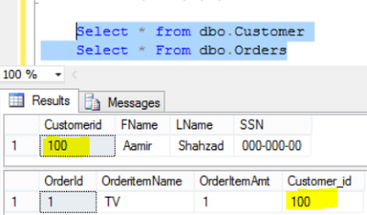
How to update Column Value when referenced by Foreign Key Constraint in SQL Server

2) Disable the Foreign Key Constraint and Update the Values Manually
Another solution can be, disable the Foreign Key constraint, update the records and finally enable the Foreign key again.

--Find the Foreign Key Constraint with Table Name
USE YourDatabaseName
GO
Select
Schema_name(Schema_id) as SchemaName,
object_name(Parent_object_id) as TableName,
name as ForeignKeyConstraintName
from sys.foreign_keys

Disable the Foreign Key Constraint by using below statement

Syntax
ALTER TABLE SchemaName.ParentTableName
NOCHECK CONSTRAINT Constraint_Name

I used below statement to disable Foreign Key constraint on dbo.Orders table.

--Disable Foregin Key by using NOCHECK
ALTER TABLE dbo.Orders
NOCHECK CONSTRAINT FK__Orders__Customer__2A4B4B5E

--Run Update Statements
update dbo.Customer
set Customerid=100

update dbo.Orders
set Customer_Id=100

Enable Foreign Key Constraint Syntax
ALTER TABLE SchemaName.ParentTableName
CHECK CONSTRAINT Constraint_Name

I execute below script to Enable Foreign Key Constraint on dbo.Orders table.

--Enable Foreign Key Constraint by using CHECK
ALTER TABLE dbo.Orders
CHECK CONSTRAINT FK__Orders__Customer__2A4B4B5E

How to disable all Foreign Key Constraint in SQL Server Database?

Scenario:
You are working as SQL Server developer, You need to provide the scripts to disable all the Foreign Key Constraint in SQL Server database. This might be scenario where you need to load one time data and you are ok if data violate referential integrity.

Solution:
Let's get the list of Foreign Key Constraints from a SQL Server Database before we generate the disable script.
--Get List of Foreign Key Constraints if Enabled or Disabled
USE YourDatabaseName
GO
Select
Schema_name(Schema_id) as SchemaName,
object_name(Parent_object_id) as TableName,
name as ForeignKeyConstraintName,
Case When Is_disabled=1 Then 'No'
ELSE 'Yes' End as IsEnabled
from sys.foreign_keys
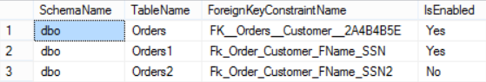
How to Check if Foreign Key Constraint is Enabled or Disabled in SQL Server
Now let's generate script to Disable Foreign Key Constraint in SQL Server Database
USE YourdatabaseName
go
-- Drop Foreign Key Constraints Script
SELECT distinct 'ALTER TABLE '
+ '['+ Schema_name(FK.schema_id)
+ '].['+ OBJECT_NAME(FK.parent_object_id)
+ ']'+ ' NOCHECK CONSTRAINT '
+ '[' + FK.name + ']' AS DisableConstraintQuery
FROM sys.foreign_keys AS FK
where is_disabled=0
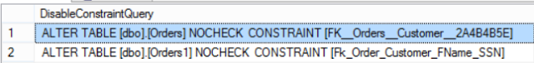
How to generate Script to Disable All Foreign Key Constraints in SQL Server Database

How to Generate Script To Enable All Foreign Key Constraints in SQL Server Database?

Scenario:
You are working as SQL Server developer, You need to prepare scripts to enable all the Foreign Key Constraint in a database which are disabled. This could happen, maybe somebody has disabled Foreign Key Constraints for a data load where they don't care about violation of referential integrity and forgot to enable them later.

Solution:
First of all let's get the list of Foreign Key Constraints with status by using below query
--Get List of Foreign Key Constraints if Enabled or Disabled
USE YourDatabaseName
GO
Select
Schema_name(Schema_id) as SchemaName,
object_name(Parent_object_id) as TableName,
name as ForeignKeyConstraintName,
Case When Is_disabled=1 Then 'No'
ELSE 'Yes' End as IsEnabled
from sys.foreign_keys
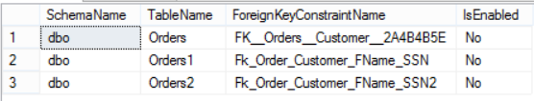
How to check if Foreign Key Constraint is Disabled or Enabled in SQL Server Database
Now let's generate scripts to enable the Foreign Key Constraints which are disabled in SQL Server Database by using below query.
USE YourdatabaseName
go
-- Enable Foreign Key Constraints Script
SELECT distinct 'ALTER TABLE '
+ '['+ Schema_name(FK.schema_id)
+ '].['+ OBJECT_NAME(FK.parent_object_id)
+ ']'+ ' CHECK CONSTRAINT '
+ '[' + FK.name + ']' AS EnableConstraintQuery
FROM sys.foreign_keys AS FK
where is_disabled=1
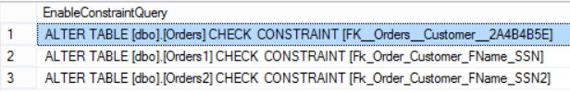
How to generate script to enable all Foreign Key Constraints in SQL Server Database

Copy the results and run in SSMS to enable disabled Foreign Key Constraints in SQL Server Database.

How to create Foreign Key Constraint With ON UPDATE CASCADE in SQL Server?

Scenario:
In previous posts, we learn that if we have Foreign key Constraint with default setting and we try to update the value in column in Reference Table which is used as Reference Column in Foreign Key Constraint, we get error. We discussed multiple ways to handle the situation, please check this link.

Foreign Key Constraint does provide the option to set the Cascading action, we can create Foreign Key Constraint with Cascading Update.

If Update Cascading settings is used, when we update the value in Referenced Table , it will also update the value in parent table (Foreign Key Table) column.

Let's test this scenario. Create two tables dbo.Customer and dbo.Orders with Foreign Key Relationship by given script

USE YourDatabaseName
GO

CREATE TABLE dbo.Customer (
Customerid INT PRIMARY KEY
,FName VARCHAR(100)
,LName VARCHAR(100)
,SSN VARCHAR(10)
)

CREATE TABLE dbo.Orders (
OrderId INT Identity(1, 1)
,OrderitemName VARCHAR(50)
,OrderItemAmt INT
,Customer_id INT FOREIGN KEY REFERENCES
Customer(CustomerId) ON UPDATE CASCADE
)

--insert sample data
insert into dbo.Customer
(CustomerId,FName, LName,SSN)
values
(1,'Aamir','Shahzad','000-000-00')

insert into dbo.Orders
(OrderItemName,OrderItemAmt,Customer_Id)
values ('TV',1,1)

Let's check the data in tables by using select query
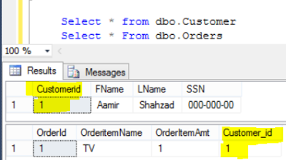
How to create Foreign Key Constraint with Update Cascade in SQL Server

Let's run our update statement on CustomerId in dbo.Customer table and see if it also update the column value in dbo.Orders for Customer_id.

update dbo.Customer
set Customerid=100
Let's check the data again in our tables
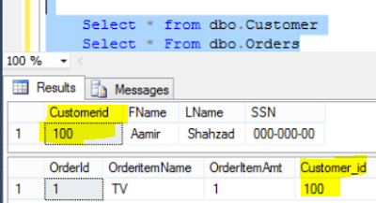
How to enable Update Cascading with Foreign Key Constraint in SQL Server

As we can see that the value is also updated in dbo.Orders.Customer_id column.

How to create Foreign Key Constraint with ON DELETE CASCADE in SQL Server?

Scenario:
You are working as SQL Server developer, you need to create two tables with Primary -Foreign Key Relationship. You want to create Foreign Key Constraint with setting if record will be deleted from Referenced Table (Primary Key Column Table), it should be deleted from Parent Table ( Foreign Key Constraint Table) as well.

Solution:
SQL Server let us use the the setting with Foreign Key Constraint called On DELETE CASCADE. If this rule is implemented, whenever record is deleted from Referenced Table( Primary Key Column Table), it will also be deleted from Parent Table ( Foreign Key Constraint Table).

Let's test this scenario with below script.

USE YourDatabaseName
GO

CREATE TABLE dbo.Customer (
Customerid INT PRIMARY KEY
,FName VARCHAR(100)
,LName VARCHAR(100)
,SSN VARCHAR(10)
)

CREATE TABLE dbo.Orders (
OrderId INT Identity(1, 1)
,OrderitemName VARCHAR(50)
,OrderItemAmt INT
,Customer_id INT FOREIGN KEY REFERENCES
Customer(CustomerId) ON DELETE CASCADE
)

--insert sample data
insert into dbo.Customer
(CustomerId,FName, LName,SSN)
values
(1,'Aamir','Shahzad','000-000-00')

Check the data in tables by using select query.

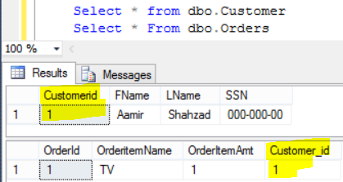
How to enable ON Delete CASCADE rule with Foreign Key Constraint in SQL Server

Let's delete the row from Referenced Table( Primary Key Column Table) and see if it also deletes from Parent Table ( Foreign Key Constraint Table)

--Delete the Record from Referenced Table(PK Column Table)
Delete from dbo.Customer
where CustomerId=1

Check the tables again to see if record is deleted from both tables due to ON Delete Cascade rule on Foreign Key Constraint.
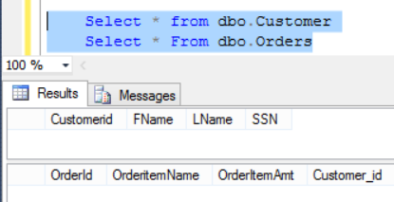
How to use ON Delete Cascade to delete records from multiple Tables in SQL Server Table

As we can see that the records are deleted from both tables due to ON DELETE CASCADE rule of Foreign Key Constraint.

How to Create Foreign Key Constraint with ON DELETE SET NULL Option in SQL Server?

Scenario:
You are working as SQL Server developer, you need to create two tables with Primary -Foreign Key Relationship. You want to create Foreign Key Constraint with setting if record will be deleted from Referenced Table (Primary Key Column Table), it should not be deleted from Parent Table ( Foreign Key Constraint Table) instead the value should be updated to Null.

Solution:
We can use ON DELETE SET NULL with Foreign Key Constraint definition to implement above requirement.

Let's perform by using below script.
USE YourDatabaseName
GO

CREATE TABLE dbo.Customer (
Customerid INT PRIMARY KEY
,FName VARCHAR(100)
,LName VARCHAR(100)
,SSN VARCHAR(10)
)

CREATE TABLE dbo.Orders (
OrderId INT Identity(1, 1)
,OrderitemName VARCHAR(50)
,OrderItemAmt INT
,Customer_id INT FOREIGN KEY REFERENCES
Customer(CustomerId) ON DELETE SET NULL
)

--insert sample data
insert into dbo.Customer
(CustomerId,FName, LName,SSN)
values
(1,'Aamir','Shahzad','000-000-00')

insert into dbo.Orders
(OrderItemName,OrderItemAmt,Customer_Id)
values ('TV',1,1)

Check the data in tables by using Select query
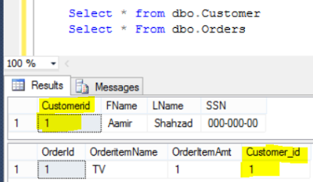
How to create Foreign Key Constraint with ON DELETE SET NULL in SQL Server

Let's delete the row from Referenced Table( Primary Key Column Table) and check if records still exists in Parent Table ( Foreign Key Constraint Table) and column value is updated to Null.

--Delete the Record from Referenced Table(PK Column Table)
Delete from dbo.Customer
where CustomerId=1

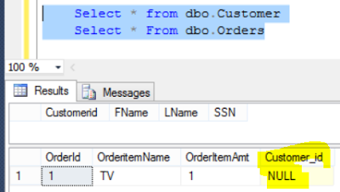
How to use ON DELETE SET NULL option with Foreign Key Constraint in SQL Server

As we can see that the record is deleted from Referenced Table( Primary Key Column Table) but still present in Parent Table ( Foreign Key Constraint Table) but value is updated to Null as expected.

6.4 : Check Constraint

What is Check Constraint in SQL Server?

What is Check Constraint :
Check Constraints limit the values that are accepted by one or more columns.

Let's understand Check Constraint with real time scenario.
You are working as SQL Server developer, You need to create dbo.Customer table which should have columns such as FName, LName and Address. As FName is going be be VARCHAR so the users can insert string values that can contain alphabets, numeric and other characters. You want to write a Check Constraint so FName only accepts alphabets.

Solution:
Let's create the table with Check Constraint by using below script
--Create Table with
use YourDatabaseName
go
Create table dbo.Customer
(
FName VARCHAR(100) Not Null,
LName VARCHAR(100),
StreetAddress VARCHAR(255),
Check (FName not like '%[^a-z]%')
)
Let's insert some records in table and see if our Check Constraint is working as expected. It should let only insert those records in which FName only contains alphabets.
--insert some sample records
insert into dbo.Customer
(FName,LName,StreetAddress)
Values ('Aamir','Shahzad','xyz address')
go
insert into dbo.Customer
(FName,LName,StreetAddress)
Values ('Aamir4','Shahzad','xyz address')
go
insert into dbo.Customer
(FName,LName,StreetAddress)
Values ('abc3c','Shahzad','xyz address')
go
insert into dbo.Customer
(FName,LName,StreetAddress)
Values ('-tName','Shahzad','xyz address')
When I executed above insert scripts, below are the messages I received from SQL Server.
(1 row(s) affected)
Msg 547, Level 16, State 0, Line 18
The INSERT statement conflicted with the CHECK constraint "CK__Customer__FName__5FB337D6". The conflict occurred in database "YourDatabaseName", table "dbo.Customer", column 'FName'.
The statement has been terminated.
Msg 547, Level 16, State 0, Line 22
The INSERT statement conflicted with the CHECK constraint "CK__Customer__FName__5FB337D6". The conflict occurred in database "YourDatabaseName", table "dbo.Customer", column 'FName'.
The statement has been terminated.
Msg 547, Level 16, State 0, Line 26
The INSERT statement conflicted with the CHECK constraint "CK__Customer__FName__5FB337D6". The conflict occurred in database "YourDatabaseName", table "dbo.Customer", column 'FName'.
The statement has been terminated.
It only inserted very first record that contains all alphabets for FName, rest of the records are rejected by our Check Constraint as they contain other characters than alphabets.
Let's check the data in table to make sure only single record is inserted.
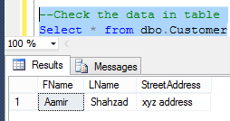
What is Check Constraint in SQL Server and how to Create Check Constraint in SQL Server

How to Create Check Constraint on Single Column in SQL Server?

Scenario :
You are working as SQL Sever developer, You are preparing scripts to create Tables in database. As part of these scripts you need to create Check Constraints but you want to follow the company's naming standards for Check Constraints. How would you add Check Constraint Name in your scripts.

Solution:
SQL Server automatically give name to Check Constraint if we don't provide. Let's execute the below script and see what name SQL Server assign to Check Constraint when we don't provide the name. In below example we are creating Check Constraint on FName and making sure it only accepts alphabets.
--Create Table with Check Constraint
use YourDatabaseName
go
Create table dbo.Customer
(
FName VARCHAR(100) Not Null,
LName VARCHAR(100),
StreetAddress VARCHAR(255),
Check (FName not like '%[^a-z]%')
)

We can use system views to gather information related to Check Constraints.
--How to get Check Constraints in SQL Server
SELECT
*
FROM INFORMATION_SCHEMA.Check_Constraints
How to create Check Constraint in SQL Server with default Name
Let's say that the name SQL Server provided to Check Constraint is not according to our company standards. Our standards say that the Check Constraint should follow below pattern
Start with Chk_SchemaName_TableName_ColumnName_CheckConstraintDescription. To add a Check Constraint , your syntax will be
Constraint Constraint_Name Check LogicForCheckConstraint.
--Create Table with Check Constraint
use YourDatabaseName
go
Create table dbo.Customer
(
FName VARCHAR(100) Not Null,
LName VARCHAR(100),
StreetAddress VARCHAR(255),
Constraint Chk_dbo_Customer_FName_AlphabetsOnly
Check (FName not like '%[^a-z]%')
)

Run the select query on system view to get Check Constraint information. I suggest to create objects with some naming convention or standards instead of letting the sql server decide name for your objects.
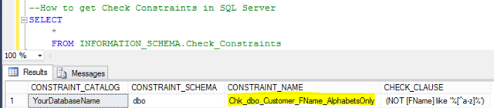
How to create Check Constraint by providing name according to your company standards in SQL Server

How to Create Check Constraint on Multiple Columns in SQL Server?

Scenario:
You are working as SQL Server developer, you need to create dbo.Customer table that should have First Name, Age and Age Type columns. You can add CustomerId as Identity. You need to create Check Constraint on Age and Age Type Columns with below logic
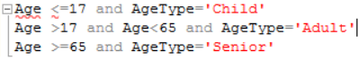
<65 agetype="Adult" and="" p="">
If true then let the record insert or update otherwise fail due to Check Constraint.

<65 agetype="Adult" and="" p=""> Solution:
<65 agetype="Adult" and="" p=""> Below script can be used to add Check Constraint on multiple columns according to our requirement.
CREATE TABLE dbo.Customer (
CustomerId INT identity(1, 1)
,NAME VARCHAR(100)
,Age INT
,AgeType VARCHAR(15)
,CONSTRAINT dbo_Customer_AgeAndAgeType CHECK (
(
Age <= 17
AND AgeType = 'Child'
)
OR (
Age > 17
AND Age < 65
AND AgeType = 'Adult'
)
OR (
Age >= 65
AND AgeType = 'Senior'
)
)
)
Let's insert few records and try to see if Check Constraint is working as expected.

--Correct values accrording to Constraint
insert into dbo.Customer(Name,Age,AgeType)
Values('Najaf',13,'Child')
go

--Wrong values according to Check Constraint
insert into dbo.Customer(Name,Age,AgeType)
Values('Leena',14,'Adult')
go
--Correct values accroding to Constraint
insert into dbo.Customer(Name,Age,AgeType)
Values('Raza',30,'Adult')
go
--Wrong values according to Check Constraint
insert into dbo.Customer(Name,Age,AgeType)
Values('Aamir',30,'Senior')
go
--Wrong values according to Check Constraint
insert into dbo.Customer(Name,Age,AgeType)
Values('John',65,'Adult')
go
--Correct values accroding to Constraint
insert into dbo.Customer(Name,Age,AgeType)
Values('Kris',65,'Senior')
go
(1 row(s) affected)
Msg 547, Level 16, State 0, Line 25
The INSERT statement conflicted with the CHECK constraint "dbo_Customer_AgeAndAgeType". The conflict occurred in database "YourDatabaseName", table "dbo.Customer".
The statement has been terminated.
(1 row(s) affected)
Msg 547, Level 16, State 0, Line 33
The INSERT statement conflicted with the CHECK constraint "dbo_Customer_AgeAndAgeType". The conflict occurred in database "YourDatabaseName", table "dbo.Customer".
The statement has been terminated.
Msg 547, Level 16, State 0, Line 37
The INSERT statement conflicted with the CHECK constraint "dbo_Customer_AgeAndAgeType". The conflict occurred in database "YourDatabaseName", table "dbo.Customer".
The statement has been terminated.
(1 row(s) affected)
Let's check the data in table by using select query. As can be seen below the only records are inserted which passed the Check Constraint. Rest of the records could not be inserted.
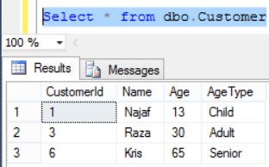
How to create Check Constraint on Multiple Columns in SQL Server Table
Let's try to update the records and see if Check Constraint is working as expected.
update dbo.Customer
set Age=30
where Customerid=1

It failed with below error as we can not have Age 30 for AgeType='Child' according to our Check Constraint logic.
Msg 547, Level 16, State 0, Line 18
The UPDATE statement conflicted with the CHECK constraint "dbo_Customer_AgeAndAgeType". The conflict occurred in database "YourDatabaseName", table "dbo.Customer".
The statement has been terminated.

How to get list of all Check Constraints in SQL Server Database?

Scenario:
You are working as SQL Server developer, you need to provide the query that should return list of all the Check Constraint in SQL Server database.

Solution:
We can use different system objects to get this information.

--List Check Constraints in Database
SELECT DB_Name() AS DBName
,Schema_Name(Schema_id) AS TableSchema
,Object_name(parent_object_id) AS TableName
,o.NAME AS ConstraintName
FROM sys.objects o
WHERE type_desc = 'CHECK_CONSTRAINT'

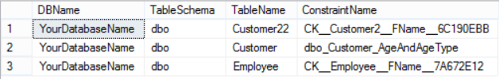
How to get list of Check Constraints in SQL Server Database

If you are interested to get definition of Check Constraints with table name, you can use below query.

--Get Check Constraints in Database with Definition
SELECT DB_Name() AS DBName
,Schema_Name(Schema_id) AS TableSchema
,Object_name(parent_object_id) AS TableName
,DEFINITION
FROM sys.check_constraints

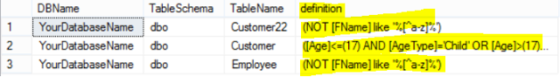
How to get list of Check Constraints with definition in SQL Server Database

How to get List of Enabled / Disabled Check Constraints in SQL Server Database?

Scenario:
You are working as SQL Server Developer and you are asked to provide list of all Check Constraint with status if enabled or disabled.

Solution:
The below query can be used to get the list of all Check Constraints from a database with status if they are enabled or disabled in SQL Server Database.
--Get List of Enabled / Disabled Check Constraints
SELECT DB_Name() AS DBName
,Schema_Name(Schema_id) AS TableSchema
,Object_name(parent_object_id) AS TableName
,DEFINITION
,CASE
WHEN is_disabled = 0
THEN 'NO'
ELSE 'YES'
END AS IsDisabled
FROM sys.check_constraints
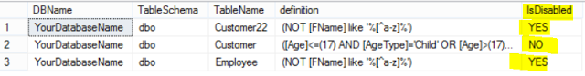
How to get list of Enabled or Disabled Check Constraints in SQL Server Database

How to disable all Check Constraints in SQL Server Database?

Scenario:
You are working as SQL Server / ETL developer. You need to load bunch of data to tables in SQL Server Database. Check Constraints are created on different tables. There are chances that the data you are going to load will not qualify according to Check Constraint. The business want you to load the data anyways even it does not qualify with Check Constraint. You want to temporary disable all the constraints in SQL Server database and then load the data and then re-enabled the Check Constraints.

Solution:
The below script can be used to generate Disable Check Constraint script for all the Check Constraints which are enabled in database. You can further filter the tables in where clause if you don't want to generate script for all the tables.

--Generate Script to Disable All Check Constraint in SQL Server Database
Select DB_Name() AS DBName,
Schema_Name(Schema_id) AS TableSchema,
Object_name(parent_object_id) as TableName,
definition,
'Alter Table [' + Schema_Name(Schema_id)
+ '].[' + Object_name(parent_object_id)
+ ']' + ' NOCHECK CONSTRAINT '
+ '[' + NAME + ']' AS DisableCheckConstraint
From sys.check_constraints
where is_disabled=0
How to generate scripts to Disable all Check Constraints in SQL Server Database
Copy the results from DisableCheckConstraint column and run in SSMS to disable required Check Constraints.

ALTER TABLE [dbo].[Customer22] NOCHECK CONSTRAINT [CK__Customer2__FName__6C190EBB]

ALTER TABLE [dbo].[Employee] NOCHECK CONSTRAINT [CK__Employee__FName__7A672E12]

How to Enable all Check Constraints in SQL Server Database?

Scenario:
You are working as SQL Server developer or ETL developer, You disabled all the Check Constraints in SQL Server Database before loading data. You need to provide the script that should be able to generate the enable Check Constraint scripts for all the Check Constraints which are disabled in SQL Server Database.

Solution:
We can use system objects to generate enable Check Constraints scripts. Below query can be used to generate scripts to Enable Check Constraints, If you don't want to enable all Check Constraints you can further filter the objects in where clause.

--Generate Script to Enable All Check Constraint in SQL Server Database
Select DB_Name() AS DBName,
Schema_Name(Schema_id) AS TableSchema,
Object_name(parent_object_id) as TableName,
definition,
'Alter Table [' + Schema_Name(Schema_id)
+ '].[' + Object_name(parent_object_id)
+ ']' + ' CHECK CONSTRAINT '
+ '[' + NAME + ']' AS EnableCheckConstraint
From sys.check_constraints
where is_disabled=1
How to generate Enable all Check Constraints Script in SQL Server Database
Copy the results from EnableCheckConstraint column, paste in SSMS and execute.
Alter Table [dbo].[Customer22] CHECK CONSTRAINT [CK__Customer2__FName__6C190EBB]
Alter Table [dbo].[Employee] CHECK CONSTRAINT [CK__Employee__FName__7A672E12]

The ALTER TABLE statement conflicted with the CHECK constraint in SQL Server?

Scenario:
You are working as SQL Server developer, you are asked to add Check Constraint to one existing table dbo.Employee on FName column and write logic for Check Constraint so it should always accept alphabets.
When you tried to add Check Constraint, you got below error.
Msg 547, Level 16, State 0, Line 19
The ALTER TABLE statement conflicted with the CHECK constraint "Chk_dbo_Employee_FName".
The conflict occurred in database "YourDatabaseName", table "dbo.Employee", column 'FName'.

Solution:
Let's generate the scenario first for the error. Create sample dbo.Employee table with some sample data.

--Create Table
use YourDatabaseName
go
Create table dbo.Employee
(
FName VARCHAR(100) Not Null,
LName VARCHAR(100),
StreetAddress VARCHAR(255)
)
--Insert data in sql table
insert into dbo.Employee(FName,LName,StreetAddress)
values ('Aamir','Shahzad','xyz address')
go
insert into dbo.Employee(FName,LName,StreetAddress)
values ('Raza A',Null,'abc address')
go

Now run the alter table statement to add Check Constraint. Once you will execute this statement you will get above error. as existing data does not qualify for Check Constraint. We have space in first name for 'Raza A' and our Check Constraint says that the data in FName should be always alphabets.

Alter table dbo.Employee
Add Constraint Chk_dbo_Employee_FName
Check (FName not like '%[^a-z]%')
1) First Solution: Correct Existing Data
Fist solution can be, you find the data that does not qualify for Check Constraint and correct that and then add Check Constraint.

2) If business don't want to fix the existing data and want to implement Check Constraint from moving forward, you can create the Check Constraint with Nocheck. By doing that it will not validate existing data against our Check Constraint rule but only apply to new data.

Alter table dbo.Employee with nocheck
Add Constraint Chk_dbo_Employee_FName
Check (FName not like '%[^a-z]%')
Let's insert couple of records and check if our Constraint is working as expected.

insert into dbo.Employee(FName,LName,StreetAddress)
values ('Test 123',Null,'test address')
go

insert into dbo.Employee(FName,LName,StreetAddress)
values ('Najaf',Null,'test address')
go
The first insert will fail as it does not qualify with our Check Constraint rule. Second record will be inserted successfully. Let's check the data in table now.

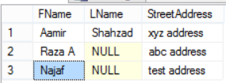
How to add Check Constraint to Column with Existing Data in SQL Server

6.5 : Default Constraint:

What is Default Constraint in SQL Server?

What is Default Constraint in SQL Server :
Default Constraint inserts the default value into a column when you do not provide value for column.

Let's understand by using below examples.

Scenario:
Let's say you need to create a dbo.Customer table with First Name, Last Name, Country Name and Region. If the user does not provide the values for Country Name and Region Columns you always want to insert Country Name='USA' and for Region='North America'.

The below script can be used to create Default Constraint for Country Name and Region columns.

USE YourDatabaseName
GO
CREATE TABLE dbo.Customer (
FirstName VARCHAR(50)
,LastName VARCHAR(50)
,CountryName VARCHAR(50) DEFAULT 'USA'
,Region VARCHAR(50) DEFAULT 'North America'
)

Now insert couple of records by provide values for all the columns by using below insert statements.

--Insert some sample data by provided CountryName and Region
Insert into dbo.Customer (FirstName,LastName,CountryName,Region)
Values('Aamir','Shahzad','Pakistan','Asia')
go
Insert into dbo.Customer (FirstName,LastName,CountryName,Region)
Values('Sukhjeet','Singh','India','Asia')
go

Now only insert the values in First Name and Last Name columns. As we have created the Default Constraint on Country Name and Region, it should automatically insert CountryName='USA' and Region='North America'.

Insert into dbo.Customer(FirstName,LastName)
Values ('John','Smith')
go

Insert into dbo.Customer(FirstName,LastName)
Values ('Christy','Ladson')
Let's check the data in dbo.Customer table to make sure our Default Constraints are working as expected.

Select * from dbo.Customer
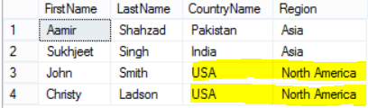
How to create Default Constraint in SQL Server
When we created Default Constraints, we did not provide any name, let's check what names SQL Server has given them by using sys.objects

--Get the Constraint Names in SQL Server
Select * from sys.objects
where type_desc='DEFAULT_CONSTRAINT'

How to check Default Constraints information in SQL Server

If your company is using some naming standards and you would like to create the default constraint with those standards, you can specify the name while creating them. I am using to use DF_SchemaName_TableName_ColumnName for my constraint name as shown below.

use YourDatabaseName
Go
Create Table dbo.tblCustomer
(
FirstName VARCHAR(50),
LastName VARCHAR(50),
CountryName VARCHAR(50) Constraint DF_dbo_tblCustomer_CountryName Default 'USA' ,
Region VARCHAR(50) Constraint DF_dbo_tblCustomer_Region default 'North America')

Let's run the query on sys.objects one more time to get Default Constraint name with Table name.

--Get the Constraint Names in SQL Server
Select name,object_name(Parent_object_id)
as TableName from sys.objects
where type_desc='DEFAULT_CONSTRAINT'

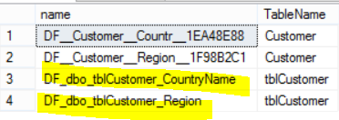
How to create Default Constraint with Name in SQL Server

How to add Default Constraint to existing Columns in SQL Server Table?

Scenario:
You are working as SQL Server developer. You already has dbo.Customer table with First Name, Last Name, Country Name and Region Columns. The table contains some records as well. You need to provide Default Constraint scripts for Country Name='USA' and Region='North America'.

Solution:
Let's create dbo.Customer table with Default Constraints and insert some sample data first.

use YourDatabaseName
Go
Create Table dbo.Customer
(
FirstName VARCHAR(50),
LastName VARCHAR(50),
CountryName VARCHAR(50),
Region VARCHAR(50))

Go
--Insert some sample data
Insert into dbo.Customer (FirstName,LastName,CountryName,Region)
Values('Aamir','Shahzad','Pakistan','Asia')
go
Insert into dbo.Customer (FirstName,LastName,CountryName,Region)
Values('Sukhjeet','Singh','India','Asia')
go
Insert into dbo.Customer(FirstName,LastName)
Values ('John','Smith')
go
Insert into dbo.Customer(FirstName,LastName)
Values ('Christy','Ladson')
go

Let's check the data in dbo.Customer table.
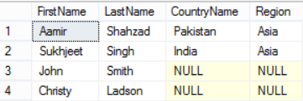
How to add Default Constraint to existing SQL Server Table

Now let's alter the table and add Default Constraints by using below statements.

Alter table dbo.Customer
Add Constraint DF_dbo_Customer_CountryName Default 'USA' for CountryName
,Constraint DF_dbo_Customer_Region default 'North America' for Region
Let's insert couple of records without providing values for Country Name and Region Columns and see if Default Constraint working as expected.

Insert into dbo.Customer(FirstName,LastName)
Values ('Chris','Cook')
go
Insert into dbo.Customer(FirstName,LastName)
Values ('Lisa','L')
Let's check the data in dbo.Customer table again.
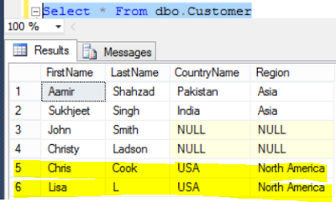
How to add Default Constraint to Existing Columns in SQL Server Table

As can be seen in above picture, the Default Constraint worked as expected.

How to List all Default Constraints with Columns in SQL Server Database?

Scenario:
You are working as SQL Server developer, you need to write script that should return all the Default Constraints with Column Names, Table Names and Schema name from a SQL Server Database.

Solution:
We can use system objects such as views and tables to get all the Default Constraints, Column Name, Table Names and Schema name from SQL Server database.

In below query we are using three system views to get required information.

SELECT
DB_Name() AS DBName,
Schema_name(t.Schema_id)AS SchemaName,
t.name AS TableName,
c.name AS ColumnName,
d.name AS DefaultConstraintName,
d.definition AS DefaultDefinition
FROM sys.default_constraints d
INNER JOIN sys.columns c ON
d.parent_object_id = c.object_id
AND d.parent_column_id = c.column_id
INNER JOIN sys.tables t ON
t.object_id = c.object_id
I executed above script on my database and it returned below results.
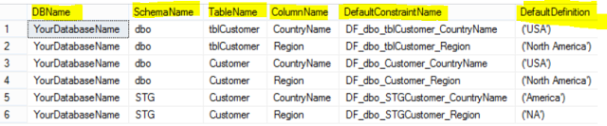
How to get Default Constraint Names with Columns from SQL Server Database

How to rename all Default Constraints according to Naming Standards or naming Convention in SQL Server?

Scenario:
You are working as SQL Server developer, You need to prepare the scripts those can be used to rename Default Constraints as per your company's standards. Your company want to name the default constraints e.g 'DF_SchemaName_TableName_ColumnName'

Solution:
We can use sp_rename Stored Procedure to rename Default Constraints. To rename single Default Constraint we can use script like below

Exec sp_rename 'Current_Default_Constraint_Name','New Default Constraint Name'

as we need to run this script for all the default constraints, we can use below query to generate rename Default Constraints.

SELECT 'exec sp_rename '''
+Schema_name(d.Schema_id)+'.'
+ '' + d.Name + ''''
+ ',''DF_' +Schema_Name(d.schema_id)
+'_'+t.name
+'_'+c.name+'''' as RenameDefaultConstraintQuery
FROM sys.default_constraints d
INNER JOIN sys.columns c ON
d.parent_object_id = c.object_id
AND d.parent_column_id = c.column_id
INNER JOIN sys.tables t ON
t.object_id = c.object_id

I execute above query on one of the database and I got below results. If you want to exclude some tables you can always filter them in where clause.

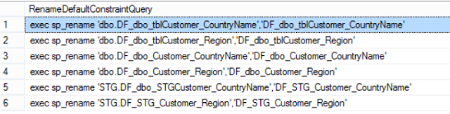
How to rename all Default Constraints in SQL Server Database according to Naming Convention

How to drop all Default Constraints in SQL Server Database ?

Scenario:
You are working as SQL Server Developer, you need to generate scripts to drop all the Default Constraints in SQL Server Database.

Solution:
To drop Default Constraint, we use below syntax

Alter Table [SchemaName].[TableName]
Drop Constraint [Constraint Name]

Below query can be used to generate scripts to generate all Default Constraints in SQL Server Database.

USE YourDatabaseName
go
SELECT
DB_Name() AS DBName,
Schema_name(t.Schema_id)AS SchemaName,
t.name AS TableName,
c.name AS ColumnName,
d.name AS DefaultConstraintName,
d.definition AS DefaultDefinition,
'Alter table ['+Schema_name(t.Schema_id)+'].['
+t.name+'] Drop Constraint ['+d.name+']' as DropDefaultConstraintQuery
FROM sys.default_constraints d
INNER JOIN sys.columns c ON
d.parent_object_id = c.object_id
AND d.parent_column_id = c.column_id
INNER JOIN sys.tables t ON
t.object_id = c.object_id
If you want to exclude some tables or schema, you can further filter the records by using where clause in query.
I executed above query and it generated drop scripts for all Default Constraints.
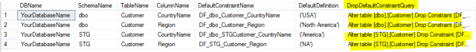
How to generate scripts to Drop all Default Constraints in SQL Server Database

Take the results from DropDefaultConstraint column and execute to drop Default Constraints.

How to generate Scripts to Add Default Constraints to Column in Multiple Tables in SQL Server Database?

Scenario:
You are working as SQL Server Developer, your company has the database with tons of tables. Each Table has some audit columns such as CreatedOn, CreatedBy. No default Constraints were ever created on them. You want to create the Default Constraint on CreatedOn Column for all the table with value getdate(), also you want to create Default Constraint for CreatedBy=SUSER_SNAME().
You may have another column of type string and you would like to generate scripts for that too.

Solution:
The below script can be used to generate Default Constraint for given column in entire database for all the tables. The name for Default Constraint will be DF_SchemaName_TableName_ColumnName.

Let's generate Default Constraint scripts for CreatedOn column with value Getdate() by using below script.

Declare @ColumnName VARCHAR(128)
Declare @DefaultValue VARCHAR(100)
SET @ColumnName='CreatedON'
SET @DefaultValue='Getdate()'

Select Schema_Name(Schema_id) as SchemaName,
t.Name as TableName,
C.Name as ColumnName,
'Alter Table ['+Schema_Name(Schema_id)
+'].['+t.Name+']'
+' Add Constraint DF_'+Schema_Name(schema_id)
+'_'+t.name
+'_'+c.name+''
+' default '+@DefaultValue+' for '
+ @ColumnName as CreateDefaultConstraint
from sys.tables t
inner join sys.columns c
on t.object_id=c.object_id
and t.is_ms_shipped=0
and c.name=@ColumnName

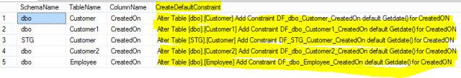
Generate Scripts to Add Default Constraint to Column in Database in SQL Server
You only have to make change to @ColumnName and @DefaultValue variables as per your requirements. Let's use the same script to add Default Constraint to CreatedBy Column with value=SUSER_SNAME().

Declare @ColumnName VARCHAR(128)
Declare @DefaultValue VARCHAR(100)
SET @ColumnName='CreatedBy'
SET @DefaultValue='SUSER_SNAME()'

Select Schema_Name(Schema_id) as SchemaName,
t.Name as TableName,
C.Name as ColumnName,
'Alter Table ['+Schema_Name(Schema_id)
+'].['+t.Name+']'
+' Add Constraint DF_'+Schema_Name(schema_id)
+'_'+t.name
+'_'+c.name+''
+' default '+@DefaultValue+' for '
+ @ColumnName as CreateDefaultConstraint
from sys.tables t
inner join sys.columns c
on t.object_id=c.object_id
and t.is_ms_shipped=0
and c.name=@ColumnName
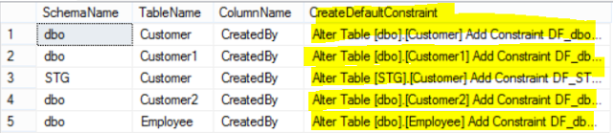
How to generate script to add Default Constraint on column in SQL Server Database

Now let's consider that you want to set default value to some string value as we want to create Default Constraint for Region column='USA' , When set the value of @DefaultValue variable, add single quotes as shown below.

Declare @ColumnName VARCHAR(128)
Declare @DefaultValue VARCHAR(100)
SET @ColumnName='Region'
SET @DefaultValue='''USA'''

Select Schema_Name(Schema_id) as SchemaName,
t.Name as TableName,
C.Name as ColumnName,
'Alter Table ['+Schema_Name(Schema_id)
+'].['+t.Name+']'
+' Add Constraint DF_'+Schema_Name(schema_id)
+'_'+t.name
+'_'+c.name+''
+' default '+@DefaultValue+' for '
+ @ColumnName as CreateDefaultConstraint
from sys.tables t
inner join sys.columns c
on t.object_id=c.object_id
and t.is_ms_shipped=0
and c.name=@ColumnName

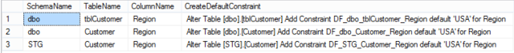
How to generate scripts to add Default Constraint on Column in multiple Tables in SQL Server Database

6.6 : Unique Constraint:

What is Unique Constraint in SQL Server?
Unique Constraint in SQL Server is created on a column or columns to restrict the column/s to accept only unique values.
Only single Null value is allowed in a column on which Unique Constraint is created.

Scenario:
Let's say that you are working as SQL Server developer for insurance company, you are asked to create dbo.Customer table that should have a column SSN and it should always accept Unique values.

Solution:
For the above scenario, we can use Unique Constraint on SSN Column. Below script can be used to create unique constraint on a column.

USE [YourDatabaseName]
GO
CREATE TABLE [dbo].[Customer](
[FirstName] [varchar](50) NULL,
[LastName] [varchar](50) NULL,
[SSN] VARCHAR(11),
Unique(SSN)
)

--Insert sample records in table
Insert into dbo.Customer(FirstName,LastName,SSN)
Values('Raza','M',Null)
,('Aamir','Shahzad','000-00-0001')
,('Aamir','Shahzad','000-00-0002')

Check the data in dbo.Customer table by using Select query
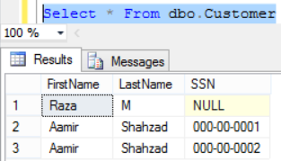
How to add Unique Constraint on a Column in SQL Server

Let's use the system views to check if Unique Constraint is added and what name SQL Server has given to it.

SELECT *
FROM INFORMATION_SCHEMA.TABLE_CONSTRAINTS
WHERE CONSTRAINT_TYPE = 'UNIQUE'

How to add Unique Constraint in SQL Server

As we can see that the SQL Server has given "UQ__Customer__CA1E8E3C7E8AFCB1" name to Unique Constraint. If we want to implement some naming convention then we should had provided name by ourselves.

If we try to insert the value that already exists in Unique Constraint column, we will get below error.

Insert into dbo.Customer(FirstName,LastName,SSN)
Values('Raza','M',Null)

Msg 2627, Level 14, State 1, Line 11
Violation of UNIQUE KEY constraint 'UQ__Customer__CA1E8E3C7E8AFCB1'. Cannot insert duplicate key in object 'dbo.Customer'. The duplicate key value is ().
The statement has been terminated.
If you would like to create the Unique Constraint with some naming convention, we can use below syntax.
USE [YourDatabaseName]
GO
CREATE TABLE [dbo].[Customer](
[FirstName] [varchar](50) NULL,
[LastName] [varchar](50) NULL,
[SSN] VARCHAR(11),
Constraint UQ_Dbo_Customer_SSN Unique(SSN)
)

How to create Unique Constraint on Multiple Columns in SQL Server?

Scenario:
You are working as SQL Server Developer, you are asked to provide create scripts for dbo.Customer table with Unique Constraint on First Name and Last Name columns.

Solution:
As we know that the Unique Constraint in SQL Server is created on a column or columns to restrict the column/s to accept only unique values.
The below script can be used to create Unique Constraint on multiple columns in our case FirstName and LastName.
USE [YourDatabaseName]
GO
CREATE TABLE [dbo].[Customer](
[FirstName] [varchar](50) NULL,
[LastName] [varchar](50) NULL,
[SSN] VARCHAR(11),
Constraint UQ_Dbo_Customer_FName_LName Unique(FirstName,LastName)
)

--Let's insert some sample data to test Unique Constraint
Insert into dbo.Customer(FirstName,LastName,SSN)
Values(Null,Null,'000-00-0000'),
('Aamir',Null,'000-00-0000'),
(Null,'Aamir','000-00-0000')
,('Aamir','Shahzad','000-00-0001')
,('Raza','M','000-00-0002')

If you have noticed the insert statement, In First Record I have put both Null values for FirstName and Last Name. In 2nd record I used the value 'Aamir' for first name and Null for Last Name. In 3rd record vice versa of 2nd record. From here what we understand that the unique constraint is working on both column values. As long as the combined value from both columns is unique, it is going to let us insert even one of them is null.
If I would like to insert another record in which I have Null for last name, it will let me without any problem, as it is unique from existing values.
Insert into dbo.Customer(FirstName,LastName,SSN)
Values('Raza',Null,'000-00-0000')
Let's check the records in table by using select query.
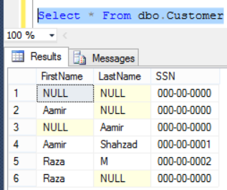
How to add Unique Constraint on Multiple Columns in SQL Server Table
If we try to insert a duplicate records, we will get below error.

Insert into dbo.Customer(FirstName,LastName,SSN)
Values('Raza',Null,'000-00-0000')
Msg 2627, Level 14, State 1, Line 30
Violation of UNIQUE KEY constraint 'UQ_Dbo_Customer_FName_LName'. Cannot insert duplicate key in object 'dbo.Customer'. The duplicate key value is (Raza, ).
The statement has been terminated.

How to create Unique Constraint on Column for already existing Table?

Scenario:
You are working as SQL Server developer, you need to create Unique Constraint on already existing table called dbo.Customer on column SSN.

Solution:
Let's create the dbo.Customer table first by using below script.

USE [YourDatabaseName]
GO
CREATE TABLE [dbo].[Customer](
[FirstName] [varchar](50) NULL,
[LastName] [varchar](50) NULL,
[SSN] VARCHAR(11)
)
Create Unique Constraint on SSN Column by using below script.

Alter Table dbo.Customer
Add Constraint UQ_dbo_Customer_SSN Unique(SSN)

If you need to create Unique Constraint on multiple columns, you can use below syntax. I am creating Unique Constraint for FirstName and LastName.

Alter Table dbo.Customer
Add Constraint UQ_dbo_Customer_FName_LName Unique(FirstName,LastName)

Use below query to check if Unique Constraints are created successfully.
SELECT *
FROM INFORMATION_SCHEMA.TABLE_CONSTRAINTS
WHERE CONSTRAINT_TYPE = 'UNIQUE'

How to create Unique Constraint on Column for existing SQL Server Table

How to get list of columns with Unique Constraints in SQL Server Database?

Scenario:
You are working as SQL Server developer, you are asked to provide a query that should return all the Unique Constraint with Columns, Table and Schema Name.

Solution:
We can use system objects to get list of unique constraints with columns, tables and schema name. Below query will return you all the unique constraints with columns from SQL Server database.

;WITH CTE_UQ
AS (
SELECT t.Table_Schema AS TableSchema
,t.table_name AS TableName
,c.column_name AS ColumnName
,t.constraint_name AS UniqueConstraintName
,t.constraint_type AS ConstraintType
FROM information_schema.table_constraints t
LEFT JOIN information_schema.key_column_usage c
ON t.constraint_catalog = c.constraint_catalog
AND t.constraint_schema = c.constraint_schema
AND t.constraint_name = c.constraint_name
WHERE t.constraint_type = 'UNIQUE'
)
SELECT TableSchema
,TableName
,UniqueConstraintName
,ConstraintType
,stuff((
SELECT ',' + ColumnName
FROM CTE_UQ i
WHERE i.TableSchema = o.TableSchema
AND i.TableName = o.TableName
AND i.UniqueConstraintName = o.UniqueConstraintName
FOR XML path('')
), 1, 1, '') UniqueColumnList
FROM CTE_UQ o
GROUP BY TableSchema
,TableName
,UniqueConstraintName
,ConstraintType

I executed above query on database and got below results.
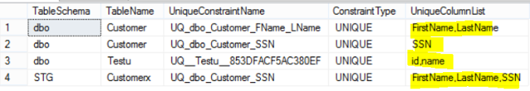
How to get Column List with Unique Constraints in SQL Server Database

How to generate drop Unique Constraint scripts in SQL Server Database?

Scenario:
You are working as SQL Server developer, you need to generate scripts to drop all Unique Constraints in SQL Server Database.

Solution:
The below syntax can be used to drop Unique Constraint on table.

Alter table [SchemaName].[TableName]
Drop Constraint [ConstraintName]

The below query can be used to generate drop Unique Constraints in SQL Server database.

SELECT
Table_Schema,
Table_Name,
Constraint_Name,
'Alter table ['
+Table_Schema+'].['
+Table_Name+']'
+' Drop Constraint ['+Constraint_Name+']'
as DropUniqueConstraintQuery
FROM INFORMATION_SCHEMA.TABLE_CONSTRAINTS
WHERE CONSTRAINT_TYPE = 'UNIQUE'

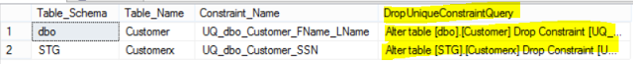
Generate scripts to drop Unique Constraint in SQL Server Database

Chapter 7 : Insert Row/s in SQL Server Table

What are the different ways to insert data into SQL Server Table?

Scenario:
As SQL Server Developer, you have to come with different ways to insert data into SQL Server Table.
Sometime you have to simply insert static records, sometime you have to insert data from another table to existing table. Let's check out different techniques to insert data into SQL Server table.

Solution:
Let's create the dbo.Customer Table first by using below definition.

USE yourDatabaseName
Go
Create Table dbo.Customer(
Id int identity(1,1),
FName VARCHAR(50),
LName VARCHAR(50),
Age int,
DOB Date,
Salary Numeric(6,2))

1) Use Multiple Inserts to insert data into table.

Insert into dbo.Customer(FName,LName,Age,DOB,Salary)
Values('Aamir','Shahzad',36,'1980-01-01',5000.50)
GO
Insert into dbo.Customer(FName,LName,Age,DOB,Salary)
Values ('Raza','M',33,'1983-03-03',4900.34)
GO
Insert into dbo.Customer(FName,LName,Age,DOB,Salary)
Values ('John','Smith',26,'1990-04-05',5000.50)

2) Use single Insert with multiple Values
As in above example, we use multiple inserts.Each was inserting single record. In SQL Server we can use single Insert with multiple values as shown below.

Insert into dbo.Customer(FName,LName,Age,DOB,Salary)
Values('Aamir','Shahzad',36,'1980-01-01',5000.50),
('Raza','M',33,'1983-03-03',4900.34),
('John','Smith',26,'1990-04-05',5000.50)

3) Use Select with Insert to insert Records
We can use Insert with Select query to insert the result set returned by select query.

Insert into dbo.Customer(FName,LName,Age,DOB,Salary)
Select 'Aamir' as FName,'Shahzad' as LName,36 as Age,'1980-01-01' as DOB,5000.50 as Salary
union all
Select 'Raza','M',33,'1983-03-03',4900.34
Union all
Select 'John','Smith',26,'1990-04-05',5000.50

4) Use Insert without provide Column Names
As you have seen in above examples, I have used column list with Insert, you don't have to use that if you know the order of columns and values you are using are also in order. I always use the column list in insert and select to make sure I am inserting correct data to table in correct columns.

--Insert without provide Column Names
Insert into dbo.Customer
Select 'Aamir' as FName,'Shahzad' as LName,36 as Age,'1980-01-01' as DOB,5000.50 as Salary
union all
Select 'Raza','M',33,'1983-03-03',4900.34
Union all
Select 'John','Smith',26,'1990-04-05',5000.50
Also we can use the insert without Column Names with Values option
Insert into dbo.Customer
Values('Aamir','Shahzad',36,'1980-01-01',5000.50),
('Raza','M',33,'1983-03-03',4900.34),
('John','Smith',26,'1990-04-05',5000.50)

5) Insert data from Another Table to Destination table
As we have seen that the select query results can be inserted into table. In above examples we have used the static values with select, You can select the data from table,view and function etc. to insert into your table. Let's say if we want to insert data into dbo.Customer table from dbo.CustomerUS table. you can use below query.

--Insert into table from another table
Select into dbo.Customer(FName,LName,Age,DOB,Salary)
Select FName,LName,Age,DOB,Salary from dbo.CustomerUS

How to insert rows in SQL Server Table by Edit Table Rows GUI?

Scenario:
You are working as SQL Server developer, you need to insert couple of records into dbo.Customer table but you don't want to use TSQL scripts. How would you insert data into table without using TSQL?

Solution:
Let's create the dbo.Customer table first by using below script.

USE yourDatabaseName
Go
Create Table dbo.Customer(
Id int identity(1,1),
FName VARCHAR(50),
LName VARCHAR(50),
Age int,
DOB Date,
Salary Numeric(6,2))
Once the table is created. Go to Database and then Tables tab. Right click on the dbo.Customer table as shown and choose Edit Top X rows according to your setting.
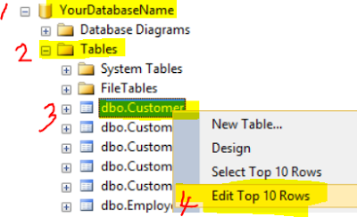
How to insert data to SQL Server Table by using Graphical user interface in SQL Server
Now start typing the values you want to insert. As Id is identity column, we don't have to insert any value.
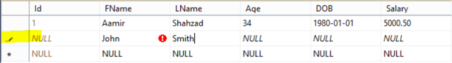
How to insert data into SQL Server Table by using Graphical user interface in SSMS

Once done with inserting the data, just close the windows and records will be saved to table.

How to insert Excel or CSV data into Table by using Graphical User Interface in SQL Server?

Scenario:
You are working as SQL Server developer, you got an excel file or CSV file that contains data for dbo.Customer table. How can you insert Excel or CSV data to table by using Graphical user Interface.

Solution:
Step 1:
Let's create dbo.Customer table first by using below script.

USE yourDatabaseName
Go
Create Table dbo.Customer(
Id int identity(1,1),
FName VARCHAR(50),
LName VARCHAR(50),
Age int,
DOB Date,
Salary Numeric(6,2))
Step 2:
Go to database , then tables and then right click on dbo.Customer and choose Edit Top X rows as per your settings.

How to insert Excel or CSV data to Table by using Graphical User Interface

Below windows will open that will let you insert the records into table dbo.Customer.

How to insert records into table from Excel by using Graphical interface in SSMS

Step 3:
Open the Excel or CSV file and copy the data as shown below. Don't copy the header as we don't want to insert header values into table.
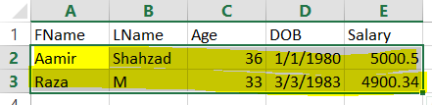
Insert Excel data into SQL Server Table by using Graphical User Interface

Step 4:
Noticed that the columns and copied data has the same order. Come to SSMS and then paste the data.
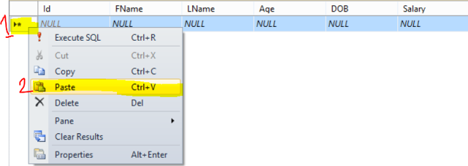
How to insert Excel or CSV data into SQL Server Table Manually by using SSMS

As Id is identity ( Auto generated) column and we are trying to insert values in that, the excel data start with FName. As Fname data can not be inserted into Id, it will be ignored and rest of the data will be shift as well. The Last Name values are inserted into FName as can be seen below.

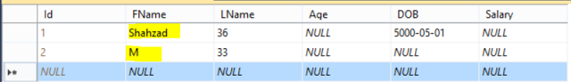
How to insert data from Excel or CSV to Table in SSMS

To avoid this, we should only select the columns in which we want to insert the data. Also select in the order in which we have the data from Excel or CSV.
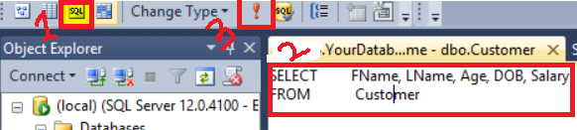

Once you run the query, you will see the selected columns only. Go ahead and past the data as Step 4.
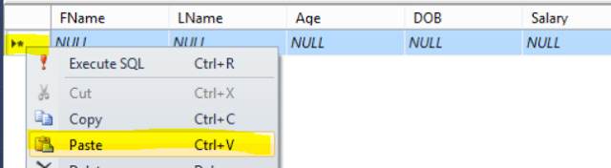
Insert data from Excel or CVS To SQL Server Table without using Import Wizard in SQL Server

Once you hit paste, data will be written to table as shown below.
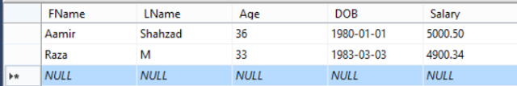
How to insert data from Excel or CSV to SQL Server Table by using Edit window in SSMS

If you have few records, you might be ok with speed. If you have millions of records, inserting records by using Edit window can take long time. you might want to use Import Wizard in cases where you have huge number of records to insert into SQL Server Table.

How to generate Insert Statements from Excel Data and Load into SQL Server Table?

Scenario:
You are working as SQL Server Developer, you received data in an Excel file for dbo.Customer tables. You need to load this data into dbo.Customer table. How would you generate Insert Statement for given data in excel so you can load into DEV, QA,UAT and Production.

Solution:
There are multiple ways to achieve this requirement. You can use Import/Export Wizard first to load the data into Development environment and then generate insert script from table in SSMS.
If you don't want to load the data into table , you can use Excel formula's to generate Insert statement from data.
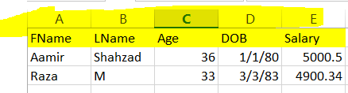
How to generate Insert Statements from Excel for SQL Server Table
First of all we need to know in which table we want to load the data. In our case it is dbo.Customer. Also the names of columns provided in Excel are exactly the same like our dbo.Customer table columns.
Go to any column and type this formula as shown below in first row. I typed in column G.
="insert into dbo.Customer ("&A1&","&B1&","&C1&","&D1&","&E1&") Values"
In Excel we start formula with = (equal to sign). For concatenation we use &. To add string we have to put double quotes around as we did for comma ",".
How to generate Insert Statements for SQL Server Table from Excel Data
Now first part of our Insert statement is ready. we have to generate the values part for our insert statement. Go to 2nd Row and use below formula.
="('"&A2&"','"&B2&"',"&C2&",'"&TEXT(D2,"dd/mm/yyyy")&"',"&E2&"),"
Drag it down to all the way till last record. All Insert values will be generate. Copy all the values from column G and paste into SSMS. There will be extra comma(,) at the end with last record. Remove that and run your insert statement to test if working as expected.
How to generate Insert Statements from Excel file for SQL Server table
Here are the generated Insert Statements, copied from G Column and pasted in SSMS.
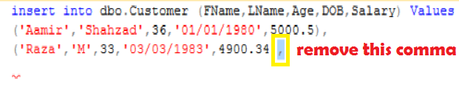

How To Use Import/Export Wizard In SQL Server ?
We have received SourceFile.xlsx file and we have to load that to SQL server Table. We can either create SSIS Package in BIDS or we can use Import/Export Wizard to load this file in SQL Server Table. In this post, we will use Import/Export Wizard.
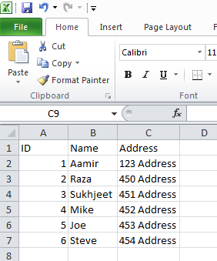
Fig 1: Excel Source File
Step 1:
Right Click on Database in which your table exists or you want to create it and load Excel data as shown below
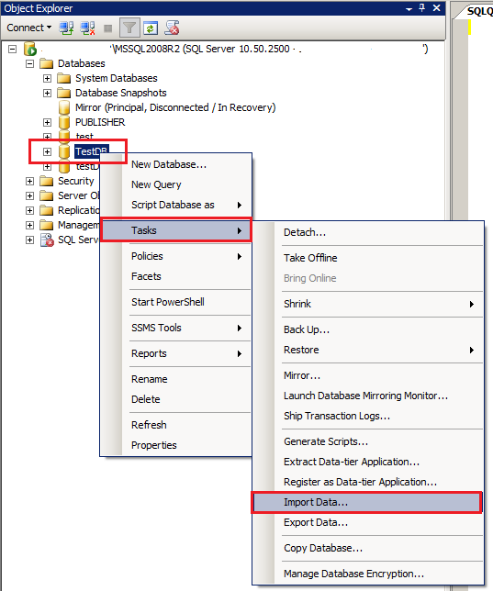
Fig 2: Import Data by using Import/Export Wizard in SQL Server Table.

Choose the Data Source:
Choose the data source which you want to use as source, As we are loading data from Excel, Choose Excel file as shown below
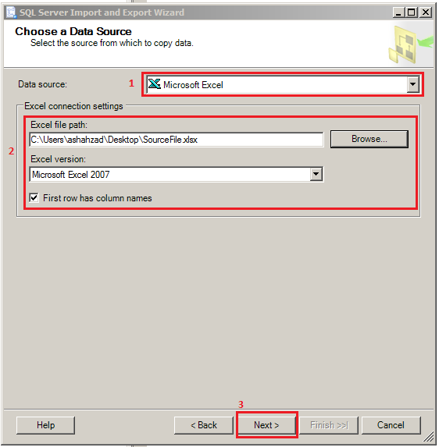
Fig 3: Choose Excel Data Source in Import Export Wizard

Choose a Destination:
Choose the destination where you want to load the data from source. In our case we are loading our data to SQL Server Table. Configure as shown below
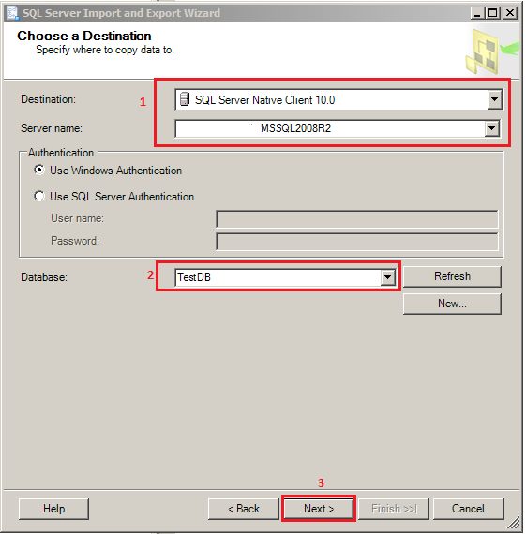
Fig 4: Choose SQL Server as Destination

Specify a Table Copy or Query:
You can directly choose the table from where do you want to load the data or you can write query if you are using Database as your source. As we are using Excel as source, we will choose Table(Sheet).
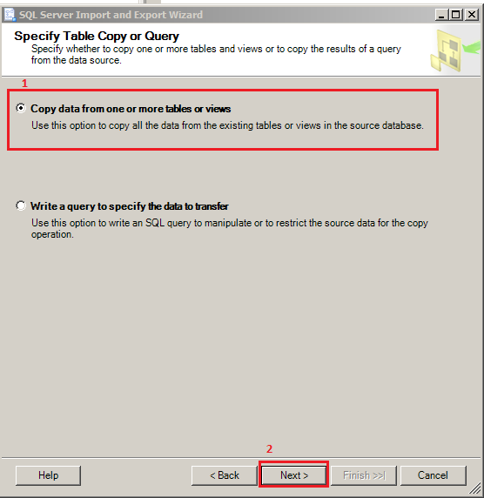
Fig 5: Choose Copy data from one or more tables or views

Select Source Tables and Views:
In this part of Wizard, we have to select the Tables or Views we want to use from source and load data to destination. As we are loading data from Excel, the Excel Tabs are shown. Choose the Sheet (Tab) which do you want to load. Under Destination, it will show you same name like Source. I have changed that to CustomerData. You can choose any name of your Table you want. You can choose multiple sheets or Tables from Source.
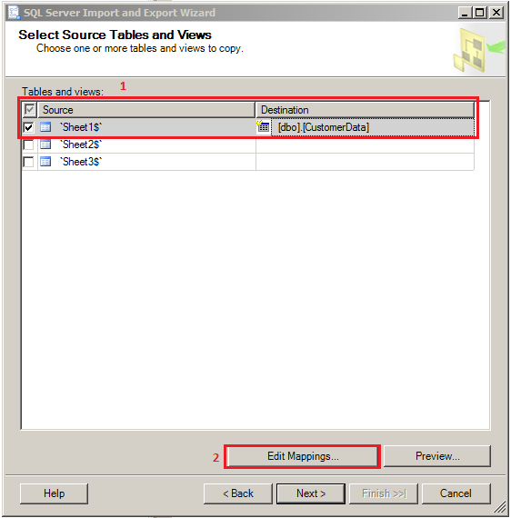
Fig 6: Select Source Tables/Views in Import Export Wizard

Column Mappings:
Click on Edit Mappings and then you can map the source columns to destination columns , Also if you need to choose correct Data type, you can change here.
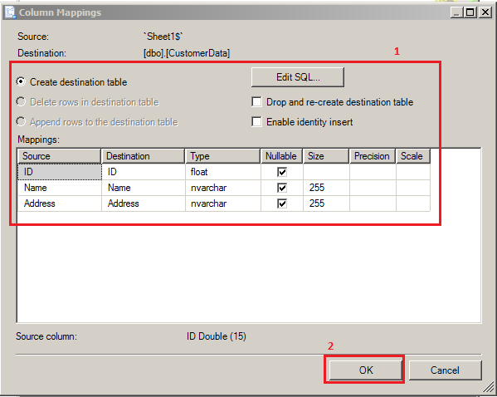
Fig 7: Column Mapping Import Export Wizard

Save and Run Package:
By Default, Run immediately is checked. I have changed the option to Save SSIS Package and provided the location where I want to save the SSIS Package. Also there is no sensitive information that I want to save in Package such as Password so I have selected Do not save sensitive data.
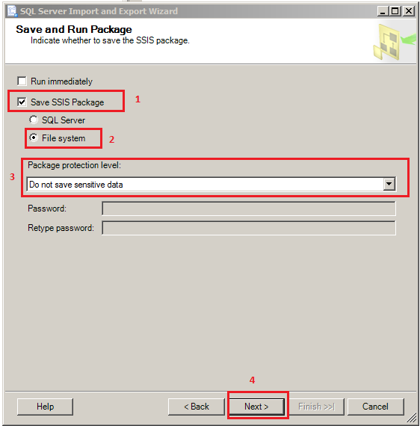
Fig 8: Save SSIS Package to File System

Save SSIS Package:
Provide the name of SSIS Package and File Location as shown below
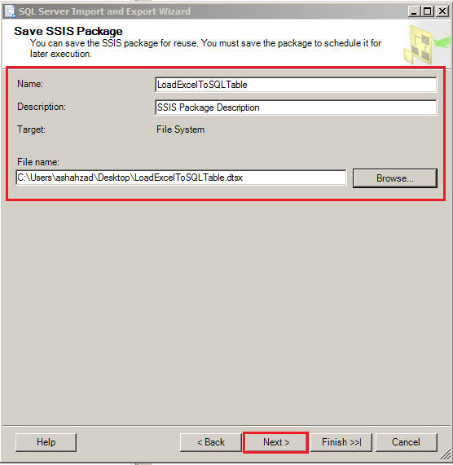
Fig 10: Provide Name for SSIS Package

Complete the Wizard:
Summary of all the steps will be shown to you in this step. You can see the source and destination etc.
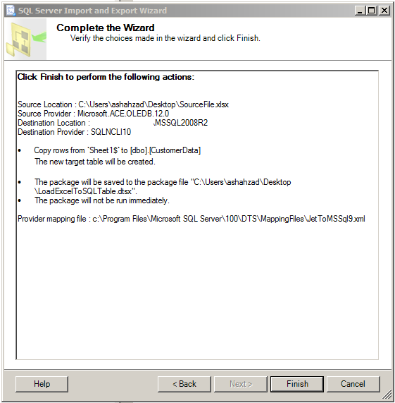
Fig 11: Summary of Steps

Once you hit Finish button, The Wizard will execute all below steps and finally save the SSIS Package.

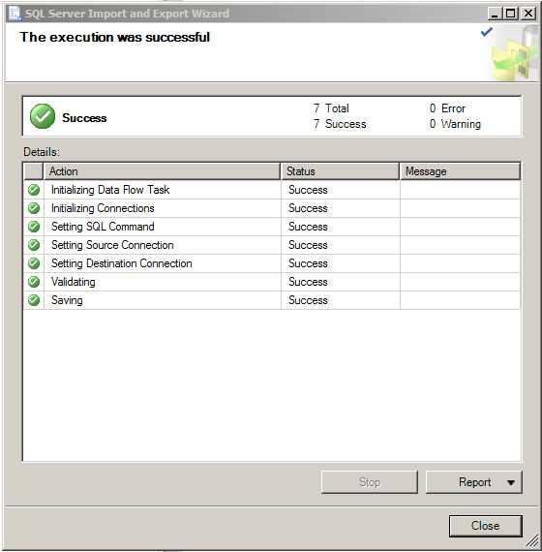
Fig 12: Save the SSIS Package to given location
The Package is created on desktop as per my given path.
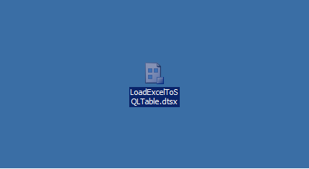
Fig 13: SSIS Package created by Import/Export Wizard

To execute this package, double click on it and below window will open. If you need to change the name of File or SQL Server, you can go to Connection Managers and change it. In my case, I do not want to make any changes. Press Execute Button

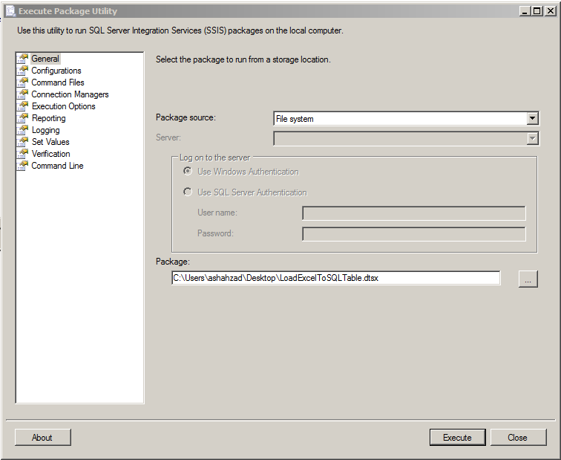
Fig: 14 Execute Package Utility

Once you hit Execute, Package Execute Progress window will appear and you will be able to see the progress of execution of your SSIS Package.
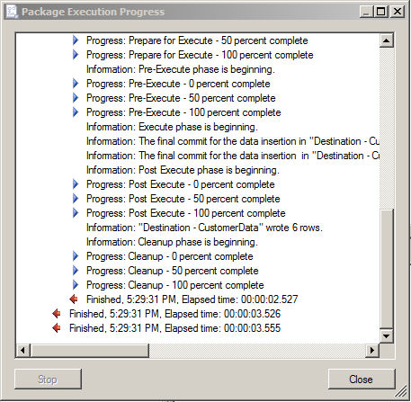
Fig 15: Package Execution Progress.

Import/Export Wizard is a way to quickly load data between different sources and destinations. You can create your SSIS Package quickly by using Import/Export Wizard and then add to SSIS Project and make changes if required.

If we need to export data from SQL Server then we need to Right Click on Database-->Tasks-->Export Data and Import/Export Wizard will start.

How to backup or create new table from Existing SQL Server Table in SQL Server ?

Scenario:
You are working as SQL Server developer, you need to provide some update or delete scripts to update or delete data from a table.You want to take the backup of those records or if the table is small you might want to backup entire table before you run update or delete statements.
How would you backup entire table or only the records on which you need to run update or delete statements?

Solution:
SQL Server does not provide Table level backup. When we say that we want to take the backup of the table, we are talking about making a copy of existing table with records.

Let's say if we have dbo.Customer Table with few records and we want to create backup table dbo.Customber_Bkp_TodayDate, we can use below script

First create dbo.Customer table with sample records

USE yourDatabaseName
Go
Create Table dbo.Customer(
Id int identity(1,1),
FName VARCHAR(50),
LName VARCHAR(50),
Age int,
DOB Date,
Salary Numeric(6,2))

--Use the Insert Into with Values single Statement
Insert into dbo.Customer
Values('Aamir','Shahzad',36,'1980-01-01',5000.50),
('Raza','M',33,'1983-03-03',4900.34),
('John','Smith',26,'1990-04-05',5000.50)
Now let's create dbo.Customber_Bkp_TodayDate backup table with all the records which are present in dbo.Customer.

Select * into dbo.Customber_Bkp_20160507 from dbo.Customer

To create new table with records, you have to use Into NewTable from OldTable as shown above.

If we are only interested to copy records where FName='Aamir' our query will be like below.

Select * into dbo.Customber_Bkp_20160507_OnlyAamir from dbo.Customer where FName='Aamir'

Run above scripts and check the tables if created with required records.
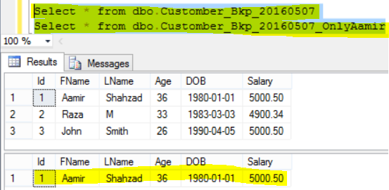
How to backup records into new table from existing SQL Server Table in SQL Server

Scripts used in the video demo:
--Take the backup or create table for all records
Select * into [YourDBName].dbo.Customer_20160510 from [dbo].[Customer]

--Create table for selected records
Select * into [YourDBName].dbo.Customer_20160510_TwoRecords from [dbo].[Customer]
where id<=2

--Check if table is created successfully
Select * From [YourDBName].dbo.Customer_20160510_TwoRecords

Select * from [dbo].[Customer]

--Update Records in current table
update [dbo].[Customer]
set LName=LName+' Test'
where id<=2

--Update records in current table from backup table
update d
set d.LName=s.LName
from [YourDBName].dbo.Customer_20160510_TwoRecords s
inner join [dbo].[Customer] d
on s.id=d.id

How to generate Insert Statements from Text Files for SQL Server Table in SQL Server?

Scenario:
You are working as SQL Server developer, you get text files such as comma separate values, Tab delimited or pipe delimited files. It is one time task and you need to generate insert statements from these files so you can load the data into dbo.Customer table in DEV,QA,UAT and Production environments by using those scripts.

Solution:
I wrote a post , how to generate Insert statements from Excel file. Click here. It means if we can open the text files with excel then we can use excel formulas to build insert statements.
If we have comma separate values file, you can directly open with excel and then use the steps shown in this post.
If you have tab delimited or pipe delimited file, first of all we need to open with excel and then use the formulas.
Step 1:
Let's say that I have Tab delimited Customer.txt file as shown below and want to open in excel.
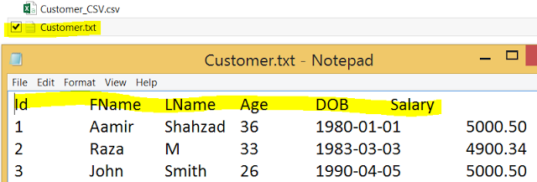
How to generate Insert Statements from Tab delimited file for SQL Server Table
Step 2:
Open Excel and then go to File and hit Open, Browse to customer.txt file
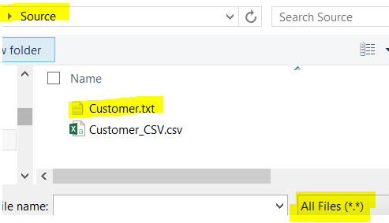
Generate Insert Statements from Text files for SQL Server Table
Test Import Wizard will open, Choose Delimited and Click My Data has Headers if it does and then Click Next
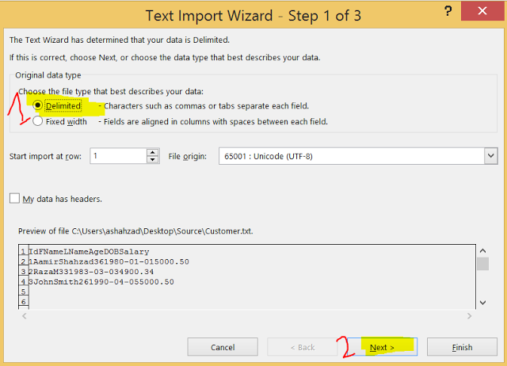
How to open Tab Delimited File in Excel to generate Insert statements for SQL Server Table
Choose the Delimiters, in our case it is Tab and hit Next.
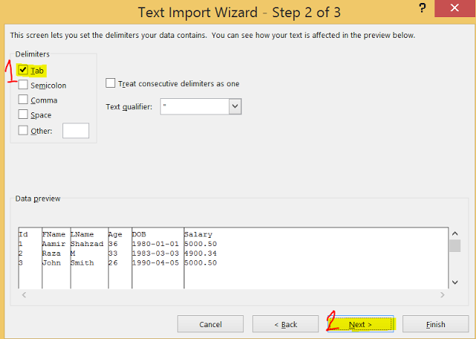
How to Convert Tab Delimited File to Excel file and Generate Insert Statements for SQL Server Table

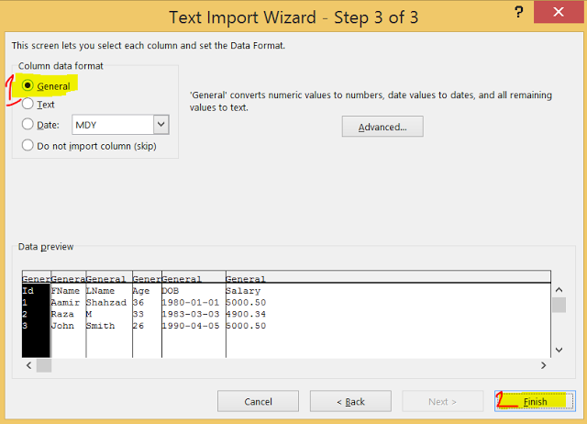
How to load Tab delimited file into Excel and Create Insert Statements for SQL Server Table
Once you will hit Finish, below excel sheet will be populated with flat file data.
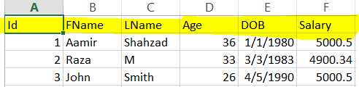
How to generate Insert Statements from Excel File for SQL Server Table

Now the data is in Excel file. we can use the excel formulas to generate insert statements as shown in this post.

Chapter 8: Select Statement for Single Table

How to quickly write Select Query in SQL Server?
You just started working with SQL Server and interested to learn how to select data from a table. Here are some tips for you
1) Select all the columns from a table/ View by using *
You can always use Select * from SchemaName.TableName to display data for all the columns from a table or view. When you use * in Select query, it return you all the columns from table or view.
Let's say that if I want to select all the columns from dbo.TotalSale table , I can use below query
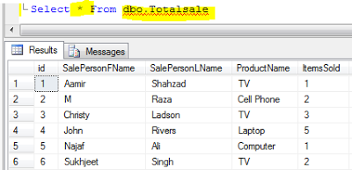
How to select data for all the columns from SQL Server Table by using *

2) Drag the Columns Tab to new query
If you would like to get all the column names for your select query, you will open new query window. Then type Select and Drag the Columns Tab under the table to query window. All the columns will be displayed. If you would like to remove few, you can remove.

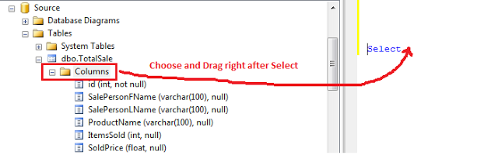
Select all the Columns quickly for a table for Select Query in SQL Server

After dragging the Columns Tab, you will see the column names are added to select.
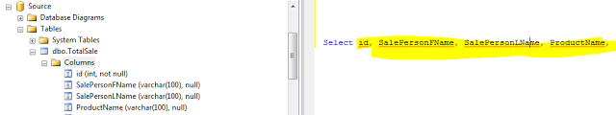
How to generate Select Query with required Columns quickly in SSMS - SQL Server Tutorial

3) Select Top X Row
Third and easy way to write your select query is, Right click on Table name and then choose Select Top X Rows ( X can be different as per your SSMS option settings). Once you choose it will generate the select query with all the column. You can remove the top x part from select and modify as required.
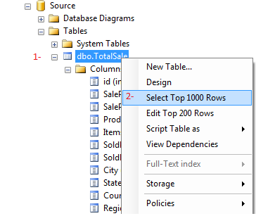
How to use Select Top X rows to generate select query with all the column names in SQL Server

How to use Sorting ( Order By) in Select Statement in SQL Server?

Scenario:
You are working as SQL Server developer, you need to output sorted data. Which Key words you would like to use in T-SQL To output sorted data?

Solution:
The Order by Keyword can be used to sort the result set. We can sort the results by single or multiple columns.
Let's create dbo.Customer table with couple of test records and then use Order by keyword to sort them.
Create table dbo.Customer(
id int, FName VARCHAR(100))
insert into dbo.Customer values(
1,'Aamir'),(2,'Raza')
1) When we only use Order by ColumnName
Let's say if you would like to sort the data by using Id column and in ascending order, you can use below query.
Select * From dbo.Customer
order by Id

Select * From dbo.Customer
order by Id ASC

Notice that in first query, I did not write ASC to order the data in ascending order. In second query I did use ASC key word. If you don't use any keyword after column names, SQL Server will order the data in ascending order.
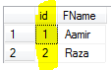
How to use Order by to sort result set in SQL Server
2) How to sorting data in desending order
To order results in desending order, you have to add DESC keyword after column names. Let's say if we would like to order the data by using FName in desending oder, we will use below query.
Select * From dbo.Customer
order by FName DESC
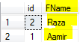
How to sort the output returned by select query by using Order by keyword
3) Using Column Numbers instead of Column Names in Order by
You can always use the Column numbers instead of column names in Order by. Let's say if we would like to order by FName,ID we can write our query by using names or column numbers as shown below.
Select * From dbo.Customer
order by FName DESC,id DESC

Select * from dbo.Customer
Order by 2 DESC,1 DESC
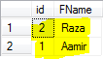
How to use Column numbers instead of using Column Names in Order By to sort results in SQL Server

How to use Where clause in Select Statement in SQL Server?
In this post we will get familiar with Where Clause in TSQL.
Where clause is used in DML statements such as select, update, delete to filter the records according to criteria we used in where clause.
Let's create the table by using this script to create TotalSale Table so we can use for different queries.
We know that to see all the data from a table we can use
Select * from dbo.TotalSale
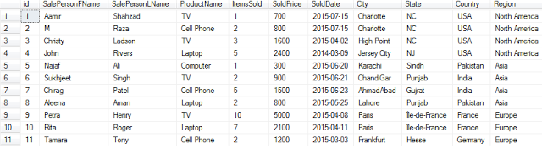
Select all records from a table by using Select * in SQL Server - SQL Server / TSQL Tutorial
With Where clause we can use different types of operations to filter the records such =, < >, >, >=, <, <=, IN, BETWEEN, LIKE, IS NULL or IS NOT NULL.
Let's try few of above operators with Select query for dbo.TotalSale table.
1) Get all the records from dbo.TotalSale table for Region equal to Asia.

Select * From dbo.TotalSale
where Region='Asia'

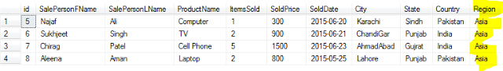
How to filter records in SQL Server Select query by using Where clause

2) Get all the records from dbo.TotalSale where ItemsSold is greater than 3.
Select * From dbo.TotalSale
where ItemsSold >3
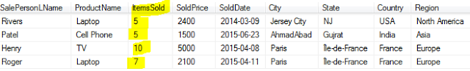
How to get only records where value is greater than some value in SQL Server Select Query
3) Get all the records where State Name starts with N letter
Select * From dbo.TotalSale
where State like 'N%'

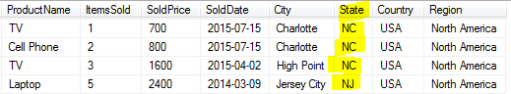
How to use like operator with Where clause to filter the records in SQL Server - SQL Server Tutorial

AND and OR keywords can be used to check multiple criteria.
4) If we want to get only the records where ItemsSold is greater than 2 and State name starts with N letter.
Select * From dbo.TotalSale
where itemssold>2
And state like 'N%'

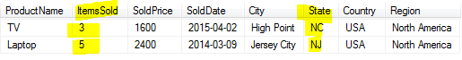
How to use AND keyword in Where clause in Select Query in SQL Server - SQL Server / TSQL Tutorial

When you use AND, all the conditions should be true to return record.
4) Get all the records where ItemsSold is greater than 2 or state name start with N.
Select * From dbo.TotalSale
where itemssold>2
OR state like 'N%'

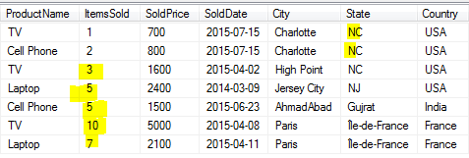
How to use OR keyword in Select query - SQL Server / TSQL Tutorial

As you can see that when we used OR keyword, either of the condition has to be true to return the results.

How to filter Rows with Null Values in Select Statement in SQL Server?

Scenario:
Let's say that you are working as SQL Server developer. You need to write two queries
1) Return all the records from dbo.Customer table where Address column has Null values
2) Return only the records from dbo.Customer table where Address column has the values other than Null.

Solution :
We can use Where clause in our Select statement to return null records or not null records. Let's create dbo.Customer table first and insert couple of records.
--Create dbo.Customer table
Create table dbo.Customer(
Id int,
Name VARCHAR(100),
Address VARCHAR(100))

--Insert records in dbo.Customer table
Insert into dbo.Customer
Values(1,'Aamir','XyZ Address')
,(2,'Raza',Null)

--Return all records from dbo.Custoemr Table
Select * From dbo.Customer
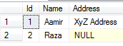
Return all records from a table by using Select statement in SQL Server Database - SQL Server / TSQL Tutorial
1) Now if we want to get all the records where Address column has Null values. our query will be like below.
Select * From dbo.Customer
where Address is Null
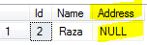
How to get records with Null values in Select query in SQL Server Database - SQL Server / TSQL Tutorial
2) If we want to get the records where Address column has values beside Null, we will be using below query.
Select * From dbo.Customer
where Address is not Null
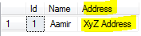
Get all the records from table where column has the value beside Null values in SQL Server Database

How to Replace Null values with "Unknown" in Select Statement in SQL Server?

Scenario:
You are working as SQL Server developer, you need to query dbo.Customer table and replace Null values in Name column to "Unknown Name". Which SQL functions will you use to replace Null value with "Unknown Name"?

Solution:
You can use ISNULL or COALESCE functions to replace Null with value we like. Let's create dbo.Customer table and insert sample records by using below statements.

--Create dbo.Customer table
Create table dbo.Customer(
Id int,
Name VARCHAR(10),
Address VARCHAR(100))

--Insert records in dbo.Customer table
Insert into dbo.Customer
Values(1,'Aamir','XyZ Address')
,(2,'Raza',Null)
,(3,null,'abc address')
Let's use ISNULL or COALESCE functions to replace Null with "Unknown Name".

Select Id,ISNULL(Name,'Unknown Name') AS NameByISNull,
COALESCE(Name,'Unknown Name') NamebyCoalesce,
Address From dbo.Customer
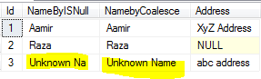
How to replace Null with Values in SQL Server - TSQL Tutorial
As you can see that we used ISNULL and replaced the Null with "Unknown Name" but it returned "Unknown Na", it did not returned complete "Unknown Name". The reason, the data type of an ISNULL expression is the data type of the first input ( Name column) that is varchar(10), that means it will always return us 10 characters.

If you have situations like this, you better use COALESCE.The data type of a COALESCE expression is the data type of the input argument with the highest data type precedence. In our case "Unknow Name" is 12 characters and it chose to use that instead of Name column data type which is varchar(10).

How to get Distinct Records from a table in SQL Server?

Scenario:
You are working as SQL Server developer, you need to get distinct (different) records from a table. Which statement will you use to get unique records from a table.

Solution:
Select distinct can be used to get different records from a table. The syntax for Select distinct is
Select distinct Column1,Column2, Column3.... from SchemaName.TableName.
Let's create sample dbo.Customer table and then insert test records by using below statements.
--Create dbo.Customer table
Create table dbo.Customer(
Id int,
Name VARCHAR(10),
Address VARCHAR(100))

--Insert records in dbo.Customer table
Insert into dbo.Customer
Values(1,'Aamir','XyZ Address')
,(2,'Raza',Null)
,(1,'Aamir','XyZ Address')
,(3,'John','XyZ Address')
As you can see that we have duplicate record 1,'Aamir','XyZ Address. Now if we would like to get distinct records from this table, we can use below query. If all columns are involved in your select, you can use * as shown below or type the names of columns.
Select distinct * From dbo.Customer
OR
Select distinct ID,Name,Address From dbo.Customer

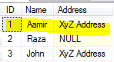
How to get distinct records from SQL Server Table - SQL Server / TSQL Tutorial

As we can see that our query returned distinct records. We had duplicate records in table but it only display distinct as we have used Distinct in our Select statement.
You can always run distinct on single or more columns if you like. If I want to get only distinct Names from dbo.Customer table, I can use below query.
Select distinct Name From dbo.Customer
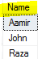
How to use Distinct in Select query in SQL Server to get distinct (difference) records

How to use Top with Ties in SQL Server ?
In last post, we learnt how to return top / bottom x rows from sql server table. In this post, we will learn Top with ties.
According to BOL
"WITH TIES
Used when you want to return two or more rows that tie for last place in the limited results set. Must be used with the ORDER BY clause. WITH TIES may cause more rows to be returned than the value specified in expression. For example, if expression is set to 5 but 2 additional rows match the values of the ORDER BY columns in row 5, the result set will contain 7 rows."
Let's create dbo.Customer table and find out the difference between Top and Top With Ties.
Create table dbo.Customer(
Id int,
Name VARCHAR(10),
Address VARCHAR(100))

--Insert records in dbo.Customer table
Insert into dbo.Customer
Values(1,'Aamir','XyZ Address')
,(2,'Raza',Null)
,(1,'Aamir','XyZ Address')
,(1,'John','XyZ Address')
,(5,'Lisa','XyZ Address')
Noticed that we have duplicate records as high lighted above. Let's run the below queries, first with only Top and second with "With Ties" and observe the output.
Select top (2) * From dbo.Customer
order by ID
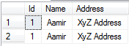
how to use Top x to get top records from table in SQL Server - TSQL Tutorial

Select top (2) WITH TIES * From dbo.Customer
order by ID
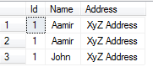
How to use Top with Ties in SQL Server to get Top x rows - SQL Server / TSQL Tutorial

The first query returned only 2 records but second query with "With Ties" returned three records as the value for Id for third record was also 1 that matched with second row ( id column value=1). If you use "With Ties" with Top, the query will also give you all ties with the last row based on the ordering column.

Understand Column Alias in Select Query in SQL Server?

Scenario:
You are working as SQL Server developer, you need to extract the data from dbo.Customer table and provide in an Excel Sheet. Your table has difference columns such as FName, LName but you want the output to come with FirstName and LastName. How would you do that?

Solution:
Alias is a great way to make your column names more readable. As in our question above, we want to display FName as FirstName and LName as LastName, Alias is the way to go. Let's create dbo.Customer table with columns and then use select query with alias to display Columns as we like.

Create table dbo.Customer
(Id int,
FName VARCHAR(50),
LName VARCHAR(50))
GO
insert into dbo.Customer
Values (
1,'Raza','M'),
(2,'Rita','John')
To create Alias you can use "AS" after column name or simply provide the alias right after column name. In below query, I have use "as" for FName but did not use for LName.

Select FName as FirstName,
LName LastName
From dbo.Customer
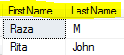
How to use Alias in SQL Server to Rename Column for output - SQL Server / TSQL Tutorial
If you would like to have space between your Alias Column Name such as "First Name". You can use [ ] around the alias or double quotes e.g "First Name".

Select FName as [First Name],
LName as "Last Name"
From dbo.Customer
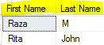
How to use Alias in SQL Server - SQL Server / TSQL Tutorial

How to use Case Statement for Conditional Formatting in Select Query?

Scenario:
You are working as SQL Server developer, you need to query dbo.Customer table that has CountryShortName column with country abbreviations. You want to generate another columns with Country Full name by using CountryShortName column values. How would you do that?

Solution:
You can use Case expressions to generate this new column depending upon the value of CountryShortName. In our example we are using only single columns but you can use multiple columns and check for multiple conditions.

Let's create dbo.Customer table with some sample data and then we will write our Select statement with Case expression.

Create table dbo.Customer
(Id int,
FName VARCHAR(50),
LName VARCHAR(50),
CountryShortName CHAR(2))
GO
insert into dbo.Customer
Values (
1,'Raza','M','PK'),
(2,'Rita','John','US'),
(3,'Sukhi','Singh',Null)

1) You can use Column Name for which you want to check the values right after Case as shown below. Then write all the conditions on that column and finally use End as NewColumnName

Select
FName,
LName,
CountryShortName,
Case CountryShortName
When 'Pk' Then 'Pakistan'
When 'US' Then 'United States of America'
When 'IN' Then 'India'
Else 'Not Provided'
End AS CountryFullName
From dbo.Customer

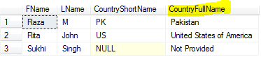
How to use Case Statement in SQL Server - SQL Server / TSQL Tutorial

If you don't like to use Else part, you can remove that but in case when you will have value and it does not match with your conditions, It will return Null. In my case,If value does not match with my conditions, I would like to show as "Not Provided" by using Else part.

2) Don't use Column Name right after Case keyword
You can also write the case statement as shown below. In below example, we did not write Column Name right after Case. In this case we have to type column after every When. This way of writing is used when you want to check conditions for multiple columns or range of values.

Select
FName,
LName,
CountryShortName,
Case
When CountryShortName='Pk' Then 'Pakistan'
When CountryShortName='US' Then 'United States of America'
When CountryShortName='IN' Then 'India'
Else 'Not Provided'
End AS CountryFullName
From dbo.Customer

How to use Case Statement for Conditional Formatting in SQL Query - SQL Server / TSQL Tutorial

How to get random rows from SQL Server Table?

Scenario:
You are working as SQL Server developer. You are asked to provide sample random data from dbo.Customer table. You might asked to provide random 100 rows or some percent of total data from table. What query you will use to provide required output?

Solution:
In previous post, we learnt how to get top n rows from table. We can either provide row count or percent of records we want to get from a table by using TOP in our select query.
We can use the same Top clause but as we are asked to provide the random records, we need to sort them randomly first. We can use newid() function in order by clause to sort them randomly.
Let's create dbo.Customer table with some sample data.
Create table dbo.Customer
(Id int,
FName VARCHAR(50),
LName VARCHAR(50),
CountryShortName CHAR(2))
GO
insert into dbo.Customer
Values (
1,'Raza','M','PK'),
(2,'Rita','John','US'),
(3,'Sukhi','Singh',Null),
(4,'James','Smith','CA'),
(5,'Robert','Ladson','US'),
(6,'Alice','John','US')
1) use NewID ( ) in Order by to get random records
Let's say if we are interested to get 3 random records from dbo.Customer table, we can use below query.
Select top 3 * From dbo.Customer
order by NEWID()

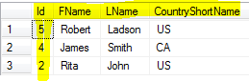
How to get Random records from SQL Server Table - SQL Server / TSQL Tutorial
you can also use percent if you like as shown below
Select top 30 percent * From dbo.Customer
order by NEWID()
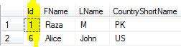
How to get random records from SQL Server table by using Top Percent with NewID() - SQL Server / TSQL Tutorial

2) By using TABLESAMPLE SYSTEM
As per Microsoft Books Online "TABLESAMPLE SYSTEM returns an approximate percentage of rows and generates a random value for each physical 8-KB page in the table. Based on the random value for a page and the percentage specified in the query, a page is either included in the sample or excluded. Each page that is included returns all rows in the sample result set".
From here you can understand that if you have small table with few pages , you might not want to use TableSample as it will include or exclude the entire page. With few records in table, you might want to use method 1 and for large tables you can use TableSample.
If I would run below query on my dbo.Customer table, Sometime I will get no records and when get the records, it will return all the records as they are placed on single page.
Select * From dbo.Customer tablesample (30 percent)
You can also use Rows you want with table sample as shown below. The rows returned can vary. you can limit them by using top n in select query.
Select * From dbo.Customer tablesample (2 rows)
When I executed above query on dbo.Customer table with total of 6 rows. It either returned me no rows or all six of them.
If you want to limit, you can use below query. Once again, I will suggest to use TableSample with big table where you have data on multiple data pages.
Select top 2 * From dbo.Customer tablesample (2 rows)

Filtering by OFFSET-FETCH Options in Select query ?

Scenario :
You are working as SQL Server developer with front end development team.The front end team needs to implement pagination. Confuse about Pagination? No problem. Think about viewing your bank statement or credit card statement. Where applications shows only 10 or 20 records per page and you have to click next to see next records.That is called pagination.
Now you understand pagination, the front end development needs SQL query from you that can be used to returned required results and they should be able to pass page number to return records.

Solution:
There are multiple ways to write Pagination queries, One of them is by using OFFSET FETCH clause. You have to sort the records if you want to use OFFSET FETCH.
Let's create dbo.TotalSale table and insert some sample records. I have only inserted 11 records.
CREATE TABLE [dbo].[TotalSale]
(
[id] [int] NOT NULL ,
[SalePersonFName] [varchar](100) NULL ,
[SalePersonLName] [varchar](100) NULL ,
[ProductName] [varchar](100) NULL ,
[ItemsSold] [int] NULL ,
[SoldPrice] [float] NULL ,
[SoldDate] [date] NULL ,
[City] [varchar](100) NULL ,
[State] [varchar](100) NULL ,
[Country] [varchar](100) NULL ,
[Region] [varchar](100) NULL
)

INSERT [dbo].[TotalSale]
( [id], [SalePersonFName], [SalePersonLName], [ProductName],
[ItemsSold], [SoldPrice], [SoldDate], [City], [State], [Country],
[Region] )
VALUES ( 1, N'Aamir', N'Shahzad', N'TV', 1, 700, CAST(N'2015-07-15' AS DATE),
N'Charlotte', N'NC', N'USA', N'North America' )
, ( 2, N'M', N'Raza', N'Cell Phone', 2, 800, CAST(N'2015-07-15' AS DATE),
N'Charlotte', N'NC', N'USA', N'North America' )
, ( 3, N'Christy', N'Ladson', N'TV', 3, 1600,
CAST(N'2015-04-02' AS DATE), N'High Point', N'NC', N'USA',
N'North America' )
, ( 4, N'John', N'Rivers', N'Laptop', 5, 2400,
CAST(N'2014-03-09' AS DATE), N'Jersey City', N'NJ', N'USA',
N'North America' )
, ( 5, N'Najaf', N'Ali', N'Computer', 1, 300,
CAST(N'2015-06-20' AS DATE), N'Karachi', N'Sindh', N'Pakistan',
N'Asia' )
, ( 6, N'Sukhjeet', N'Singh', N'TV', 2, 900, CAST(N'2015-06-21' AS DATE),
N'ChandiGar', N'Punjab', N'India', N'Asia' )
, ( 7, N'Chirag', N'Patel', N'Cell Phone', 5, 1500,
CAST(N'2015-06-23' AS DATE), N'AhmadAbad', N'Gujrat', N'India',
N'Asia' )
, ( 8, N'Aleena', N'Aman', N'Laptop', 2, 800,
CAST(N'2015-05-25' AS DATE), N'Lahore', N'Punjab', N'Pakistan',
N'Asia' )
, ( 9, N'Petra', N'Henry', N'TV', 10, 5000, CAST(N'2015-04-08' AS DATE),
N'Paris', N'Île-de-France', N'France', N'Europe' )
, ( 10, N'Rita', N'Roger', N'Laptop', 7, 2100,
CAST(N'2015-04-11' AS DATE), N'Paris', N'Île-de-France', N'France',
N'Europe' )
, ( 11, N'Tamara', N'Tony', N'Cell Phone', 2, 1200,
CAST(N'2015-03-03' AS DATE), N'Frankfurt', N'Hesse', N'Germany',
N'Europe' )
1) Let's say if we would like to skip first 5 rows and want to show all rest of the rows we can use below query.
Select
[id], [SalePersonFName], [SalePersonLName], [ProductName],
[ItemsSold], [SoldPrice]
from dbo.TotalSale
order by id
OFFSET 5 rows

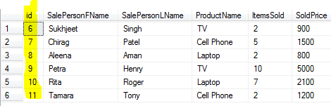
How to use OFFSET FETCH Clause in SQL Server to skip first X rows and show all rest of them - SQL Server Tutorial
2) Now if we would like to show 3 records per page, we can use below query. In this case we are going to show first page
Select
[id], [SalePersonFName], [SalePersonLName], [ProductName],
[ItemsSold], [SoldPrice]
from dbo.TotalSale
order by id
OFFSET 0 ROWS FETCH NEXT 3 ROWS ONLY;

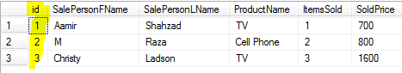
How to use OFFSET FETCH clause to return records per page in SQL Server - SQL Server Tutorial
Noticed that I have OFFSET 0, that means that I want to show first page and with 3 rows. If I want to show second page records, I will set to OFFSET 1, the Next 3 ROWS ONLY part will stay the same as want to show only 3 rows per page.
We can use variables so we don't have to make changes in the query and by changing the value of variables, we can return our required results. You can create Stored Procedure if you like by using below query.
Declare @PageNumber int
Declare @RowsPerPage int
set @RowsPerPage=3
SET @PageNumber=1

Select
[id], [SalePersonFName], [SalePersonLName], [ProductName],
[ItemsSold], [SoldPrice]
from dbo.TotalSale
order by id
OFFSET (@PageNumber-1)*@RowsPerPage ROWS FETCH NEXT @RowsPerPage ROWS ONLY;
If we need to provide Stored Procedure to Front End team, which accepts page number and number of rows they would like to return for each page, you can use below to create Stored Procedure.
Create procedure dbo.sp_GetSaleRecordsPerPage
@PageNumber int,
@RowsPerPage int
AS
BEGIN
Select
[id], [SalePersonFName], [SalePersonLName], [ProductName],
[ItemsSold], [SoldPrice]
from dbo.TotalSale
order by id
OFFSET (@PageNumber-1)*@RowsPerPage
ROWS FETCH NEXT @RowsPerPage ROWS ONLY;
END
Let's say if we would like to return second page with 4 records, we can use the dbo.sp_GetSaleRecordsPerPage by providing below parameter values.
EXEC dbo.sp_GetSaleRecordsPerPage 2,4
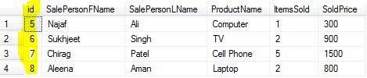
How to perform Pagination in SQL Server by using OFFSET FETCH clause - TSQL Tutorial

Chapter 9 : Operators

9.1 Logical Operators

What is Logical OR Operator in SQL Server?
Logical Operators are used to test some conditions. If the condition is true, the row will be selected for output.

What is OR Logical Operator :
OR logical operator is used when we want to return the row if at least one of the condition is true.

Scenario :
Let's say that you have dbo.Customer table and you want to return all the rows if FName='Raza' Or CountryShortName='US'.

Create the dbo.Customer table by using below script.

Create table dbo.Customer
(Id int,
FName VARCHAR(50),
LName VARCHAR(50),
CountryShortName CHAR(2))
GO
insert into dbo.Customer
Values (
1,'Raza','M','PK'),
(2,'Rita','John','US'),
(3,'Sukhi','Singh',Null),
(4,'James','Smith','CA'),
(5,'Robert','Ladson','US'),
(6,'Alice','John','US')
We can use below query with OR Logical operator to return all rows where FName='Raza' Or CountryShortName='US'.
Select * From dbo.Customer
where FName='Raza'
OR CountryShortName='US'

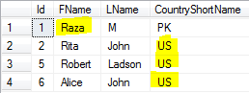

As we have used OR logical operator in our query, the row will be returned if at-least one condition is true. We can see that for FName='Raza', the row is selected even second condition is not true.
Same goes for other three records which are returned even FName is not equal to 'Raza' but CountryShortName is equal to 'US' that makes one condition true.

What is Logical AND Operator in SQL Server?
Logical Operators are used to test some conditions. If the condition is true, the row will be selected for output.

What is AND Logical Operator :
Logical AND operator is used when we want to return the row if all the specified conditions are true.

Scenario :
Think about a situation where you need to return all the records from a dbo.Customer table where FName='Raza' and CountryShortName='US'
Create the dbo.Customer table with some sample records by using below scripts.
Create table dbo.Customer
(Id int,
FName VARCHAR(50),
LName VARCHAR(50),
CountryShortName CHAR(2))
GO
insert into dbo.Customer
Values (
1,'Raza','M','PK'),
(2,'Rita','John','US'),
(3,'Sukhi','Singh',Null),
(4,'James','Smith','CA'),
(5,'Robert','Ladson','US'),
(6,'Alice','John','US'),
(7,'Raza','M','US')
To return the records where FName='Raza' and CountryShortName='US' we can use below query.
Select * From dbo.Customer
where FName='Raza'
AND CountryShortName='US'

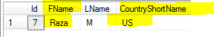

Noticed that our query returned single record as both conditions are only true for single record.

What is NOT Logical Operator in SQL Server?
Logical Operators are used to test some conditions. If the condition is true, the row will be selected for output.

What is NOT Logical Operator :
NOT logical operator is used when we want to return the row if specified condition is false.
Scenario :
Let's say that you have dbo.Customer table and you would like to return all the records but where FName is not equal to 'Raza'.
Create table dbo.Customer
(Id int,
FName VARCHAR(50),
LName VARCHAR(50),
CountryShortName CHAR(2))
GO
insert into dbo.Customer
Values (
1,'Raza','M','PK'),
(2,'Rita','John','US'),
(3,'Sukhi','Singh',Null),
(4,'James','Smith','CA'),
(5,'Robert','Ladson','US'),
(6,'Alice','John','US'),
(7,'Raza','M','US')
We can use NOT Logical Operation to get our required results.
Select * From dbo.Customer
where NOT FName='Raza'

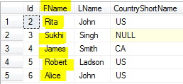
How to use Logical Not Operator in SQL Server - SQL Server / TSQL Tutorial

Noticed that it returned all the rows for which the condition is false.

What is IN Logical Operator in SQL Server?

What is IN Logical Operator :
IN logical operator is used when we want to return the row if specified value matches with any value in the sub-query or a list.
The IN Logical operator is going to be true if the operand is equal to one of the list of expressions.
Let's say that we have dbo.Customer table with below rows. We want to return the rows where CountryShortName is equal to 'PK' OR 'US'.
Create table dbo.Customer
(Id int,
FName VARCHAR(50),
LName VARCHAR(50),
CountryShortName CHAR(2))
GO
insert into dbo.Customer
Values (
1,'Raza','M','PK'),
(2,'Rita','John','US'),
(3,'Sukhi','Singh',Null),
(4,'James','Smith','CA'),
(5,'Robert','Ladson','US'),
(6,'Alice','John','US')
Let's write our query by using IN logical operator.
Select * From dbo.Customer
where CountryShortName IN ('US','PK')

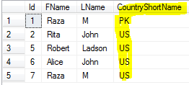
How to use IN Logical Operator in SQL Server - SQL Server / TSQL Tutorial

What is LIKE Logical Operator in SQL Server ?

What is LIKE Logical Operator :
LIKE logical operator is used when we want to return the row if operand matches a pattern. Like operator returns TRUE if the operand matches a pattern.
Sometime we need to perform pattern matching instead of equal or not equal. Like is used when we want to return the row if specific character string matches a specified pattern. Pattern can be combination of regular characters and wildcard characters.
To return the row back, regular characters must exactly match the characters specified in the character string.The wildcard characters can be matched with arbitrary parts of the character string.
Let's create dbo.Customer table and then create some real time examples
Create table dbo.Customer
(Id int,
FName VARCHAR(50),
LName VARCHAR(50),
CountryShortName CHAR(2))
GO
insert into dbo.Customer
Values (
1,'Raza','M','PK'),
(2,'Rita','John','US'),
(3,'Sukhi','Singh',Null),
(4,'James','Smith','CA'),
(5,'Robert','Ladson','US'),
(6,'Alice','John','US'),
(7,'Raza','M','US'),
(8,'Dita','M','US'),

(9,'Adita','M','US')

1) Using %
Let's say if we want to find all the rows where FName contains "i" in them. We can use below query
Select * From dbo.Customer
where FName like '%i%'

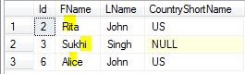
How to use % with Like Operator in SQL Server - SQL Server / TSQL Tutorial

Noticed that by using % before and after "i", we are telling the query to find all rows in which FName has "i" character and does not matter what other characters are before and after "i".
2) Using _ (underscore)
The underscore can be used when we want to check single character that can be anything and provide the rest of the characters for our match. Let's say that if I want to find all rows where FName first character can be anything but rest of them should be "ita". I can use below query.
Select * From dbo.Customer
where FName like '_ita'
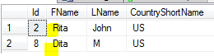
How to use underscore( _ ) with Like Operator in SQL Server - SQL Server / TSQL Tutorial

3) Using [ ] - Any single character within the specified rang [a-t] or set [abc]
Like operator with [ ] can be used when we want to have range. Let's say if I want to find all the rows where FName first character start with [a-f]. We can use below query.
Select * From dbo.Customer
where FName like '[a-f]%'

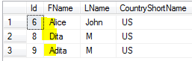
How to use Rang with Like operator in SQL Server for search - SQL Server / TSQL Tutorial

As you can see that I have used [a-f]%. That means I want the first character from a to f and after that any characters are fine as I used %.
4) [^] Any single character NOT within the specified rang [a-t] or set [abc]
Let's say if I want to find all the rows where FName first character Dost NOT start with [a to f]. We can use below query.
Select * From dbo.Customer
where FName like '[^a-f]%'

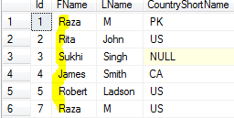
How to use Not in Range with Like Operator in SQL Server - SQL Server / TSQL Tutorial

Noticed that it only returned us the rows which does not start with any character from a-f.
Let's say that if we are want to get all the rows where FName does not start with a,d,j. we can use below query.
Select * From dbo.Customer
where FName like '[^adj]%'

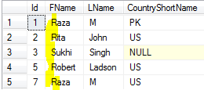

What is BETWEEN Logical Operator in SQL Server?

What is BETWEEN Logical Operator :
BETWEEN returns TRUE if the operand is within range. BETWEEN logical operator is used when we want to return the row if operand is within range.

Scenario:
Let's say that we have dbo.Cutomer table and one of the column is Age. If we would like to return all the records from dbo.Customer table where age between 33 and 60. What Logical Operator we can use?

Solution:
We can use BETWEEN logical operator to test ranges. If True then row will be returned otherwise not.

Create table dbo.Customer
(Id int,
FName VARCHAR(50),
LName VARCHAR(50),
CountryShortName CHAR(2),
Age tinyint)
GO
insert into dbo.Customer
Values (
1,'Raza','M','PK',20),
(2,'Rita','John','US',12),
(3,'Sukhi','Singh',Null,25),
(4,'James','Smith','CA',60),
(5,'Robert','Ladson','US',54),
(6,'Alice','John','US',87),
(7,'Raza','M','US',33),
(8,'Dita','M','US',15),
(9,'Adita','M','US',29)
BETWEEN returns TRUE if the value of test_expression is greater than or equal to the value of begin_expression and less than or equal to the value of end_expression.

We can use below query to return all the rows if age is between 33 and 60.

Select * From dbo.Customer
where Age between 33 and 60

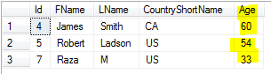
How to use BETWEEN Logical Operator to check range and return rows - SQL Server / TSQL Tutorial

We can also use NOT BETWEEN that will retrun TRUE if the value of test expression is less than the value of begin expression or greater than the value of end expression.
If we want to return all the records where Age is less than 33 or greater than 60 we can use NOT BETWEEN as shown below.

Select * From dbo.Customer
where Age NOT between 33 and 60
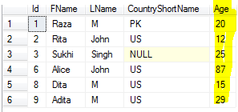
How to use NOT BETWEEN in SQL Server Query - SQL Server / TSQL Tutorial

How to use EXISTS Logical Operator in SQL Server?
Exists returns TRUE if a subquery contains any rows. EXISTS is used when we want to test for the existence of rows specified by a subquery.
Let's create dbo.Customer and dbo.Country Table and then use EXISTS to return records for different scenarios.
Create table dbo.Customer
(Id int,
FName VARCHAR(50),
LName VARCHAR(50),
CountryShortName CHAR(2),
Age tinyint)
GO
insert into dbo.Customer
Values (
1,'Raza','M','PK',20),
(2,'Rita','John','US',12),
(3,'Sukhi','Singh',Null,25),
(4,'James','Smith','CA',60),
(5,'Robert','Ladson','US',54),
(6,'Alice','John','US',87),
(7,'Raza','M','US',33),
(8,'Dita','M','US',15),
(9,'Adita','M','US',29)

Create table dbo.Country (
CId tinyint,
CountryName VARCHAR(50),
CountryShortName CHAR(2))
go
Insert into dbo.Country
Values
(1,'Pakistan','Pk'),
(2,'United States of America','US')
1) EXISTS will return TRUE if subquery contains any rows.
That is right, if our subquery will return any rows and we have used EXISTS, the outer query is going to return all rows.
Select * from dbo.Customer
WHERE Exists ( Select 1)

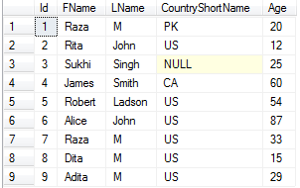
How to use EXISTS in SQL Server - SQL Server / TSQL Tutorial
Noticed that our subquery is static query ( Select 1). As subquery did return row and EXISTS returned TRUE so all the records from dbo.Customer table are displayed.
2) Use EXISTS and Join with SubQuery
The more real time example of EXISTS would be when we want to find all the records from dbo.Customer table which has matching CountryShortName from dbo.Country Table.
SELECT *
FROM dbo.Customer a
WHERE EXISTS
(SELECT 1
FROM dbo.Country b
WHERE a.CountryShortName=b.CountryShortName)
Noticed that I have compared CountryShortName from dbo.Customer and dbo.Country. Each outer row is going to be compared with subquery results and if matches , then we get the row.
We can use the IN clause for same requirement.
SELECT *
FROM dbo.Customer a
WHERE a.CountryShortName IN
(SELECT b.CountryShortName
FROM dbo.Country b
WHERE a.CountryShortName=b.CountryShortName)
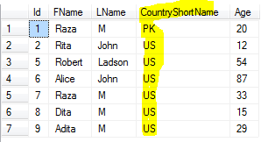
How to use EXISTS in SQL Server to return matching records - SQL Server / TSQL Tutorial

How to use ALL Logical Operator in SQL Server?
ALL Logical operator returns TRUE if all of a set of comparisons are TRUE. ALL compares a scalar value with a single column set of values.
Let's understand ALL with examples.

Scenario :
Think about a scenario where we have two tables dbo.Customer and dbo.Customer1. Both tables has the column Age. If you need to get all the records from dbo.Customer table where Age is greater than maximum value of Age column in dbo.Customer1 table.What would be your query.

Solution:
We can use subquery and max function to write our query for above requirement. Let's create the tables first.
--Create Customer Table
Create table dbo.Customer
(Id int,
FName VARCHAR(50),
LName VARCHAR(50),
CountryShortName CHAR(2),
Age tinyint)
GO
--Insert Rows in dbo.Customer Table
insert into dbo.Customer
Values (
1,'Raza','M','PK',20),
(2,'Rita','John','US',12),
(3,'Sukhi','Singh',Null,25),
(4,'James','Smith','CA',60),
(5,'Robert','Ladson','US',54),
(6,'Alice','John','US',87)

--Create dbo.Customer1 table
Create table dbo.Customer1
(Id int,
FName VARCHAR(50),
LName VARCHAR(50),
CountryShortName CHAR(2),
Age tinyint)
GO
--Insert rows in dbo.Customer1 Table
insert into dbo.Customer1
Values
(7,'Raza','M','US',33),
(8,'Dita','M','US',15),
(9,'Adita','M','US',29)
1) Get all the records from dbo.Customer table where Age is greater than maximum Age value of dbo.Customer1 table by using Subquery and Max function.
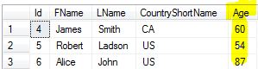
2) using ALL with SubQuery
For above requirement we can use ALL logical operator. In that case we don't have to use Max function. ALL is going compare our outer query value to set of values from subquery. We can use >All, >ALL means greater than every value returned by subquery, In other words greater than max value.
Select * From dbo.Customer
where Age> All ( Select age from dbo.Customer1)
How to use ALL Logical Operator in SQL Server - SQL Server / TSQL Tutorial

With ALL you can use different comparison operators such as = , <> , != , > , >= , !> , < , <= , !<

How to use ANY / SOME Logical Operator in SQL Server?
ANY Logical operator returns TRUE if any one of a set of comparisons are TRUE. ANY compares a scalar value with a single column set of values.
Note : SOME and ANY are equivalent. We are going to use ANY in our below examples.

Scenario :
Let's say that we have two tables dbo.Customer and dbo.Customer1. Both tables has the column Age. If you need to get all the records from dbo.Customer table where Age is at-least greater than one value from Age column from dbo.Customer1 table.

Solution:
We can use subquery and MIN function to write our query for above requirement. Let's create the tables first.
--Create Customer Table
Create table dbo.Customer
(Id int,
FName VARCHAR(50),
LName VARCHAR(50),
CountryShortName CHAR(2),
Age tinyint)
GO
--Insert Rows in dbo.Customer Table
insert into dbo.Customer
Values (
1,'Raza','M','PK',10),
(2,'Rita','John','US',12),
(3,'Sukhi','Singh',Null,25),
(4,'James','Smith','CA',60),
(5,'Robert','Ladson','US',54),
(6,'Alice','John','US',87)

--Create dbo.Customer1 table
Create table dbo.Customer1
(Id int,
FName VARCHAR(50),
LName VARCHAR(50),
CountryShortName CHAR(2),
Age tinyint)
GO
--Insert rows in dbo.Customer1 Table
insert into dbo.Customer1
Values
(7,'Raza','M','US',33),
(8,'Dita','M','US',15),
(9,'Adita','M','US',29)

1) Get all the records from dbo.Customer table where Age is greater than min Age value of dbo.Customer1 table by using Subquery and Min function.

Select * From dbo.Customer
where Age> ( Select MIN(age) from dbo.Customer1)
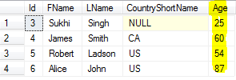
2) Use ANY to get required results.
We can use ANY instead of using Min function with subquery. As we want to get all rows from dbo.Customer where Age is greater than any value of Age column in dbo.Customer, We will use >Any.
>ANY means greater than at least one value, that is, greater than the minimum.
Select * From dbo.Customer
where Age>ANY ( Select age from dbo.Customer1)

We got the same records what were returned by our first query.
If you will use =ANY that is equal to IN. With ANY you can use different comparison operators such as = , <> , != , > , >= , !> , < , <= , !<

Aggregate Functions

How to use Sum, Avg and Count in Select Statement?

Scenario:
Let's say that you have dbo.Customer table with SaleAmount column and you are asked to write a query that should return you sum of SaleAmount, Average of SaleAmount and Count of all the records.

Solution:
You can use Aggregate functions such as Sum, Avg and count in TSQL to find the answer of your question.
Let's create dbo.Customer Table with sample data so we can use Sum, Avg and Count aggregate functions.

Create table dbo.Customer
(Id int,
FName VARCHAR(50),
LName VARCHAR(50),
CountryShortName CHAR(2),
SaleAmount Int)
GO
--Insert Rows in dbo.Customer Table
insert into dbo.Customer
Values (
1,'Raza','M','PK',10),
(2,'Rita','John','US',12),
(3,'Sukhi','Singh',Null,25),
(4,'James','Smith','CA',60),
(5,'Robert','Ladson','US',54),
(6,'Alice','John','US',87),
(6,'John',Null,'US',Null)
Let's run our query to find sum of SaleAmount, Avg of SaleAmount and Count of records.
SELECT Sum(saleamount) AS TotalSale,
Avg(saleamount) AS AvgSale,
Count(*) AS SaleRecordCount
FROM dbo.customer

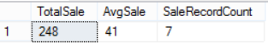

How to use Sum, Avg and Count Aggregate Functions in SQL Server

How to Get Max and Min values from a Table by using Aggregate Function?

Scenario:
Let's say you are working as SQL Server Developer, you have dbo.Customer table with SaleAmount. You are asked to write a query that should return Max SaleAmount and Min SaleAmount from the dbo.Customer table.

Solution:
You can use Max and Min aggregate functions in SQL Server to find the Maximum and Minimum values.

Let's create dbo.Customer Table with sample data so we can use Max and Min functions.

Create table dbo.Customer
(Id int,
FName VARCHAR(50),
LName VARCHAR(50),
CountryShortName CHAR(2),
SaleAmount Int)
GO
--Insert Rows in dbo.Customer Table
insert into dbo.Customer
Values (
1,'Raza','M','PK',10),
(2,'Rita','John','US',12),
(3,'Sukhi','Singh',Null,25),
(4,'James','Smith','CA',60),
(5,'Robert','Ladson','US',54),
(6,'Alice','John','US',87),
(6,'John',Null,'US',Null)
Let's run the below query with Max and Min functions to finder the answer of our question.

SELECT Max(saleamount) AS MaxSaleAmount,
Min(saleamount) AS MinSaleAmount
FROM dbo.customer

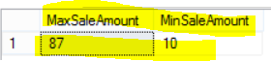
How to use Max and Min function in SQL Server

Understand Group by Clause in SQL Server?

Scenario:
You are working as SQL Server Developer. You have a dbo.Customer table which has CountryShortName and SaleAmount. You are asked to write a query that should return Sum of SaleAmount , count of records by CountryShortName.

Solution:
Group by clause is often used with aggregate functions such as Sum, Avg,Count,Max,Min to group the result set by column/s.

Let's create our sample table with some data and write our query with Group by to answer our question.

Create table dbo.Customer
(Id int,
FName VARCHAR(50),
LName VARCHAR(50),
CountryShortName CHAR(2),
SaleAmount Int)
GO
--Insert Rows in dbo.Customer Table
insert into dbo.Customer
Values (
1,'Raza','M','PK',10),
(2,'Rita','John','US',12),
(3,'Sukhi','Singh',Null,25),
(4,'James','Smith','CA',60),
(5,'Robert','Ladson','US',54),
(6,'Alice','John','US',87),
(6,'John',Null,'US',Null)
Let's write our query by using Sum, Count and Group by Clause

SELECT Sum(saleamount) AS TotalSaleByCountry,
Count(*) AS RecordCountByCountry,
countryshortname
FROM dbo.customer
GROUP BY countryshortname
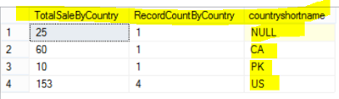
How to use Group by Clause in SQL Server

You can also use multiple columns in group by clause. think about if our table would have states and you would like to group by CountryShortName and State, You would simple include State in query as shown below.

SELECT Sum(saleamount) AS TotalSaleByCountry,
Count(*) AS RecordCountByCountry,
countryshortname,
[State]
FROM dbo.customer
GROUP BY countryshortname,[State]

How to apply Having Clause with Group by in Select Query ?

Scenario:
You are working as SQL Server developer, you are asked to write a query that should return Total SaleAmount from dbo.Customer table by CountryShortName. You are also asked to filter the records where Total SaleAmount by CountryShortName is greater than 10.

Solution:
From above scenario, you have noticed couple of things. First we need to sum the SaleAmount. Second we need to group by the SaleAmount by CountryShortName. The Last thing we need to filter those records after calculating the sum and only returns where total SaleAmount is greater than 10. We can not use Where clause here as where will filter the records before Group by. SQL Server provide us Having clause that we can use to filter the records after group by.

Let's create dbo.Customer Table with below records and then write our query by using Group by and Having clause.

Create table dbo.Customer
(Id int,
FName VARCHAR(50),
LName VARCHAR(50),
CountryShortName CHAR(2),
SaleAmount Int)
GO
--Insert Rows in dbo.Customer Table
insert into dbo.Customer
Values (
1,'Raza','M','PK',10),
(2,'Rita','John','US',12),
(3,'Sukhi','Singh',Null,25),
(4,'James','Smith','CA',60),
(5,'Robert','Ladson','US',54),
(6,'Alice','John','US',87),
(6,'John',Null,'US',Null)
Let's write our query by using Group by and then use Having to filter the record where Sum(SaleAmount) is greater than 10.

SELECT countryshortname,
Sum(saleamount) SaleAmountByCountry
FROM dbo.customer
GROUP BY countryshortname
HAVING Sum(saleamount) > 10
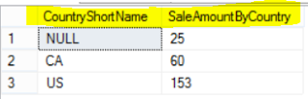
How to filter aggregated data by using Having clause in SQL

How to find duplicate records by using Group by and Having clause in SQL Server - SQL ?

Scenario:
You are working as SQL Server developer. You need to write the query for dbo.Customer table that should return the duplicate records and count of duplicate record.

Solution:
You can use Group by and Count aggregate function to find all the duplicate records in table and count.
Let's say that we have dbo.Customer table with below definition and data. We would like to find the record if it is duplicate by columns FName,LName and CountryShortName.
Create table dbo.Customer
(Id int,
FName VARCHAR(50),
LName VARCHAR(50),
CountryShortName CHAR(2),
SaleAmount Int)
GO
--Insert Rows in dbo.Customer Table
insert into dbo.Customer
Values (
1,'Raza','M','PK',10),
(2,'Rita','John','US',12),
(3,'Sukhi','Singh',Null,25),
(4,'James','Smith','CA',60),
(5,'Robert','Ladson','US',54),
(6,'Alice','John','US',87),
(6,'Raza','M','Pk',Null)
Let's write our query, we have include all the columns in select list with count(*) and then group by the same columns. At the end we will be using Having clause to filter the record which are duplicate.
SELECT fname,
lname,
countryshortname,
Count(*) AS RecordCount
FROM dbo.customer
GROUP BY fname,
lname,
countryshortname
HAVING Count(*) > 1
As from data we can see that the only record which is duplicate by FName,LName and Country short name is 'Raza','M','PK'and have total two records as returned by our query.
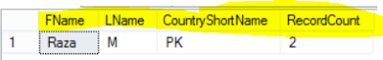
How to find duplicate records by using Group by and Having Clause in SQL Server

Cursors

Define the Steps for SQL Server Cursor ?
Cursors are objects which are provides to us in SQL Server to perform row by row operation.
Here are the steps how do you write a cursor
1-Declare A Cursor by using name of Cursor with a Select statment
2- Open Cursor to populate with output of Select statement
3- Fetch the rows to process them one after one
4- Close the Cursor
5- De-allocate Cursor
We encounter different situations in which we can use cursors. Below are some example in which we can use cursors
Examples:
1-- Kill all connections from a SQL Server Database
2-- Add a new columns such as CreatedBy to all the tables in a Database
3--Enable/Disable all the triggers in a SQL Server Database
4--Generate Scripts/Take backup of All Database on SQL Server one after one
5--Truncate/Delete all the tables from a SQL Server Database
Example Code:
The below code can be used to kill all the processes to a database. We can not rename a database if any process is accessing the database. To rename we have to kill all the processes before we rename the database in SQL Server.
USE MASTER
GO
DECLARE @DatabaseName AS VARCHAR(500)
-->Provide the DataBaseName for which want to Kill all processes.
SET @DatabaseName='TestDB'
DECLARE @Spid INT

--1: Declare Cursor:
DECLARE KillProcessCur CURSOR FOR
SELECT spid
FROM sys.sysprocesses
WHERE DB_NAME(dbid) = @DatabaseName

--2: OPEN Cursor
OPEN KillProcessCur

--3: Fetch A record
FETCH Next FROM KillProcessCur INTO @Spid

--Loop Through the Rows one by one
WHILE @@FETCH_STATUS = 0
BEGIN
DECLARE @SQL VARCHAR(500)=NULL
SET @SQL='Kill ' + CAST(@Spid AS VARCHAR(5))

PRint @SQL

EXEC (@SQL)
PRINT 'ProcessID =' + CAST(@Spid AS VARCHAR(5))
+ ' killed successfull'
FETCH Next FROM KillProcessCur INTO @Spid
END

--4: Close the Cursor
CLOSE KillProcessCur
--5: Deallocate Cursor
DEALLOCATE KillProcessCur

TSQL - Add Column To All Tables in a Database [ Cursor Example]

Scenario:
Sometime we have requirement that add column in all the tables in Database. Today we have to add CreatedOn column in all the tables if it does not exist in table already.

Solution:
We will be using Cursor to perform this operation.
Please provide Column name and Data Type for these variables. In below example I am adding CreatedOn column with DateTime data type.
SET @COLUMN_NAME='ColumnNameYouWantToAdd'
SET @COLUMN_DATATYPE='DataTypeOfColumn'
------------------------------------------------Code---------------------------------------------------
USE TESTDB
GO
--Declare Variables
DECLARE @TableName VARCHAR(100)
DECLARE @TableSchema VARCHAR(100)
DECLARE @COLUMN_NAME VARCHAR(50)
SET @COLUMN_NAME='CreatedOn' -- Change Column Name according to your requirement
DECLARE @COLUMN_DATATYPE VARCHAR(50)
SET @COLUMN_DATATYPE='DateTime' -- Provide data type for column

--Declare Cursor
DECLARE CUR CURSOR FOR
SELECT TABLE_SCHEMA,
TABLE_NAME
FROM INFORMATION_SCHEMA.TABLES
WHERE TABLE_TYPE = 'BASE TABLE'
--OPEN CURSOR
OPEN CUR
--Fetch First Row
FETCH NEXT FROM CUR INTO @TableSchema,@TableName
--Loop
WHILE @@FETCH_STATUS = 0
BEGIN

DECLARE @SQL NVARCHAR(MAX)
SET @SQL=NULL
IF NOT EXISTS ( SELECT 1 FROM INFORMATION_SCHEMA.COLUMNS
WHERE TABLE_NAME=@TableName AND COLUMN_NAME=@COLUMN_NAME
and Table_Schema=@TableSchema)
BEGIN
SET @SQL='ALTER TABLE '+@TableSchema+'.'+@TableName +' ADD '+@COLUMN_NAME
+ ' '+@COLUMN_DATATYPE
PRINT @SQL
EXEC ( @SQL)
END

IF EXISTS ( SELECT 1 FROM INFORMATION_SCHEMA.COLUMNS
WHERE TABLE_NAME=@TableName AND COLUMN_NAME=@COLUMN_NAME
and Table_Schema=@TableSchema)
BEGIN
PRINT 'Column Already exists in Table'
END
FETCH NEXT FROM CUR INTO @TableSchema,@TableName
END
--Close and Deallocate Cursor
CLOSE CUR
DEALLOCATE CUR

DBA - How To Kill All Database Processes On SQL Server?
The below code can be used to Kill all the processes to SQL Server Database. The code can be used in situations where changes to the database can not be done if any process is running on database such as renaming database can not be done if any process is running on that database.
USE MASTER
GO
DECLARE @DatabaseName AS VARCHAR(500)
-->Provide the DataBaseName for which want to Kill all processes.
SET @DatabaseName='YourDataBaseName'
DECLARE @Spid INT
DECLARE KillProcessCur CURSOR FOR
SELECT spid
FROM sys.sysprocesses
WHERE DB_NAME(dbid) = @DatabaseName
OPEN KillProcessCur
FETCH Next FROM KillProcessCur INTO @Spid
WHILE @@FETCH_STATUS = 0
BEGIN
DECLARE @SQL VARCHAR(500)=NULL
SET @SQL='Kill ' + CAST(@Spid AS VARCHAR(5))
EXEC (@SQL)
PRINT 'ProcessID =' + CAST(@Spid AS VARCHAR(5))
+ ' killed successfull'
FETCH Next FROM KillProcessCur INTO @Spid
END
CLOSE KillProcessCur
DEALLOCATE KillProcessCur

Truncate all the tables in a Database in SQL Server ?

Scenario:
Let's think about a database that we use for our ETL process and we call that database staging. We want to truncate all the tables in morning so those can be used for the daily process. Once way is to write our Truncate statement for each of the table but tables can be dropped or new tables can be created as well. We want to write a query that we can be use to Truncate all the tables from a database and we don't have to rewrite our Truncate statements.
If the tables do not have Primary Key -Foreign Key relationship, we can use Truncate. But we often have tables which are referenced by other tables. We can not use Truncate statement for those tables. The only way to Truncate those tables is to drop the Foreign Key Constraint before Truncating and then Truncate and Recreate Relationship after that.
The below Code can be used to Truncate all the tables from the database. If Tables will have the Pk-Fk relationship, The script will drop the Foreign Key Constraints first and then Truncate those tables and finally recreate the Foreign Key constraints.
Before you run below Script, Make sure you are pointing to correct Database and Server! All the best with Truncating all the tables from a SQL Server Database.
-- Drop Temp Tables if Exists
IF OBJECT_ID('tempdb..#DropConstraint') IS NOT NULL
DROP TABLE #DropConstraint
IF OBJECT_ID('tempdb..#CreateConstraint') IS NOT NULL
DROP TABLE #CreateConstraint
IF OBJECT_ID('tempdb..#TempTruncateTables') IS NOT NULL
DROP TABLE #TempTruncateTables
-- Drop Constraint Script Save in #DropConstraint Temp Table
SELECT 'ALTER TABLE ' + '['
+ Schema_name(o.schema_id) + '].['
+ OBJECT_NAME(FK.parent_object_id) + ']'
+ ' DROP CONSTRAINT ' + '[' + FK.name + ']' AS DropConstraintQuery
INTO #DropConstraint
FROM sys.foreign_keys AS FK
INNER JOIN sys.foreign_key_columns AS FKC
ON FK.OBJECT_ID = FKC.constraint_object_id
INNER JOIN sys.objects O
ON O.OBJECT_ID = FKC.parent_object_id
-- Create Constraint Script Save in #CreateConstraint Temp Table
SELECT 'ALTER TABLE ' + '['
+ Schema_name(o.schema_id) + '].' + '['
+ OBJECT_NAME(FK.parent_object_id) + ']'
+ ' ADD CONSTRAINT ' + '[' + FK.name
+ '] Foreign Key (['
+ (SELECT name
FROM sys.columns c
WHERE c.OBJECT_ID = FKC.parent_object_id
AND c.column_id = FKC.parent_column_id)
+ ']) REFERENCES ' + '['
+ Schema_name(o.schema_id) + '].['
+ (SELECT name
FROM sys.objects o
WHERE OBJECT_ID = FKC.referenced_object_id)
+ '] (['
+ (SELECT name
FROM sys.columns c
WHERE c.OBJECT_ID = FKC.referenced_object_id
AND c.column_id = FKC.referenced_column_id)
+ '])' AS CreateConstraintQuery
INTO #CreateConstraint
FROM sys.foreign_keys AS FK
INNER JOIN sys.foreign_key_columns AS FKC
ON FK.OBJECT_ID = FKC.constraint_object_id
INNER JOIN sys.objects o
ON FKC.parent_object_id = o.OBJECT_ID
-- Build Truncate Statement for all the tables and save into #TempTruncateTables
SELECT 'Truncate table ' + Schema_name(schema_id)
+ '.' + name AS TruncateTableQuery
INTO #TempTruncateTables
FROM sys.tables
WHERE TYPE = 'U'
AND is_ms_shipped = 0
GO
-- Drop Constraints
DECLARE @DropConstraintQuery AS VARCHAR(4000)
DECLARE DropConstraintCur CURSOR FOR
SELECT DropConstraintQuery
FROM #DropConstraint
OPEN DropConstraintCur
FETCH Next FROM DropConstraintCur
INTO @DropConstraintQuery
WHILE @@FETCH_STATUS = 0
BEGIN
DECLARE @SQL VARCHAR(MAX)=NULL
SET @SQL=@DropConstraintQuery
EXEC (@SQL)
PRINT ' Query ::' + @DropConstraintQuery
+ 'Completed'
FETCH Next FROM DropConstraintCur INTO @DropConstraintQuery
END
CLOSE DropConstraintCur
DEALLOCATE DropConstraintCur
GO-- Truncate tables
DECLARE @TempTruncateTablesCur AS VARCHAR(4000)
DECLARE TempTruncateTablesCur CURSOR FOR
SELECT TruncateTableQuery
FROM #TempTruncateTables
OPEN TempTruncateTablesCur
FETCH Next FROM TempTruncateTablesCur
INTO @TempTruncateTablesCur
WHILE @@FETCH_STATUS = 0
BEGIN
DECLARE @SQL VARCHAR(MAX)=NULL
SET @SQL=@TempTruncateTablesCur
EXEC (@SQL)
PRINT ' Query ::' + @TempTruncateTablesCur
+ 'Completed'
FETCH Next FROM TempTruncateTablesCur INTO @TempTruncateTablesCur
END
CLOSE TempTruncateTablesCur
DEALLOCATE TempTruncateTablesCur
GO
-- Create Constraint After Truncate
DECLARE @CreateConstraintQuery AS VARCHAR(4000)
DECLARE CreateConstraintQueryCur CURSOR FOR
SELECT CreateConstraintQuery
FROM #CreateConstraint
OPEN CreateConstraintQueryCur
FETCH Next FROM CreateConstraintQueryCur
INTO @CreateConstraintQuery
WHILE @@FETCH_STATUS = 0
BEGIN
DECLARE @SQL VARCHAR(MAX)=NULL
SET @SQL=@CreateConstraintQuery
EXEC (@SQL)
PRINT ' Query ::' + @CreateConstraintQuery
+ 'Completed'
FETCH Next FROM CreateConstraintQueryCur INTO @CreateConstraintQuery
END
CLOSE CreateConstraintQueryCur
DEALLOCATE CreateConstraintQueryCur
GO
Things we covered in this Post
- How to drop temp table if exists in SQL Server
- How to use system tables to get Primary key and foreign key Constraint
- How to use Cursors in SQL Server
- How to Drop Foreign Key Constraints dynamically and Recreate them
- How to Truncate all tables in SQL Server Database
- How to use Dynamic SQL in TSQL
- How to use Variables in TSQL

How to Drop or Delete all Triggers from a Database in SQL Server?
Sometime we have requirement to delete/drop all the triggers from a SQL Server Database. The below code can be used to drop all the triggers on all the tables you have created in a SQL Server database. Before you go ahead and run this script, please make sure you have chosen correct database and server as it will delete all the triggers from chosen SQL Server Database.
USE [Database]
GO
DECLARE @TriggerName AS VARCHAR(500)
-- Drop or Delete All Triggers in a Database in SQL Server
DECLARE DropTrigger CURSOR FOR
SELECT TRG.name AS TriggerName
FROM sys.triggers TRG
INNER JOIN sys.tables TBL
ON TBL.OBJECT_ID = TRG.parent_id
OPEN DropTrigger
FETCH Next FROM DropTrigger INTO @TriggerName
WHILE @@FETCH_STATUS = 0
BEGIN
DECLARE @SQL VARCHAR(MAX)=NULL
SET @SQL='Drop Trigger ' + @TriggerName
PRINT 'Trigger ::' + @TriggerName
+ ' Droped Successfully'
EXEC (@SQL)
PRINT @SQL
FETCH Next FROM DropTrigger INTO @TriggerName
END
CLOSE DropTrigger
DEALLOCATE DropTrigger

How to Disable All the Triggers in SQL Server Database?
Sometime we have requirement that we need to disable all the triggers in SQL Server Database. We can use Cursor in TSQL To loop through list of Triggers and then disable them.
The below script can be use to disable all the triggers in SQL Server Database.
USE [Database]
GO
DECLARE @TriggerName AS VARCHAR(500)
DECLARE @TableName AS VARCHAR(500)
DECLARE @SchemaName AS VARCHAR(100)
--Disable All Triggers in a Database in SQL Server
DECLARE DisableTrigger CURSOR FOR
SELECT TBL.name AS TableName,
Schema_name(TBL.schema_id) AS Table_SchemaName,
TRG.name AS TriggerName
FROM sys.triggers TRG
INNER JOIN sys.tables TBL
ON TBL.OBJECT_ID = TRG.parent_id
AND TRG.is_disabled=0
AND TBL.is_ms_shipped=0
OPEN DisableTrigger
FETCH Next FROM DisableTrigger INTO @TableName,@SchemaName,@TriggerName
WHILE @@FETCH_STATUS = 0
BEGIN
DECLARE @SQL VARCHAR(MAX)=NULL
SET @SQL='Disable Trigger ' + @TriggerName +' ON '+@SchemaName+'.'+@TableName
EXEC (@SQL)
PRINT 'Trigger ::' + @TriggerName + 'is disabled on '+@SchemaName+'.'+@TableName
PRINT @SQL
FETCH Next FROM DisableTrigger INTO @TableName,@SchemaName,@TriggerName
END
CLOSE DisableTrigger
DEALLOCATE DisableTrigger
To check if all the triggers are disabled correctly in SQL Server Database, use below query
SELECT TBL.name AS TableName,
Schema_name(TBL.schema_id) AS Table_SchemaName,
TRG.name AS TriggerName,
TRG.parent_class_desc,
CASE
WHEN TRG.is_disabled = 0 THEN 'Enable'
ELSE 'Disable'
END AS TRG_Status
FROM sys.triggers TRG
INNER JOIN sys.tables TBL
ON TBL.OBJECT_ID = TRG.parent_id
AND trg.is_disabled=1 --use this filter to get Disabled Triggers

SQL Server Cursor Types - Forward Only Static Cursor ?
Cursors are the objects those allow us to access the data row by row from result set.
Forward Only Cursors do not allow backward scrolling. The only scrolling option we have is FETCH NEXT.
Forward only Static Cursors are not sensitive to any changes ( update, delete, insert) made to original data source after the cursor is created.
Script for Forward_Only Static Cursor
--drop table dbo.Customer
Create table dbo.Customer (
CustomerId Int Identity(1,1),
CustomerName VARCHAR(100),
StreetAddress VARCHAr(100),
City VARCHAR(100),
State CHAR(2))
go

--Insert couple of Records in Sample Table
Insert into dbo.Customer
Select 'Aamir shahzad','Test Street Address','Charlotte','NC'
Union
Select 'M Raza','Test Street Address','Charlotte','NC'

Select * from dbo.Customer

--Insert NEW Record
Insert into dbo.Customer
Select 'John Smith','Test Street Address','New York City','NY'

--Delete Records
Delete from dbo.Customer
Where CustomerName in ('Aamir Shahzad','M Raza')

--Update All Record
Update dbo.Customer
set CustomerName='NO NAME'

--Cursor Script

Declare @CustomerID INT
Declare @CustomerNAme VARCHAR (100)
DECLARE @StreetAddress VARCHAR(100)
DECLARE @City VARCHAR(100)
DECLARE @State CHAR(2)

--DECLARE A CURSOR
DECLARE CUR CURSOR
Forward_Only Static
FOR
Select CustomerID,CustomerName,StreetAddress,City,State from dbo.Customer

--OPEN CURSOR
OPEN CUR
Print 'CURSOR IS OPEN'
--FETCH NEXT RECORD
FETCH NEXT FROM CUR INTO @CustomerID,@CustomerNAme,@StreetAddress,@City,@State
WHILE @@FETCH_STATUS=0
BEGIN
RAISERROR ('',0,1) WITH NOWAIT
WAITFOR DELAY '00:00:15'
PRINT CONCAT(@CustomerID,' ',@CustomerNAme,' ',@StreetAddress,' ',@City,' ',@State)
FETCH NEXT FROM CUR INTO @CustomerID,@CustomerNAme,@StreetAddress,@City,@State

END
CLOSE CUR
DEALLOCATE CUR

SQL Server Cursor Types - Dynamic Cursor ?
Cursors are the objects those allow us to access the data row by row from result set.
Dynamic Cursors are update-able. The dynamic cursor will fetch the changes (insert,update or delete) on each fetch while cursor is open if any modification happened to original data in table/s. This type of Cursor is helpful when we want to extract the records from original table/s while cursor is open and we are still in process of modification of data or inserting new records and want to include them in cursor result set to perform operation.
Dynamic cursors are scrollable (First,Last,Prior,Next,Relative) but absolute option does not work with dynamic Cursors.
Script for Dynamic Cursor in SQL Server used in the video as well.
--drop table dbo.Customer
Create table dbo.Customer (
CustomerId Int Identity(1,1),
CustomerName VARCHAR(100),
StreetAddress VARCHAr(100),
City VARCHAR(100),
State CHAR(2))
go

--Insert couple of Records in Sample Table
Insert into dbo.Customer
Select 'Aamir shahzad','Test Street Address','Charlotte','NC'
Union
Select 'M Raza','Test Street Address','Charlotte','NC'

Select * from dbo.Customer

--Insert NEW Record
Insert into dbo.Customer
Select 'John Smith','Test Street Address','New York City','NY'

--Delete Records
Delete from dbo.Customer
Where CustomerName in ('Aamir Shahzad','M Raza')

--Update All Record
Update dbo.Customer
set CustomerName='NO NAME'

--Cursor Script

Declare @CustomerID INT
Declare @CustomerNAme VARCHAR (100)
DECLARE @StreetAddress VARCHAR(100)
DECLARE @City VARCHAR(100)
DECLARE @State CHAR(2)

--DECLARE A CURSOR
DECLARE CUR CURSOR
DYNAMIC
FOR
Select CustomerID,CustomerName,StreetAddress,City,State from dbo.Customer

--OPEN CURSOR
OPEN CUR
Print 'CURSOR IS OPEN'
--FETCH NEXT RECORD
FETCH NEXT FROM CUR INTO @CustomerID,@CustomerNAme,@StreetAddress,@City,@State
WHILE @@FETCH_STATUS=0
BEGIN
RAISERROR ('',0,1) WITH NOWAIT
WAITFOR DELAY '00:00:15'
PRINT CONCAT(@CustomerID,' ',@CustomerNAme,' ',@StreetAddress,' ',@City,' ',@State)
FETCH NEXT FROM CUR INTO @CustomerID,@CustomerNAme,@StreetAddress,@City,@State

END
CLOSE CUR
DEALLOCATE CUR

SQL Server Cursor Types - What are Static Cursors in SQL Server ?
Cursors are the objects those allow us to access the data row by row from result set.
Static Cursor make the copy of result set in memory at time of cursor creation and use that temporary result set to return rows. If any changes are made to original table/s data such as insert, update or delete. The Static cursor does not update stored result set with those changes unless we close the cursor and reopen.
Static Cursors are scrollable (First,Last,Prior,Next,Relative,Absolute)
Script for Static Cursor in SQL Server used in the video as well.
--drop table dbo.Customer
Create table dbo.Customer (
CustomerId Int Identity(1,1),
CustomerName VARCHAR(100),
StreetAddress VARCHAr(100),
City VARCHAR(100),
State CHAR(2))
go

--Insert couple of Records in Sample Table
Insert into dbo.Customer
Select 'Aamir shahzad','Test Street Address','Charlotte','NC'
Union
Select 'M Raza','Test Street Address','Charlotte','NC'

Select * from dbo.Customer

--Insert NEW Record
Insert into dbo.Customer
Select 'John Smith','Test Street Address','New York City','NY'

--Delete Records
Delete from dbo.Customer
Where CustomerName in ('Aamir Shahzad','M Raza')

--Update All Record
Update dbo.Customer
set CustomerName='NO NAME'

--Cursor Script

Declare @CustomerID INT
Declare @CustomerNAme VARCHAR (100)
DECLARE @StreetAddress VARCHAR(100)
DECLARE @City VARCHAR(100)
DECLARE @State CHAR(2)

--DECLARE A CURSOR
DECLARE CUR CURSOR
STATIC
FOR
Select CustomerID,CustomerName,StreetAddress,City,State from dbo.Customer

--OPEN CURSOR
OPEN CUR
Print 'CURSOR IS OPEN'
--FETCH NEXT RECORD
FETCH NEXT FROM CUR INTO @CustomerID,@CustomerNAme,@StreetAddress,@City,@State
WHILE @@FETCH_STATUS=0
BEGIN
RAISERROR ('',0,1) WITH NOWAIT
WAITFOR DELAY '00:00:15'
PRINT CONCAT(@CustomerID,' ',@CustomerNAme,' ',@StreetAddress,' ',@City,' ',@State)
FETCH NEXT FROM CUR INTO @CustomerID,@CustomerNAme,@StreetAddress,@City,@State

END
CLOSE CUR
DEALLOCATE CUR

SQL Server Cursor Types - Forward Only Dynamic Cursor ?
Cursors are the objects those allow us to access the data row by row from result set.
Forward Only Cursors do not allow backward scrolling. The only scrolling option we have is FETCH NEXT.
Forward only Static Cursors are sensitive to any changes ( update, delete, insert) made to original data source. If the changes are made, they will be extracted on Next Fetch.
Script for Forward_Only Dynamic Cursor
--drop table dbo.Customer
Create table dbo.Customer (
CustomerId Int Identity(1,1),
CustomerName VARCHAR(100),
StreetAddress VARCHAr(100),
City VARCHAR(100),
State CHAR(2))
go

--Insert couple of Records in Sample Table
Insert into dbo.Customer
Select 'Aamir shahzad','Test Street Address','Charlotte','NC'
Union
Select 'M Raza','Test Street Address','Charlotte','NC'

Select * from dbo.Customer

--Insert NEW Record
Insert into dbo.Customer
Select 'John Smith','Test Street Address','New York City','NY'

--Delete Records
Delete from dbo.Customer
Where CustomerName in ('Aamir Shahzad','M Raza')

--Update All Record
Update dbo.Customer
set CustomerName='NO NAME'

--Cursor Script

Declare @CustomerID INT
Declare @CustomerNAme VARCHAR (100)
DECLARE @StreetAddress VARCHAR(100)
DECLARE @City VARCHAR(100)
DECLARE @State CHAR(2)

--DECLARE A CURSOR
DECLARE CUR CURSOR
Forward_Only Dynamic
FOR
Select CustomerID,CustomerName,StreetAddress,City,State from dbo.Customer

--OPEN CURSOR
OPEN CUR
Print 'CURSOR IS OPEN'
--FETCH NEXT RECORD
FETCH NEXT FROM CUR INTO @CustomerID,@CustomerNAme,@StreetAddress,@City,@State
WHILE @@FETCH_STATUS=0
BEGIN
RAISERROR ('',0,1) WITH NOWAIT
WAITFOR DELAY '00:00:15'
PRINT CONCAT(@CustomerID,' ',@CustomerNAme,' ',@StreetAddress,' ',@City,' ',@State)
FETCH NEXT FROM CUR INTO @CustomerID,@CustomerNAme,@StreetAddress,@City,@State

END
CLOSE CUR
DEALLOCATE CUR

SQL Server Cursor Types - KEYSET Cursor ?
When we open Keyset Cursor the membership and order of rows in the cursor is fixed. KeySet Cursor create a temp table in TempDB with uniquely built values from the columns which we use in Select statement.
Here are important points to remember about KEYSET Cursor in SQL Server
- If your Select query is using any table without Unique Index, the KEYSET cursor is simply going to be converted to Static Cursor. Make sure all of the tables you are using in Select Query has unique index. This is important as KEYSET Cursor build unique identifiers for the rows by using these unique values.
- If we insert the rows in source table/s once the cursor is open. Those Inserts will not be visible in already opened cursor.
- If we make update to nonkey values in the base tables, those changes will be visible in cursor.
- If you update the Key column value in Base Table/s while the cursor is opened and then try to fetch the value. @@FETCH_STATUS will return you -2. The updated made inside the cursor to Key Column with WHERE CURRENT OF clause will be visible at the end of Cursor.
- If you delete the row from Base Table/s while the cursor is open and then try to fetch that row in cursor, @@FETCH_STATUS will return -2.
- KEYSET cursors are scrollable.
It is hard to put the snapshots together with all the details here. I would suggest you watch the video to see how KEYSET options work in real.

Create table dbo.Customer (
CustomerId Int ,
CustomerName VARCHAR(100),
StreetAddress VARCHAr(100),
City VARCHAR(100),
State CHAR(2))
go

--Create Unique Index on CustomerID

CREATE UNIQUE INDEX UQ_CustomerID
ON dbo.Customer (CustomerID);

--Insert few Records in Sample Table
Insert into dbo.Customer
Select 1,'Aamir shahzad','Test Street Address','Charlotte','NC'
Union all
Select 2,'M Raza','Test Street Address','Charlotte','NC'
union all
Select 3,'John Smith','Test Street Address','New York City','NY'
union All
Select 4,'Christy Richard','Test Street Address','Rio Rancho','NM'

--Insert NEW Record
Insert into dbo.Customer
Select 5,'Robert Ladson','Pathway Street Address','High Point','NC'

--Delete Records
Delete from dbo.Customer
Where CustomerID in (3,4)

--Update All Record for NONKEY Column
Update dbo.Customer
set CustomerName='NO NAME'

--Update Key Column value
Update dbo.customer
set CustomerID=9
where Customerid=3

--KEYSET CURSOR Script
Declare @CustomerID INT
Declare @CustomerNAme VARCHAR (100)
DECLARE @StreetAddress VARCHAR(100)
DECLARE @City VARCHAR(100)
DECLARE @State CHAR(2)

--DECLARE A CURSOR
DECLARE CUR CURSOR
KEYSET
FOR
Select CustomerID,CustomerName,StreetAddress,City,State from dbo.Customer

--OPEN CURSOR
OPEN CUR
Print 'CURSOR IS OPEN'
--FETCH NEXT RECORD
FETCH NEXT FROM CUR INTO @CustomerID,@CustomerNAme,@StreetAddress,@City,@State
WHILE @@FETCH_STATUS=0
BEGIN
RAISERROR ('',0,1) WITH NOWAIT
WAITFOR DELAY '00:00:15'
--You can use CONCAT Function in SQL 2012 AND Latest for Contatenation of Integters and Strings
--PRINT CONCAT(@CustomerID,' ',@CustomerNAme,' ',@StreetAddress,' ',@City,' ',@State)
Print CAST(@CustomerID AS VARCHAR(10))+' '+@CustomerNAme+' '+@StreetAddress+' '+@City+' '+@State
FETCH NEXT FROM CUR INTO @CustomerID,@CustomerNAme,@StreetAddress,@City,@State
Print @@FETCH_STATUS
END
CLOSE CUR
DEALLOCATE CUR

SQL Server Cursor Types - What is the Difference between LOCAL AND GLOBAL Cursor ?

Local Cursor:
The scope of Local Cursor is limited to the batch, stored procedure or trigger in which it is created. Once the Batch, Stored Procedure or Trigger is completed. The Local Cursor will not be available to use anymore.

GLOBAL CURSOR:
The scope of GLOBAL Cursor is limited to the connection in which it is created. You can use GLOBAL CURSOR in multiple batches, you can open in first and fetch the data in second. You can also open the GLOBAL CURSOR in one Stored Procedure and Fetch the Data in Next Stored Procedure as long as they are using the same connection.

If you would not use the keyword Local or Global , the Cursor will be created with TYPE by using the Database Setting as shown below.
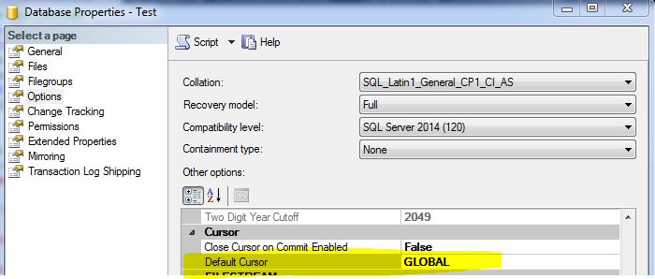

Fig 1: Difference between Local Cursor and Global Cursor in SQL Server

Let's create a sample table and insert some records and do some test to prove our above definition.

--drop table dbo.Customer
Create table dbo.Customer (
CustomerId Int ,
CustomerName VARCHAR(100),
StreetAddress VARCHAr(100),
City VARCHAR(100),
State CHAR(2))
go

--Insert few Records in Sample Table
Insert into dbo.Customer
Select 1,'Aamir shahzad','Test Street Address','Charlotte','NC'
Union all
Select 2,'M Raza','Test Street Address','Charlotte','NC'
union all
Select 3,'John Smith','Test Street Address','New York City','NY'
union All
Select 4,'Christy Richard','Test Street Address','Rio Rancho','NM'

--Test with GLOBAL Cursor in Multiple Batches.
use Test
go

DECLARE Customer_Cursor CURSOR
--use LOCAL OR GLOBAL HERE
GLOBAL
FOR
Select CustomerID,
CustomerName,
StreetAddress,
City,
State
from dbo.Customer
OPEN Customer_Cursor;
GO

--Terminate the Batch and change the Database
use TestDB
go
FETCH NEXT FROM Customer_Cursor
WHILE (@@FETCH_STATUS <> -1)
BEGIN
FETCH NEXT FROM Customer_Cursor
END
CLOSE Customer_Cursor;
GO
DEALLOCATE Customer_Cursor;
GO

We will be able to see the records as we have defined Cursor as GLOBAL and it will be
available during entire Connection , even we have terminated the first Batch by using GO
statement.

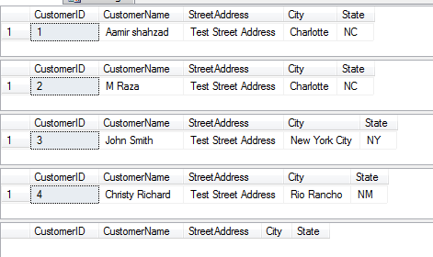

Fig 2: Global Cursor in SQL Server

--Test with LOCAL Cursor in Multiple Batches.
use Test
go

DECLARE Customer_Cursor CURSOR
--use LOCAL OR GLOBAL HERE
LOCAL
FOR
Select CustomerID,
CustomerName,
StreetAddress,
City,
State
from dbo.Customer
OPEN Customer_Cursor;
GO

--Terminate the Batch and change the Database
use TestDB
go
FETCH NEXT FROM Customer_Cursor
WHILE (@@FETCH_STATUS <> -1)
BEGIN
FETCH NEXT FROM Customer_Cursor
END
CLOSE Customer_Cursor;
GO
DEALLOCATE Customer_Cursor;
GO

As the scope for LOCAL Cursor is limited to Batch, Stored Procedure or Trigger, The second batch is not able to see the Cursor as we have defined LOCAL Cursor type in our above query
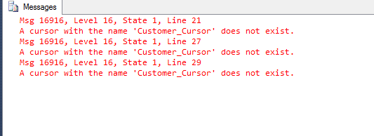
Fig 3: Local Cursor in SQL Server

Now let's perform the test with Stored Procedure and see how Local Cursor and Global Cursor works in Stored Procedure in SQL Server.

--Test with LOCAL Cursor in Multiple Batches.
use Test
go

Create Procedure Dec_Cursor_Customer AS
BEGIN
DECLARE Customer_Cursor CURSOR
--use LOCAL OR GLOBAL HERE
GLOBAL
FOR
Select CustomerID,
CustomerName,
StreetAddress,
City,
State
from dbo.Customer
OPEN Customer_Cursor;
END

GO
Create Procedure Fetch_Cusor_Customer
AS
BEGIN
FETCH NEXT FROM Customer_Cursor
WHILE (@@FETCH_STATUS <> -1)
BEGIN
FETCH NEXT FROM Customer_Cursor
END
END

--Execute the Procedures to What we get with GLOBAL and LOCAL Cursor Type

EXEC Dec_Cursor_Customer
GO
EXEC Fetch_Cusor_Customer
CLOSE Customer_Cursor;
GO
DEALLOCATE Customer_Cursor;
GO

If we execute the above Stored Procedure, we will get the results as we got in Fig 2. As we have declare as GLOBAL type ,we will be able to use it in multiple Stored Procedure as long as you run them in same connection.

Go ahead and Alter the Stored Procedure and change the type from GLOBAL to Local and then execute the procedures. Even we are in same connection, We will get the error that we got in Fig 3. As the scope of Cursor is limited to Batch,Stored Procedure or Trigger once you define as LOCAL.

Change Data Capture

How to Enable Change Data Capture(CDC) on a Database in SQL Server

Scenario:
You are working as SQL Server DBA or developer, you need to write script that you can use to enable Change Data Capture (CDC) on any database.

The below script can be used to enable Change Data Capture (CDC) on any database, you simple have to provide database name to variable @DBName.

/*--------------------------------
1: Enable CDC ON Database
----------------------------------*/
DECLARE @DBName NVARCHAR(100)
DECLARE @Cdc_Status BIT
--> Provide your Database Name on which you want to Enable CDC

SET @DBName='TESTDB'
SET @Cdc_Status=(SELECT is_cdc_enabled
FROM sys.databases
WHERE name = @DBName)
IF @Cdc_Status = 1
PRINT ' CDC is already enabled on Database:: '
+ @DBName
IF @Cdc_Status = 0
BEGIN
DECLARE @SQL NVARCHAR(500)

SET @SQL=@DBName + '.sys.Sp_cdc_enable_db'

EXEC (@SQL)

PRINT ' CDC Enabled on ' + @DBName + ' successfully'
END

How to Disable Change Data Capture(CDC) On a Database in SQL Server?

Scenario:
You are working as SQL Server DBA or Developer, you need to write script that should accept database name and then disable Change Data Capture ( CDC ) on that database.

The below script can be used to Disable Change Data Capture on a database. You need to set the value for @DBName variable to database on which you want to disable Change Data Capture.

/*--------------------------------
1: Disable CDC ON Database
----------------------------------*/
DECLARE @DBName NVARCHAR(100)
DECLARE @Cdc_Status BIT
--> Provide your Database Name on which you want to Disable CDC

SET @DBName='TESTDB'
SET @Cdc_Status=(SELECT is_cdc_enabled
FROM sys.databases
WHERE name = @DBName)
IF @Cdc_Status = 0
PRINT ' CDC is already disabled on Database:: '
+ @DBName
IF @Cdc_Status = 1
BEGIN
DECLARE @SQL NVARCHAR(500)

SET @SQL=@DBName + '.sys.Sp_cdc_disable_db'

EXEC (@SQL)

PRINT ' CDC Disabled on ' + @DBName
+ ' successfully'
END

How to Enable CDC on Set of Tables OR Enable on All Tables in a Database in SQL Server ?

Scenario:
You are working as SQL Server DBA or Developer, you need to write script that you can use to enable Change Data Capture (CDC ) on all the tables in a database or Enable on some specific Tables.

The below script can be used to Enable Change Data Capture on all the table in a database of selected tables. You can change the query to include or exclude the tables you like.

/*------------------------------------------------
Enable CDC on Set of Tables
( To Enable CDC on Table , CDC Should be enabled on Database level)
--------------------------------------------------*/
USE [DatabaseName]
GO

DECLARE @TableName VARCHAR(100)

DECLARE @TableSchema VARCHAR(100)

DECLARE CDC_Cursor CURSOR FOR
SELECT *
FROM (

SELECT 'T' AS TableName,'dbo' AS TableSchema
UNION ALL
SELECT 'T2' AS TableName,'dbo' AS TableSchema
--IF want to Enable CDC on All Table, then use
--SELECT Name,SCHEMA_NAME(schema_id) AS TableSchema
--FROM sys.objects
--WHERE type = 'u'
-- AND is_ms_shipped <> 1
) CDC

OPEN CDC_Cursor

FETCH NEXT FROM CDC_Cursor INTO @TableName,@TableSchema

WHILE @@FETCH_STATUS = 0
BEGIN
DECLARE @SQL NVARCHAR(1000)
DECLARE @CDC_Status TINYINT

SET @CDC_Status=(SELECT COUNT(*)
FROM cdc.change_tables
WHERE Source_object_id = OBJECT_ID(@TableSchema+'.'+@TableName))

--IF CDC Already Enabled on Table , Print Message
IF @CDC_Status = 1
PRINT 'CDC is already enabled on ' +@TableSchema+'.'+@TableName
+ ' Table'

--IF CDC is not enabled on Table, Enable CDC and Print Message
IF @CDC_Status <> 1
BEGIN
SET @SQL='EXEC sys.sp_cdc_enable_table
@source_schema = '''+@TableSchema+''',
@source_name = ''' + @TableName
+ ''',
@role_name = null;'

EXEC sp_executesql @SQL

PRINT 'CDC enabled on ' +@TableSchema+'.'+ @TableName
+ ' Table successfully'
END

FETCH NEXT FROM CDC_Cursor INTO @TableName,@TableSchema
END

CLOSE CDC_Cursor

DEALLOCATE CDC_Cursor

How to Disable CDC On Set Of Tables OR Disable On All Tables In a Database in SQL Server ?

Scenario:
You are working as SQL Server DBA or Developer, You need to prepare script that should be able to Disable Change Data Capture (CDC) on all the tables in a database Or if you would like to disable on some specific table , it should be able to handle that.

The below script can be used to Disable Change Data Capture on all the tables in a database and if you would like to provide the list of tables, you have the option too. By simply changing select query, you can include or exclude list of tables on which you would like to disable CDC.

/*------------------------------------------------
Disable CDC on Set of Tables
--------------------------------------------------*/
DECLARE @TableName VARCHAR(100)
DECLARE CDC_Cursor CURSOR FOR
--Provide List of Tables here on which CDC needs to be disabled.
SELECT *
FROM (SELECT 'T' AS TableName
UNION ALL
SELECT 'T2' AS TableName
--IF want to Disable CDC on All Table, then use
--SELECT Name
--FROM sys.objects
--WHERE type = 'u'
-- AND is_ms_shipped <> 1
) CDC
OPEN CDC_Cursor
FETCH NEXT FROM CDC_Cursor INTO @TableName
WHILE @@FETCH_STATUS = 0
BEGIN
DECLARE @SQL NVARCHAR(1000)
DECLARE @CDC_Status TINYINT

SET @CDC_Status=(SELECT COUNT(*)
FROM cdc.change_tables
WHERE Source_object_id = OBJECT_ID(@TableName))

--IF CDC is Already Disabled on Table , Print Message
IF @CDC_Status = 0
PRINT 'CDC is already Disabled on ' + @TableName
+ ' Table'

--IF CDC is not Disabled on Table, Disable CDC and Print Message
IF @CDC_Status = 1
BEGIN
SET @SQL='EXEC sys.sp_cdc_disable_table
@source_schema = ''dbo'',
@source_name = ''' + @TableName
+ ''',
@capture_instance = N''All'';'

EXEC sp_executesql
@SQL

PRINT 'CDC disabled on ' + @TableName
+ ' Table successfully'
END

FETCH NEXT FROM CDC_Cursor INTO @TableName
END

CLOSE CDC_Cursor
DEALLOCATE CDC_Cursor

How to Modify Change Data Capture (CDC) Retention Period in SQL Server ?

Scenario :
You are working as SQL Server DBA or developer, you just enabled Change Data Capture on one of the database. The default retention period is 3 days. You would like to change the retention period to 1000 days. How would you do that?

Solution:
The below script can be used to change the retention period for Change Data Capture ( CDC) in SQL Server database.

/*---------------------------------------
Change CDC Retention Period
The retention is provide in minutes , If we are providing in Days then we
have to convert that to minutes.
-----------------------------------------*/
USE [DatabaseName]
GO
DECLARE @Retention_IN_DAYS INT
DECLARE @Retention_IN_Minutes INT

SET @Retention_IN_DAYS=10--> Provide the Retention period in days here
SET @Retention_IN_Minutes=@Retention_IN_DAYS * 24 * 60
--Print Current Retention Period
SELECT retention / 60 / 24 AS [Retention_In_Days]
FROM msdb.dbo.cdc_jobs
WHERE job_type = 'cleanup'
--SET Retention to Required Days
EXECUTE sys.sp_cdc_change_job
N'cleanup',
@retention = @Retention_IN_Minutes
--Check if Retention is Set for Given Days
SELECT retention / 60 / 24 AS [Retention_In_Days]
FROM msdb.dbo.cdc_jobs
WHERE job_type = 'cleanup'

How to Enable Change Data Capture (CDC) On Entire Table OR Enable CDC On Table With List Of Columns in SQL Server

Scenario:
Sometime we have requirement to Enable CDC on Table including all the columns OR enable CDC on table with set of columns. The SP can perform both tasks depending upon provided parameters.This Stored Procedure will be used when CDC is already not enabled on Table. If Change Data Capture (CDC) is already enabled on Table , The Stored Procedure will not perform any action.

Solution:
The below stored Procedure can be used to enable CDC on all the columns of a table or any chosen columns.
USE [DatabaseName]
GO
/*-----------------------------------------------------------------------------------------------------
How to Execute: EXEC usp_EnableCdcOnTableWithOrWithoutColumnList @pSchemaName,@pTableName,@pColumnList

Enable CDC on Table with All columns
Example :usp_EnableCdcOnTableWithOrWithoutColumnList 'SchemaName','TableName',NULL

Enable CDC on Table with Given columns
Example :usp_EnableCdcOnTableWithOrWithoutColumnList 'SchemaName','TableName','Col1,Col2'
---------------------------------------------------------------------------------------------------------*/

SET ANSI_NULLS ON
GO
SET QUOTED_IDENTIFIER ON
GO
CREATE PROCEDURE [dbo].[Usp_enablecdcontablewithorwithoutcolumnlist]
@pSchemaName VARCHAR(50),--> Provide the Schema Name where table exists
@pTableName VARCHAR(100),--> TableName to ENABLE CDC ON.
@pColumnList VARCHAR(1000)--> ColumnList eg.'col1,col2'
AS
BEGIN
--DECLARE LOCAL VARIABLES

DECLARE @vSQLStatment NVARCHAR(MAX)
DECLARE @vSQLEnableCDC NVARCHAR(MAX)
DECLARE @vXML XML;
DECLARE @vCDCEnableInd INT
DECLARE @vColumnCount INT

-- IF CDC ALREADY ENABLED

SET @vCDCEnableInd=(SELECT is_tracked_by_cdc
FROM sys.tables
WHERE name = @pTableName)

-- CHECK IF CORRECT TABLE NAME IS PROVIDED

IF NOT EXISTS (SELECT 1
FROM INFORMATION_SCHEMA.COLUMNS
WHERE TABLE_NAME = @pTableName)
BEGIN
PRINT ' The given table does not exists in Database::'
+ @pTableName
END
-- ENABLE CDC WITH ALL THE COLUMNS IF NO COLUMNS PROVIDED

ELSE
BEGIN
IF @pColumnList IS NULL
AND @vCDCEnableInd = 1
BEGIN
PRINT 'CDC is alrady enabled on ::' + @pTableName

END

IF @pColumnList IS NULL
AND @vCDCEnableInd = 0
BEGIN
SELECT @vSQLStatment = 'EXEC sys.sp_cdc_enable_table
@source_schema = ''' + @pSchemaName
+ ''',
@source_name = ''' + @pTableName
+ ''',
@role_name = null;'

EXEC sp_executesql
@vSQLStatment

PRINT ' CDC Enabled on ::' + @pTableName
+ ' for all the columns'
END

-- IF COLUMN LIST IS PROVIDED FOR CDC

IF ( LEN(@pColumnList) > 0 )
BEGIN
SET @vXML=CAST('' + REPLACE(@pColumnList, ',', '')
+ '
' AS XML);
-- CHECK IF Incorrect COLUMN NAME IS PROVIDEDED

SELECT @vColumnCount = COUNT(*)
FROM @vXML.nodes('/a') AS R(nref)
WHERE NOT EXISTS (SELECT 1
FROM INFORMATION_SCHEMA.COLUMNS I
WHERE I.TABLE_NAME = @pTableName
AND I.COLUMN_NAME = nref.value('.', 'nvarchar(50)'))

IF ( @vColumnCount <> 0 )
PRINT ' The List of Columns provided do not exit in Source Table.Check the ColumnList'
-- IF All columns Exists in Source Table, Enable CDC

IF ( @vColumnCount = 0
AND @vCDCEnableInd = 1 )
BEGIN
PRINT ' The CDC is already Enabled for this table.'
END

IF ( @vColumnCount = 0
AND @vCDCEnableInd = 0 )
BEGIN
--Enable CDC

SET @vSQLEnableCDC='EXEC sys.sp_cdc_enable_table
@source_schema=''' + @pSchemaName
+ ''',@source_name=''' + @pTableName
+ ''', @role_name=NULL, @captured_column_list= '''
+ @pColumnList + ''''

EXEC (@vSQLEnableCDC)

PRINT ' CDC Enabled on ::' + @pTableName + ' for '
+ @pColumnList + ' Columns.'
END
END
END
END

How to Create History OR Audit Views from Change Data Capture ( CDC) Tables in SQL Server

Scenario:
You are working as SQL Server DBA or developer, you have enabled Change Data Capture on one of the SQL Server Database, After enabling CDC you want to create AUDIT OR HIST Views
so can get the changed records.

Solution:
The below script will create view for each of the table on which CDC is enabled in your database.
I have used Audit Schema, before you run the script, You need to create Audit Schema or If you want to create views in Hist Schema then change Schema in Below Code from Audit To Hist.

Each view will return us below columns
- Commit_Time,
- Colum_Name,
- Old_Value,
- New_Value,
- ModifiedBy

IF OBJECT_ID(N'tempdb..##CDC_TableList') IS NOT NULL
BEGIN
DROP TABLE ##CDC_TableList
END

SELECT T.name AS TableName,
C.name AS ColumnName,
'CASE WHEN (sys.Fn_cdc_is_bit_set (sys.Fn_cdc_get_column_ordinal (''dbo_'
+ T.name + ''',''' + C.name+
+ '''),__$update_mask) = 1) THEN Cast('
+ C.Name
+ ' AS SQL_VARIANT) ELSE NULL END AS '
+ C.name AS CaseStm INTO ##CDC_TableList
FROM sys.tables T
INNER JOIN sys.columns c
ON T.OBJECT_ID = c.OBJECT_ID
WHERE is_tracked_by_cdc = 1
AND c.is_identity = 0
AND C.name NOT IN ( 'CreatedBy', 'CreatedDate', 'ModifiedBy', 'ModifiedDate' )
AND T.TYPE='U'
AND T.is_ms_shipped<>1

-- Select * from sys.tables

DECLARE @TableName NVARCHAR(200)
DECLARE cdc_cursor CURSOR FOR
SELECT DISTINCT TableName FROM ##CDC_TableList
OPEN cdc_cursor
FETCH NEXT FROM cdc_cursor INTO @TableName

WHILE @@FETCH_STATUS = 0
BEGIN

DECLARE @ColumnList NVARCHAR(MAX)
DECLARE @CaseStmList NVARCHAR(MAX)
DECLARE @SQL_Stm NVARCHAR(MAX)
DECLARE @SQL_Stm_DropView NVARCHAR(MAX)
PRINT @TableName

SELECT @ColumnList = STUFF(o.COLUMNNAME, 1, 1, '')
FROM ##CDC_TableList t CROSS APPLY (SELECT ',' + ColumnName+CHAR(10) AS [text()]
FROM ##CDC_TableList c
WHERE c.TableName = t.TableName
FOR XML PATH('')) o (COLUMNNAME)
WHERE t.TableName=@TableName
PRINT @ColumnList

SELECT @CaseStmList = STUFF(o.COLUMNNAME, 1, 1, '')
FROM ##CDC_TableList t CROSS APPLY (SELECT ',' + CaseStm+CHAR(10) AS [text()]
FROM ##CDC_TableList c
WHERE c.TableName = t.TableName
FOR XML PATH('')) o (COLUMNNAME)
WHERE t.TableName=@TableName
--PRINT @CaseStmList

--If using Other Schema than AUDIT THEN change to that.
SET @SQL_Stm=' CREATE VIEW AUDIT.vw_'+@TableName+' AS

SELECT sys.Fn_cdc_map_lsn_to_time(up_b.__$start_lsn) AS Commit_Time, up_b.Column_Name, up_b.Old_Value, up_a.New_Value,up_a.ModifiedBy
FROM
( SELECT __$start_lsn, column_name, old_value,ModifiedBy
FROM (SELECT __$start_lsn,'+@CaseStmList+',ModifiedBy FROM cdc.fn_cdc_get_all_changes_dbo_'+@TableName+'( sys.fn_cdc_get_min_lsn(''dbo_'+@TableName+'''), sys.fn_cdc_map_time_to_lsn(''largest less than or equal'',GETDATE()), N''all update old'')
WHERE __$operation = 3
) AS BeforeUpdate
UNPIVOT (old_value FOR column_name IN ('+@ColumnList+') ) AS unp) AS up_b INNER JOIN
(SELECT __$start_lsn, column_name, new_value,ModifiedBy
FROM (SELECT __$start_lsn,'+@CaseStmList+',ModifiedBy FROM cdc.fn_cdc_get_all_changes_dbo_'+@TableName+'(sys.fn_cdc_get_min_lsn(''dbo_'+@TableName+'''), sys.fn_cdc_map_time_to_lsn(''largest less than or equal'',GETDATE()), N''all'')
WHERE __$operation = 4
) AS AfterUpdate
UNPIVOT (new_value FOR column_name IN ('+@ColumnList+') ) AS unp ) AS up_a
ON up_b.__$start_lsn = up_a.__$start_lsn AND up_b.column_name = up_a.column_name'
--Drop View if already exists
SET @SQL_Stm_DropView= 'IF EXISTS (SELECT TABLE_NAME FROM INFORMATION_SCHEMA.VIEWS
WHERE TABLE_NAME = ''vw_'+@TableName+''')
DROP VIEW AUDIT.vw_'+@TableName
PRINT @SQL_Stm_DropView

EXEC (@SQL_Stm_DropView)
EXEC ( @SQL_Stm)
FETCH NEXT FROM cdc_cursor INTO @TableName
END

CLOSE cdc_cursor
DEALLOCATE cdc_cursor

How to Add OR Drop Column From CDC Enabled Table Without Losing Data in SQL Server Database?

Scenario: Download Script
Sometime we have to add or drop column to Source table on which Change Data Capture (CDC) is already enabled.
The New Added column will not be tracked by Change Data Capture(CDC) and for Dropped column, CDC table will show Null.
The SP can be used to Add New column to Change Data Capture (CDC) without losing Any previous data in CDC Table. The same SP can be used to drop column from Change Data Capture (CDC) as It is dropped from Source Column but leave the remaining columns without losing any Data in CDC Table.
USE [DataBaseName]

GO

/*--------------------------------------------------------------------------------------------------------
How to Execute: EXEC usp_AddOrDropColumnToCDCTableWithoutLosingData @SchemaName,@TableName,@ColumnName,@Action

Adding New Column
Example :EXEC usp_AddOrDropColumnToCDCTableWithoutLosingData 'dbo','T','NAME','ADD'

Drop existing Column
Example :EXEC usp_AddOrDropColumnToCDCTableWithoutLosingData 'dbo','T','Name','DROP'

--------------------------------------------------------------------------------------------------------*/
SET ANSI_NULLS ON

GO

SET QUOTED_IDENTIFIER ON

GO

CREATE PROCEDURE dbo.Usp_addordropcolumntocdctablewithoutlosingdata @pSchemaName VARCHAR(50),
@pTableName VARCHAR(100),
@pColumnName VARCHAR(100),
@pAction VARCHAR(10)
AS
BEGIN
DECLARE @vSQLTempTable NVARCHAR(MAX)
DECLARE @vSQLAlterTable NVARCHAR(MAX)
DECLARE @vDisableCDC NVARCHAR(MAX)
DECLARE @vGetAlreadyExistingColumns NVARCHAR(MAX)
DECLARE @vEnableCDC NVARCHAR(MAX)
DECLARE @vLoadCDCTable NVARCHAR(MAX)
DECLARE @vDropCreateTemp NVARCHAR(MAX)
DECLARE @vDataType VARCHAR(50)
DECLARE @vColumnList NVARCHAR(2000)
DECLARE @vColumnExists INT
DECLARE @vColumnExistsCDC INT
DECLARE @vTempTableName VARCHAR(100)
DECLARE @vDropColumnList NVARCHAR(2000)
DECLARE @vDropColumnListExcSys NVARCHAR(2000)

SET @vTempTableName='##' + @pSchemaName + '_' + @pTableName

BEGIN TRY
IF ( @pAction = 'ADD'
OR @pAction = 'Drop' )
BEGIN
--Check if Column exists for SourceTable table
SET @vColumnExists=(SELECT Count(*)
FROM INFORMATION_SCHEMA.COLUMNS
WHERE TABLE_SCHEMA = @pSchemaName
AND TABLE_NAME = @pTableName
AND COLUMN_NAME = @pColumnName)

IF ( @vColumnExists = 0
AND @pAction = 'ADD' )
BEGIN
PRINT ' COLUMN ::' + @pColumnName
+ ' does not exists for Source Table ::'
+ @pTableName
+ ' Please add column to Source Table to include in CDC Table.'
END
ELSE
BEGIN
PRINT ' COLUMN ::' + @pColumnName
+ ' exists for Source Table ::' + @pTableName
+ '-->Proceeding to Next Step.'
END

--Check if Column exists for CDC table
IF ( @vColumnExists != 0
AND @pAction = 'ADD' )
SET @vColumnExistsCDC=(SELECT Count(*)
FROM INFORMATION_SCHEMA.COLUMNS
WHERE TABLE_SCHEMA = 'cdc'
AND TABLE_NAME = @pSchemaName + '_' + @pTableName + '_CT'
AND COLUMN_NAME = @pColumnName)

IF ( @vColumnExistsCDC != 0
AND @pAction = 'ADD' )
BEGIN
PRINT ' COLUMN ::' + @pColumnName
+ ' is already part of CDC Tble ::cdc.'
+ @pSchemaName + '_' + @pTableName + 'CT'
END

IF ( @vColumnExistsCDC = 0
AND @pAction = 'ADD' )
BEGIN
PRINT ' COLUMN ::' + @pColumnName
+ ' is not part of CDC Tble ::cdc.'
+ @pSchemaName + '_' + @pTableName
+ 'CT -->Proceeding to ADD this column'
END

--COPY EXISTING CDC TABLE TO TEMP TABLE
--Drop Temp table before Creating/Loading IT
SET @vDropCreateTemp=' IF Object_id(N''tempdb..'
+ @vTempTableName
+ ''') IS NOT NULL
BEGIN
DROP TABLE ##'
+ @pSchemaName + '_' + @pTableName + ' END'

PRINT @vDropCreateTemp

EXEC (@vDropCreateTemp)

SET @vSQLTempTable= 'SELECT * INTO ' + @vTempTableName
+ ' From cdc.' + @pSchemaName + '_' + @pTableName
+ '_CT'

PRINT @vSQLTempTable

EXEC(@vSQLTempTable)

IF ( @vColumnExistsCDC = 0
AND @pAction = 'ADD' )
BEGIN
--ADD COLUMN TO TEMP TABLE
SET @vDataType=(SELECT CASE
WHEN DATA_TYPE IN ( 'CHAR', 'varchar', 'nvarchar' ) THEN DATA_TYPE + '('
+ Cast(CHARACTER_MAXIMUM_LENGTH AS VARCHAR(50))
+ ')'
WHEN Data_Type IN ( 'int', 'bigint', 'smallint', 'tinyint',
'money', 'bit', 'date', 'datetime' ) THEN Data_Type
WHEN data_type IN ( 'numeric', 'decimal' ) THEN DATA_TYPE + '('
+ Cast(Numeric_Precision_Radix AS VARCHAR(50))
+ ',' + Cast(Numeric_scale AS VARCHAR(50))
+ ')'
END AS DataType
FROM INFORMATION_SCHEMA.COLUMNS
WHERE TABLE_NAME = @pTableName
AND COLUMN_NAME = @pColumnName)
SET @vSQLAlterTable='ALTER TABLE ' + @vTempTableName + ' ADD '
+ @pColumnName + ' ' + @vDataType

PRINT @vSQLAlterTable

EXEC (@vSQLAlterTable)

-- ENABLE CDC ON TABLE ( INCLUDING NEW COLUMN)
IF Object_id(N'tempdb..##ColumnList') IS NOT NULL
BEGIN
DROP TABLE ##ColumnList
END

CREATE TABLE ##ColumnList
(
ColumnList NVARCHAR(2000)
)

SET @vGetAlreadyExistingColumns= N' DECLARE @vCDCAlreadyEnabledColumns NVARCHAR(2000)
SELECT @vCDCAlreadyEnabledColumns = COALESCE(@vCDCAlreadyEnabledColumns+ '','', '''')
+ QUOTENAME(COLUMN_NAME) FROM INFORMATION_SCHEMA.COLUMNS WHERE TABLE_NAME='''
+ @pSchemaName + '_' + @pTableName + '_'
+ 'CT'' AND COLUMN_NAME NOT
IN (''__$start_lsn'',
''__$end_lsn'',
''__$seqval'',
''__$operation'',
''__$update_mask'')
PRINT @vCDCAlreadyEnabledColumns
Insert into ##ColumnList values (@vCDCAlreadyEnabledColumns)'

PRINT @vGetAlreadyExistingColumns

EXEC ( @vGetAlreadyExistingColumns)

SELECT @vColumnList = ColumnList + ',[' + @pColumnName + ']'
FROM ##ColumnList

PRINT @vColumnList

-- DISABLE CDC ON SOURCE TABLE
SET @vDisableCDC='EXEC sys.sp_cdc_disable_table @source_schema='''
+ @pSchemaName + ''',
@source_name='''
+ @pTableName + ''',@capture_instance='''
+ @pSchemaName + '_' + @pTableName + ''''

PRINT @vDisableCDC

EXEC (@vDisableCDC)

--Enable CDC
SET @vEnableCDC='EXEC sys.sp_cdc_enable_table
@source_schema=''' + @pSchemaName
+ ''',@source_name=''' + @pTableName
+ ''', @role_name=NULL, @captured_column_list= '''
+ @vColumnList + ''''

PRINT @vEnableCDC

EXEC (@vEnableCDC)

-- INSERT RECORD FROM Temp to CDC Table
SET @vLoadCDCTable=' INSERT INTO cdc.' + @pSchemaName + '_'
+ @pTableName
+ '_CT
SELECT * FROM '
+ @vTempTableName + ''

-- Drop Table '+@vTempTableName+''
PRINT @vLoadCDCTable

EXEC (@vLoadCDCTable)
END

/***-------------------------------------DROP COLUMN LOGIC STARTS-----------------------------************/
--Build Column List excluding Drop column
IF EXISTS (SELECT 1
FROM INFORMATION_SCHEMA.COLUMNS
WHERE TABLE_SCHEMA = 'cdc'
AND TABLE_NAME = @pSchemaName + '_' + @pTableName + '_CT'
AND COLUMN_NAME = @pColumnName)
AND @pAction = 'Drop'
BEGIN
SELECT @vDropColumnList = Stuff(o.COLUMNNAME, 1, 1, '')
FROM INFORMATION_SCHEMA.COLUMNS t
CROSS APPLY (SELECT ',' + Column_Name + Char(10) AS [text()]
FROM INFORMATION_SCHEMA.COLUMNS c
WHERE c.Table_Name = t.Table_Name
AND c.COLUMN_NAME <> @pColumnName
FOR XML PATH('')) o (COLUMNNAME)
WHERE t.Table_Name = 'dbo_' + @pTableName + '_CT'

--Get Columns without Sytem Columns
SELECT @vDropColumnListExcSys = Stuff(o.COLUMNNAME, 1, 1, '')
FROM INFORMATION_SCHEMA.COLUMNS t
CROSS APPLY (SELECT ',' + Column_Name + Char(10) AS [text()]
FROM INFORMATION_SCHEMA.COLUMNS c
WHERE c.Table_Name = t.Table_Name
AND c.COLUMN_NAME <> @pColumnName
AND C.COLUMN_NAME NOT IN ( '__$start_lsn', '__$end_lsn', '__$seqval', '__$operation', '__$update_mask' )
FOR XML PATH('')) o (COLUMNNAME)
WHERE t.Table_Name = 'dbo_' + @pTableName + '_CT'

-- DISABLE CDC for Drop Column
SET @vDisableCDC='EXEC sys.sp_cdc_disable_table @source_schema='''
+ @pSchemaName + ''',
@source_name='''
+ @pTableName + ''',@capture_instance='''
+ @pSchemaName + '_' + @pTableName + ''''

EXEC (@vDisableCDC)

-- ENABLE TABLE EXCLUDING GIVEN COLUMN
SET @vEnableCDC='EXEC sys.sp_cdc_enable_table
@source_schema=''' + @pSchemaName
+ ''',@source_name=''' + @pTableName
+ ''', @role_name=NULL, @captured_column_list= '''
+ @vDropColumnListExcSys + ''''

EXEC (@vEnableCDC)

--COPY DATA FROM TEMP DATA TO CDC TABLE
SET @vLoadCDCTable=' INSERT INTO cdc.' + @pSchemaName + '_'
+ @pTableName + '_CT(' + @vDropColumnList
+ ')
SELECT '
+ @vDropColumnList + ' FROM ' + @vTempTableName
+ ''

--Drop Table '+@vTempTableName+''
EXEC (@vLoadCDCTable)
END
END
ELSE
PRINT ' ADD OR Drop are the correct actions available for this Procedure.Please provide ADD or Drop for SP Signature'
END TRY

BEGIN CATCH
ROLLBACK

PRINT ' ERROR Occured and All Transactions are rolledback.'
END CATCH
END

